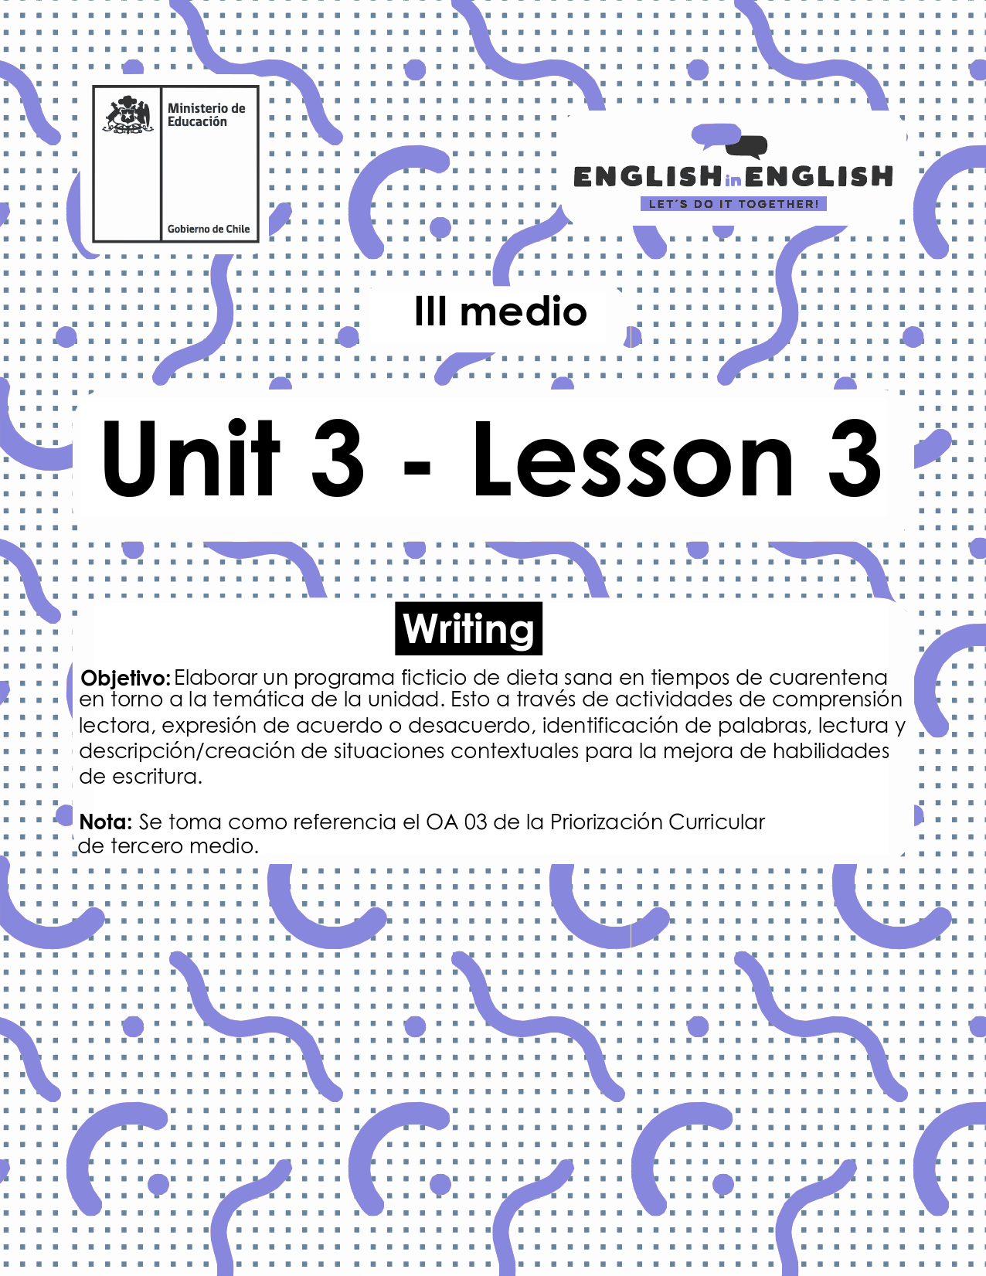

UNIT 3
LESSON 3

ÚTILES

- Texto del estudiante de 3° medio.
- Diccionario de inglés.
- Lápices.
- Cuaderno de asignatura.

SECTION 1: SETTING THE CONTEXT:
Hello students! welcome back to lesson 3. In this lesson we will rehearse our writing skills.
1.Let´s start by looking at the following picture and answering these questions:
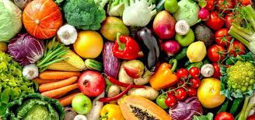
- Have you ever been on a diet? Why/why not?

- Did it work for you? Please explain.

- Name 10 food you consume while dieting. (look that the picture for reference)

- What is your opinion about vegan and vegetarian diets?

2. Read the following statements about dieting and tick if you agree (A) or disagree (D)
Statements | A | D
- Drinking plenty of water helps you boost your brain fitness.
- If you have not managed to lose weight previously, you will probably never do it.
- Generally, metabolism and body flexibility decrease with age.
- Reducing carbohydrates daily will make you feel healthy and get good sleeping.
- Eating fat and high calorie snacks regularly will prevent feeling stressed.

3. By considering the previous exercise, read the statements again, and write down the reason(s) why you agree or disagree with some of them. Follow the given pattern.

I agree with sentence __ because ________________________________________

I disagree with sentence__ because __________________________________

4.- If you had to select some piece of information to include in a weekly diet scheme, which of the following would you include? why?
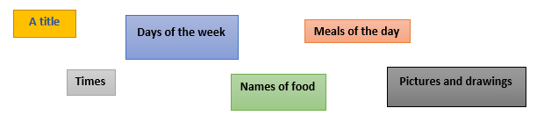
Example:
I would include the days of the week to organize the scheme with a clear structure.
I would include …………………………………………………………………………
I would include …………………………………………………………………………

SECTION 2: LET´S PRACTICE

5. Some people say that diets are not good for a healthy lifestyle because they cut some vital resources that our body needs. However, a balanced and well-prepared diet can be beneficial for your health. Here are three examples of balanced diets:
Omnivorous diets and tips:
- Drink fat-free, low-fat milk, or water instead of sugary drinks. We recommend at least 5 or 6 glasses of water a day.
- Eat at least five servings a day of fruits and veggies.
- Choose a variety of protein foods, like lean meat and poultry, seafood, beans, soy products, and nuts.
- Eat whole grains (like whole-wheat bread, brown rice, and oatmeal), which provide fiber to help you feel full, so you can avoid sugary snacks.
- Eat breakfast. Studies show that people who eat breakfast do better in school, tend to eat less throughout the day, and are less likely to be overweight.
- Pay attention to portion sizes.
- Limit eating out and choose smaller sizes at fast-food restaurants. Avoid supersizing even if it feels like better value.
- Don't take diet pills or supplements, stick to a diet and exercise.
Texto adaptado de https://kidshealth.org/en/teens/dieting.html#:~:text=The%20best%20way%20to%20diet,sweets%2C%20and%20other%20junk%20food.

Vegetarian diets and tips:
All vegetarians, especially individuals who don't eat any animal products, need to be sure they get enough iron, calcium, vitamin D, vitamin B12, and zinc. Here are some meals and types of food where you can get proteins if you are in a vegetarian diet:
- Omelettes made with vegetables such as asparagus, broccoli, mushroom, sweet peppers, and onions – serve with whole grain bread or toast and a glass of milk or fortified soy milk.
- Burritos or tacos made with black beans or refried beans.
- Stir fries made with tofu, vegetables, and nuts – enjoy with whole wheat couscous or brown rice.
- Salads made with leafy greens, chickpeas, nuts, vegetables, pasta, rice, couscous or quinoa.
- Falafels and hummus made with chickpeas served with whole grain pita bread and salad, sweet peppers or carrots.
- Peanut or almond butter on whole wheat or multigrain bagels with banana or apple slices- with a glass of calcium fortified orange juice.
- Soups made with lentils, beans, and vegetables – serve with whole grain bread or crackers.
- Pizza topped with vegetables.
- Vegetarian lasagna.
- Soy milk smoothies with a banana, frozen berries and a splash of orange juice.
Texto adaptado de: https://www.unlockfood.ca/en/Articles/Adolescents-teenagers/Meal-planning-for-the-vegetarian-teen.aspx

Vegan diet and tips:
- Drinking one cup of soymilk fortified with vitamin B12, calcium, and vitamin D each day can go a long way towards giving you the nutrition that might otherwise be lacking in a vegan diet. And if you were to drink two cups, you would really be covered.
- A daily supplement with vitamin B12, vitamin D, iodine, iron, and zinc is also a good idea. There are many available—you can get one at any grocery store.
- You should get some omega-3s in your daily diet. A tablespoon of canola oil or a teaspoon of flaxseed oil on some bread is a good way, and walnuts are also a good source.
- Other than that, it is important to eat yellow and green vegetables daily for vitamin A, iron, and calcium, and to eat legumes for protein, zinc, and folate.
- It is a good idea for vegetarian teens, and especially teenage girls, to make sure they eat a food that has a large amount of vitamin C with at least two meals each day, especially meals with legumes. This is because vitamin C greatly increases iron absorption of plant foods. Some foods that are high in vitamin C per typical serving are orange juice and grapefruit juice, oranges, broccoli, strawberries, grapefruit, yellow peppers, and red peppers.
Texto adaptado de: https://veganhealth.org/teens/
Now that you have read about different types of diets to have a balanced eating, let’s talk about your eating habits:
- How many days a week do you eat vegetables and fruits?

- What type of vegetables do you eat?

- Do you drink the recommended amount of water a day?

- Do you pay attention to portion sizes?

- Do you eat grains and legumes? Yes, I do.

- What type of grains and legumes do you like?

- Why do you think pasta and bread are not mentioned in these diet tips?

- Do you have any tip you would like to add?

6. There are some countries that have a completely different eating style. For example, in Asia people eat rice with vegetables and fish soup for breakfast, and then for lunch they have a small bite or a sandwich. Answer the following questions about you:
- What is your ideal breakfast?

- Do you think people should have a big meal for dinner? Why / why not?

- Would you follow the type of Asian diet mentioned above? Why / Why not?

- What type of food would you ban from a diet and why?

- What snacks would you recommend and why?

7. Re-read the three text about Omnivorous, vegetarian and vegan diet in exercise 5, then include key food in the following table. Keep in mind that you can repeat some food.

Omnivorous | Vegetarian | Vegan

SECTION 3: LET´S CONSTRUCT AND APPLY YOUR KNOWLEDGE

8. Now it is time to apply all your knowledge about healthy eating. For this, imagine that you are asked to create a weekly diet scheme to keep your classmates healthy over a week of quarantine. Follow these steps to construct this scheme

- Add a title to your scheme
- Think about a type of diet you would like your classmates to follow (omnivorous? Vegetarian? Vegan? A mix of them?)
- Complete the scheme with food
- Add colors and some drawings to make it attractive

TITLE:
 | Monday | Tuesday | Wednesday | Thursday | Friday
Breakfast
Lunch
Snack
Dinner

EXTRA ACTIVITY:
- What about other extra tips you would like to mention? Write them down: (For example: try to work out three times weekly).

