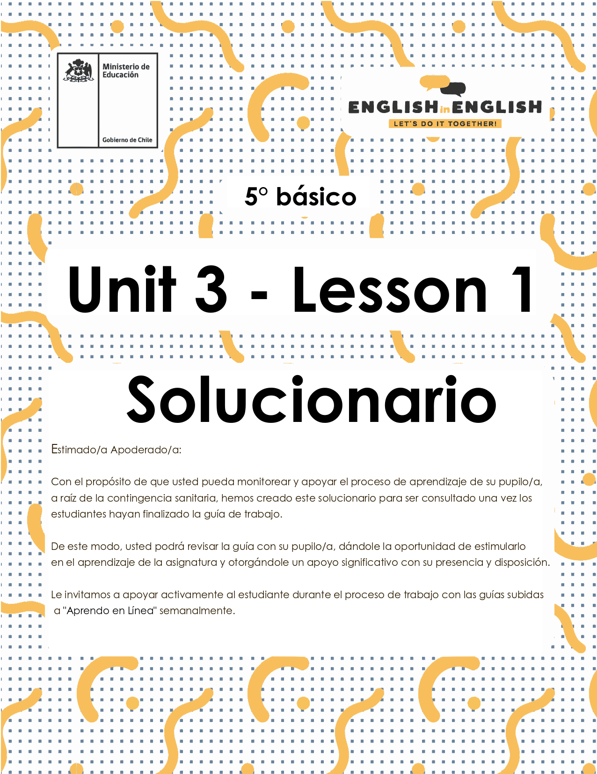

# UNIT 3

# LESSON 1

## SECTION 1: SETTING THE CONTEXT

## “What we eat”

|  |  |
| --- | --- |
| **1. Observe these families and answer the questions.**   * Observa estas familias y responde las preguntas.  |  | | --- | | **Respuesta:** (las respuestas variarán dependiendo de la opinión del estudiante)   1. *In what part of the house are they? (¿En qué parte de la casa están?)*  * They are in the dining room and the kitchen.  1. *What are they doing? (¿Qué están haciendo?)*  * *They are eating and cooking,*  1. *What do you think they are eating? (¿Qué crees que están comiendo?)*  * *Traditional food, homemade food.*  1. *What is your favorite food? (¿Cuál es tu comida favorita?)*   *________________________* | |

**2. Observe the images and the vocabulary.**

* Observa las imágenes y el vocabulario.

|  |  |  |  |  |  |  |  |  |  |  |  |  |  |  |  |  |  |  |  |  |  |  |  |  |  |  |  |  |  |  |  |  |  |  |  |  |  |  |  |  |  |  |  |
| --- | --- | --- | --- | --- | --- | --- | --- | --- | --- | --- | --- | --- | --- | --- | --- | --- | --- | --- | --- | --- | --- | --- | --- | --- | --- | --- | --- | --- | --- | --- | --- | --- | --- | --- | --- | --- | --- | --- | --- | --- | --- | --- | --- |
| **Respuesta:**  Se debe observar el vocabulario de la unidad. De izquierda a derecha son:   |  |  |  | | --- | --- | --- | | COMIDAS DEL DÍA | | | | En la mañana comemos: | En la tarde comemos: | En la noche comemos: | | Desayuno | Almuerzo | Cena |  |  |  |  |  |  |  | | --- | --- | --- | --- | --- | --- | | ALIMENTOS | | | | | | | Carne | Verduras | Frutas | Productos lácteos | Comidas | Otros alimentos | | Pollo | Tomate | Plátano | Queso | Arroz | Pan | | Pescado | Papa | Manzana | Leche | Tallarines | Panqueques |  |  |  |  |  |  | | --- | --- | --- | --- | --- | | BEBIDAS | | | | | | Té | Café | Agua | Jugo | Bebida | |

## SECTION 2: LET'S PRACTICE

## “Reading: The foods I like”

**1. Observe the images below. What do you think that they are talking about? Complete the mind map with your ideas, and then read the text.**

* Observa las imágenes de abajo. ¿De qué crees que están hablando?
* Completa el mapa con tus ideas y lee el texto.

|  |
| --- |
| **Respuesta:** (las respuestas variarán dependiendo de las ideas del estudiante)   * Food * Drinks * Meals of the day * Breakfast * Lunch * Dinner |

**2. Read the text again. Mark with a  or an  according to the information.**

* Lee el texto nuevamente.
* Mark con un  or an  de acuerdo a la información.

|  |  |  |  |  |  |  |  |  |  |  |  |  |  |  |  |  |  |  |  |  |  |  |  |  |  |  |  |  |  |  |  |  |  |  |  |  |  |  |  |  |  |  |  |  |  |  |  |  |  |  |  |  |  |  |  |  |  |  |  |  |  |  |  |
| --- | --- | --- | --- | --- | --- | --- | --- | --- | --- | --- | --- | --- | --- | --- | --- | --- | --- | --- | --- | --- | --- | --- | --- | --- | --- | --- | --- | --- | --- | --- | --- | --- | --- | --- | --- | --- | --- | --- | --- | --- | --- | --- | --- | --- | --- | --- | --- | --- | --- | --- | --- | --- | --- | --- | --- | --- | --- | --- | --- | --- | --- | --- | --- |
| **Respuesta:** (las respuestas variarán dependiendo de la opinión del estudiante)   |  |  |  |  |  |  |  | | --- | --- | --- | --- | --- | --- | --- | | Breakfast | Pancakes | Bread | Milk | Apples | Juice | Tea | | Brenda | X |  | X |  |  | X | | Mark |  | X |  | X |  | X |  |  |  |  |  |  |  |  | | --- | --- | --- | --- | --- | --- | --- | | Lunch | Tomatoes | Banana | Rice | Chicken | Water | Soda | | Brenda |  |  |  |  |  | X | | Mark | X | X | X |  | X |  |  |  |  |  |  |  |  |  | | --- | --- | --- | --- | --- | --- | --- | | Dinner | Fish | Spaghetti | Potatoes | Water | Juice | Soda | | Brenda |  | X |  |  |  | X | | Mark | X |  | X | X |  | X | |

## SECTION 3: LET’S CONSTRUCT AND APPLY OUR KNOWLEDGE

## “Writing”

**1. Observe the chart and write the answers in the box. Follow the example**

* Observa la tabla y escribe las respuestas del cuadro.
* Sigue el ejemplo.

|  |
| --- |
| **Respuesta:**   1. Spaghetti? No, I don’t. 2. Watermelon? No, I don’t. 3. Salad? Yes, I do. 4. Pizza? Yes, I do. 5. Potatoes? No, I don’t. 6. Fish? Yes, I do. |

**2. Arrange the words and write the sentences. Follow the example**

* Ordena las palabras y escribe las oraciones.
* Sigue el ejemplo.

|  |
| --- |
| **Respuesta:**   1. I don’t like pizza. 2. He likes milk. 3. She doesn’t like chicken. 4. I like water. |

**3. Observe the images and write the sentences. Follow the example.**

* Observa las imágenes y escribe las oraciones.
* Sigue el ejemplo.

|  |  |  |  |  |
| --- | --- | --- | --- | --- |
| **Respuesta:**   |  |  | | --- | --- | | 1.  I like tomatoes  I like pancakes.  I like milk. | 2.  I don’t like bananas.  I don’t like cheese.  I don’t like chicken. | | 3.  I don’t like coffee.  I don’t like bread.  I don’t like eggs. | 4.  I like soda.  I like pizza.  I like fish. | |

**4. Write 2 sentences about the food/drinks that you like and 2 sentences about the foods/drinks that you don’t like.**

* Escribe 2 oraciones sobre alimentos/bebidas que te gustan y 2 oraciones sobre alimentos/bebidas que no te gustan.

|  |  |  |  |  |  |  |  |  |  |  |  |  |
| --- | --- | --- | --- | --- | --- | --- | --- | --- | --- | --- | --- | --- |
| **Respuesta:** (las respuestas dependen del estudiante, aquí presentamos un ejemplo)   |  |  |  |  | | --- | --- | --- | --- | | Likes - dislikes | Breakfast | Lunch | Dinner | | I like... | I like bread.  I like juice. | I like potatoes.  I like fish. | I like spaghetti.  I like tea. | | I don’t like... | I don’t like fruits.  I don’t like coffee. | I don’t like bread.  I don’t like vegetables. | I don’t like soda.  I don’t like meat. | |

## SECTION 4: SPONGE ACTIVITY

* **Prepare your favorite breakfast and draw it on the tray.**
* Prepara tu desayuno favorito y dibújalo en la bandeja.

|  |
| --- |
| **Respuesta:** (las respuestas dependen del estudiante)  Se debe dibujar alimentos o bebidas para el desayuno favorito de cada estudiante. |

## SECTION 5: DIGITAL RESOURCES

* **Play this game to practice vocabulary. Click here:** <https://englishflashgames.blogspot.com/2008/09/food-game.html>
  + Juega a localizar los alimentos en la cocina y practica el vocabulario, haciendo click en el siguiente enlace: <https://englishflashgames.blogspot.com/2008/09/food-game.html>

## NO OLVIDAR REPASAR EL CONTENIDO CON UN ADULTO