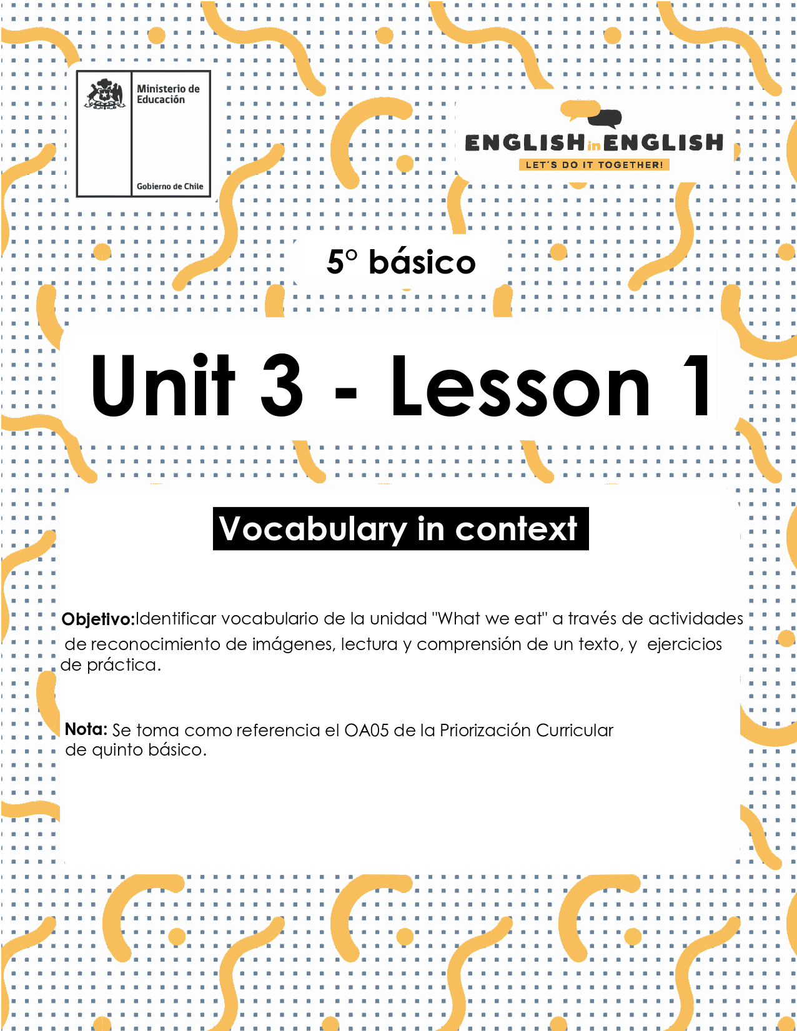

# UNIT 3

# LESSON 1

## ÚTILES RECOMENDADOS:

* Texto del Estudiante 5° Básico
* Diccionario de Inglés físico / online <https://dictionary.cambridge.org/es/diccionario/espanol-ingles/>
* Cuaderno de inglés o 2 hojas en blanco.
* Lápiz grafito y goma.

## SECTION 1: SETTING THE CONTEXT

## “What we eat”

|  |  |  |  |  |  |
| --- | --- | --- | --- | --- | --- |
| **1. Observe these families and answer the questions.**   * Observa estas familias y responde las preguntas.  |  |  |  | | --- | --- | --- | |  |  | 1. *In what part of the*   *house are they?*   1. *What are they doing?* 2. *What do you think they are eating?* 3. *What is your favorite food?* | |  |  | |

**2. Observe the images and the vocabulary.**

* Observa las imágenes y el vocabulario.

|  |  |  |
| --- | --- | --- |
| **MEALS OF THE DAY** | | |
| In the morning we eat: | In the afternoon we eat: | In the evening we eat: |
|  |  |  |
| Breakfast | Lunch | Dinner |

|  |  |  |  |  |  |
| --- | --- | --- | --- | --- | --- |
| **FOODS** | | | | | |
| Meat | Vegetables | Fruits | Dairy products | Meals | Other foods |
| Chicken | Tomato | Banana | Cheese | Rice | Bread |
| Fish | Potato | Apple | Milk | Spaghetti | Pancakes |

|  |  |  |  |  |
| --- | --- | --- | --- | --- |
| **DRINKS** | | | | |
| Tea | Coffee | Water | Juice | Soda |

## SECTION 2: LET'S PRACTICE

## “Reading: The foods I like”

**1. Observe the images below. What do you think that they are talking about? Complete the mind map with your ideas, and then read the text.**

* Observa las imágenes de abajo. ¿De qué crees que están hablando?
* Completa el mapa con tus ideas y lee el texto.

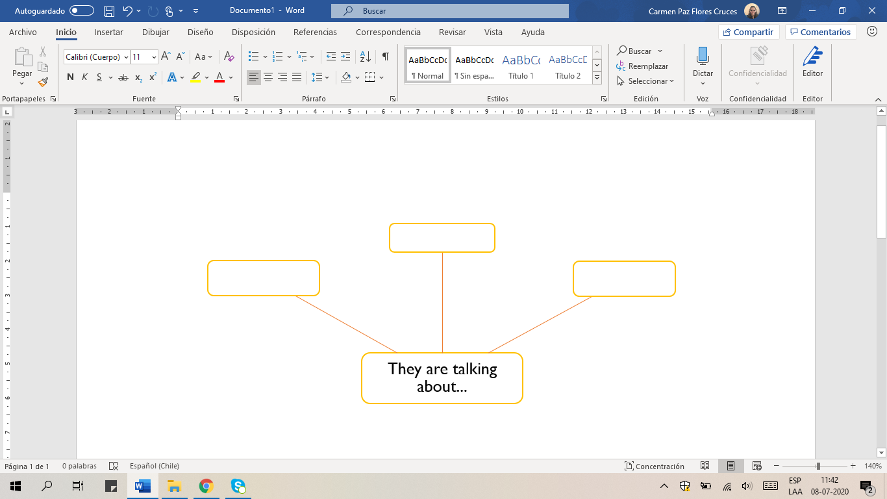

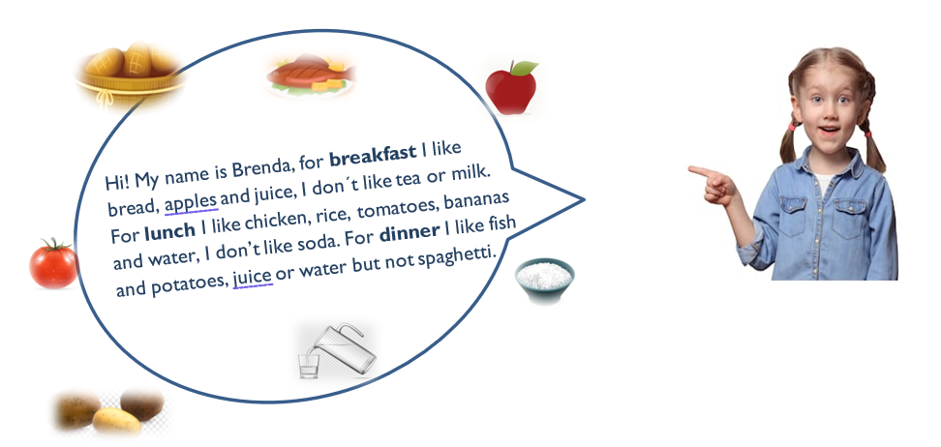

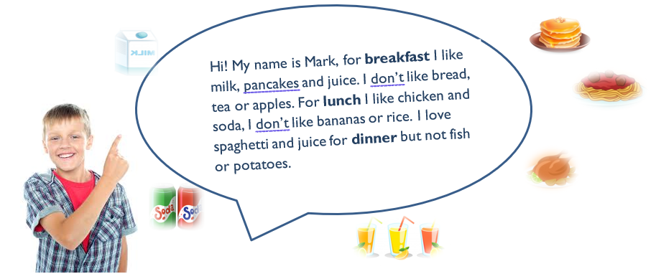

**2. Read the text again. Mark with a  or an  according to the information.**

* Lee el texto nuevamente.
* Mark con un  or an  de acuerdo a la información.

|  |  |  |  |  |  |  |
| --- | --- | --- | --- | --- | --- | --- |
|  | Pancakes | Bread | Milk | Apples | Juice | Tea |
| Brenda |  |  |  |  |  |  |
| Mark |  |  |  |  |  |  |

|  |  |  |  |  |  |  |
| --- | --- | --- | --- | --- | --- | --- |
|  | Tomatoes | Banana | Rice | Chicken | Water | Soda |
| Brenda |  |  |  |  |  |  |
| Mark |  |  |  |  |  |  |

|  |  |  |  |  |  |  |
| --- | --- | --- | --- | --- | --- | --- |
|  | Fish | Spaghetti | Potatoes | Water | Juice | Soda |
| Brenda |  |  |  |  |  |  |
| Mark |  |  |  |  |  |  |

## SECTION 3: LET’S CONSTRUCT AND APPLY OUR KNOWLEDGE

## “Writing”

**1. Observe the chart and write the answers in the box. Follow the example**

* Observa la tabla y escribe las respuestas del cuadro.
* Sigue el ejemplo.

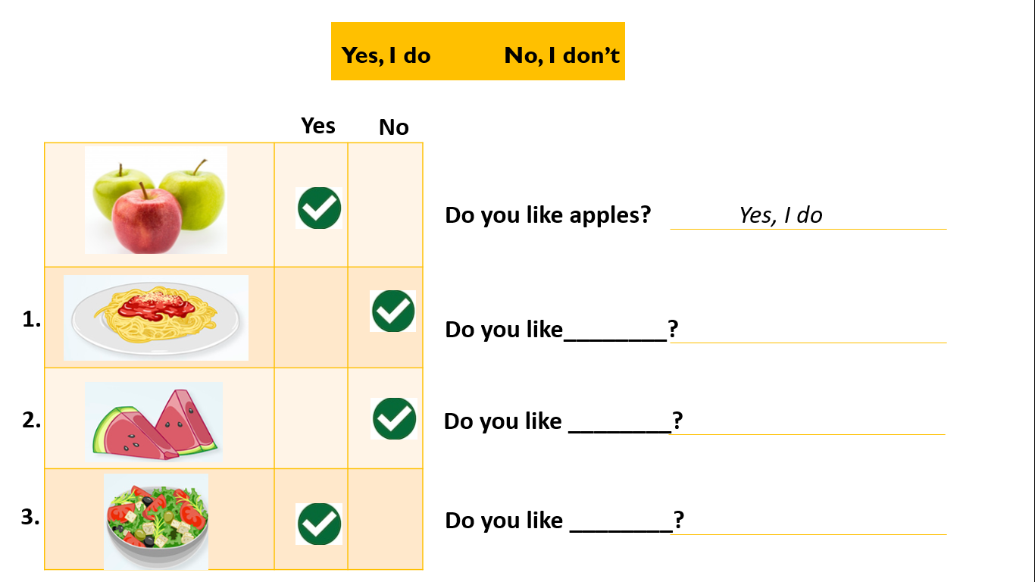

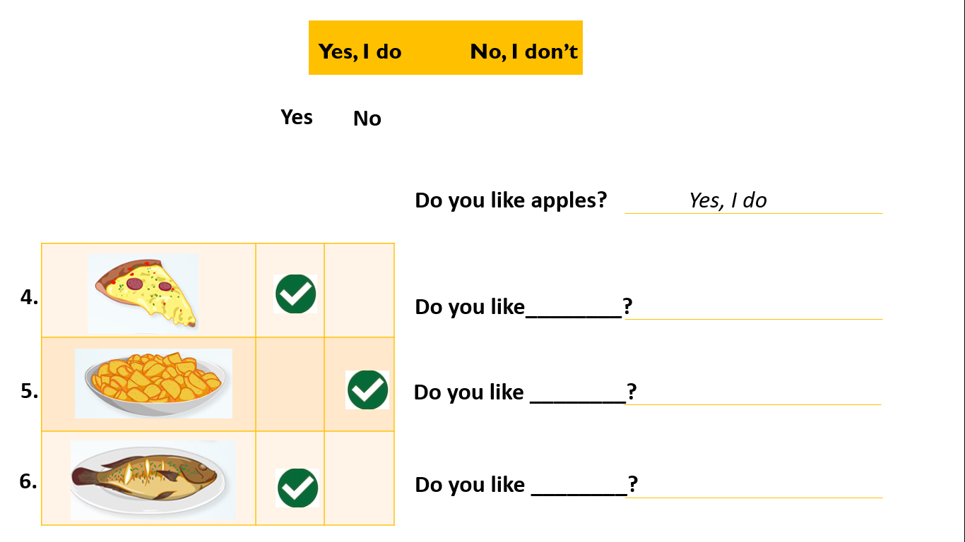



**2. Arrange the words and write the sentences. Follow the example**

* Ordena las palabras y escribe las oraciones.
* Sigue el ejemplo.

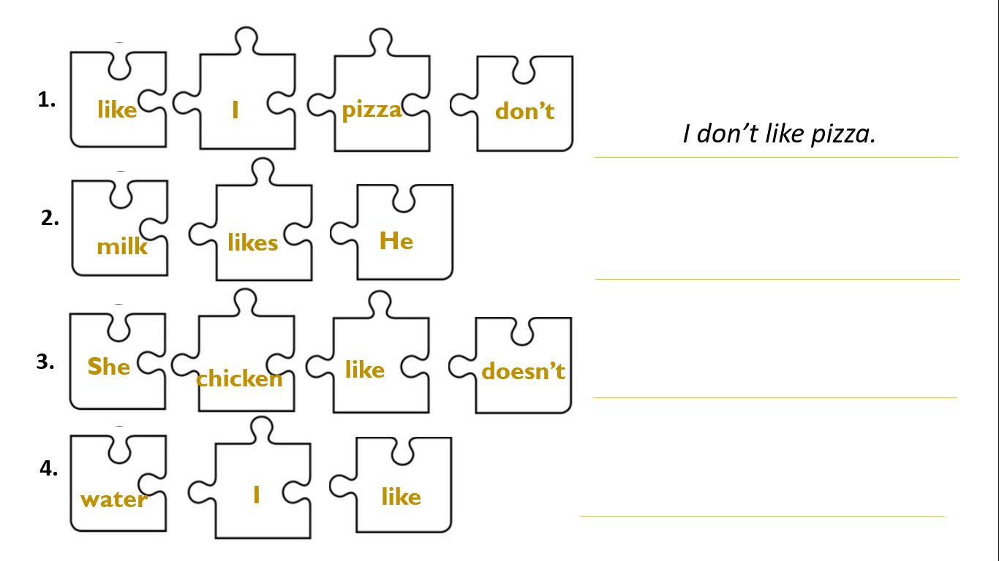

**3. Observe the images and write the sentences. Follow the example.**

* Observa las imágenes y escribe las oraciones.
* Sigue el ejemplo.

|  |  |
| --- | --- |
|  |  |
|  |  |

**4. Write 2 sentences about the food/drinks that you like and 2 sentences about the foods/drinks that you don’t like.**

* Escribe 2 oraciones sobre alimentos/bebidas que te gustan y 2 oraciones sobre alimentos/bebidas que no te gustan.

|  |  |  |  |
| --- | --- | --- | --- |
| Likes - dislikes | Breakfast | Lunch | Dinner |
| I like... |  |  |  |
| I don’t like... |  |  |  |

## SECTION 4: SPONGE ACTIVITY

* **Prepare your favorite breakfast and draw it on the tray.**
* Prepara tu desayuno favorito y dibújalo en la bandeja.

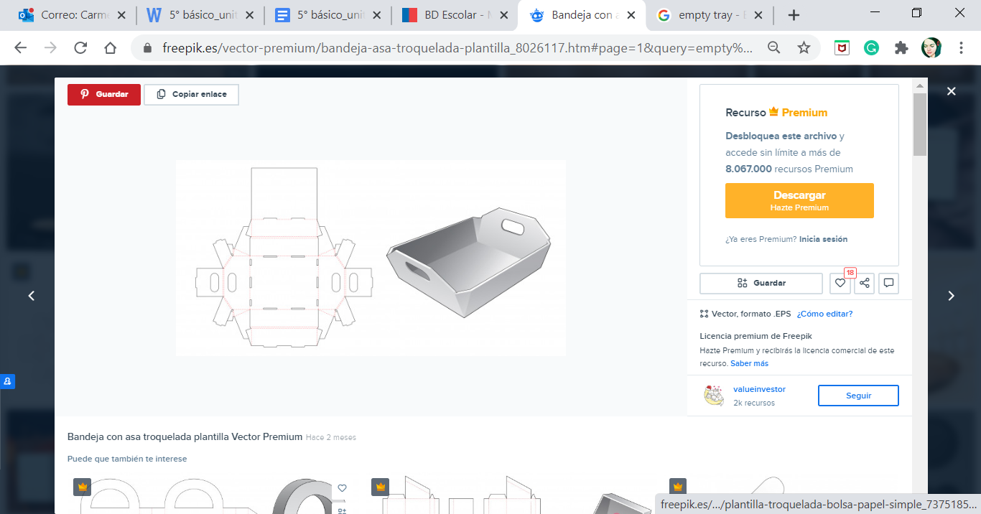

## SECTION 5: DIGITAL RESOURCES

* **Play this game to practice vocabulary. Click here:** <https://englishflashgames.blogspot.com/2008/09/food-game.html>
  + Juega a localizar los alimentos en la cocina y practica el vocabulario, haciendo click en el siguiente enlace: <https://englishflashgames.blogspot.com/2008/09/food-game.html>

## NO OLVIDAR REPASAR EL CONTENIDO CON UN ADULTO