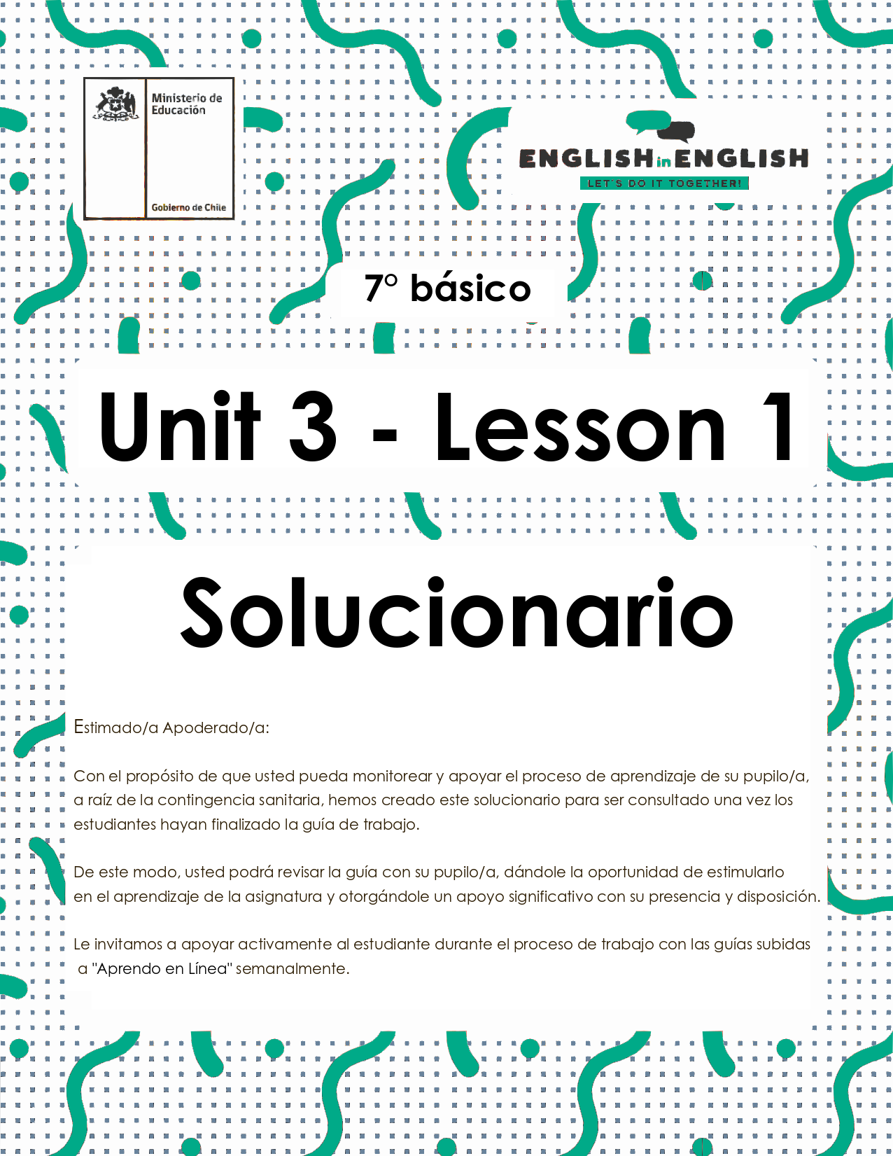
UNIT 3
LESSON 1

ÚTILES RECOMENDADOS:
- Texto del estudiante 7° básico.
- Cuaderno de inglés o 2 hojas en blanco.
- Lápiz grafito y goma.
- Diccionario de Inglés físico / online https://dictionary.cambridge.org/es/diccionario/espanol-ingles/

SECTION 1: SETTING THE CONTEXT
Sports and free time activities

1. Observe the images and answer the questions about you:
- Observa las imágenes y responde las preguntas sobre ti.
RESPUESTA ABIERTA
Example of answers:
My favorite free time activity is to play guitar.
I need a guitar.
I don't like to play football.

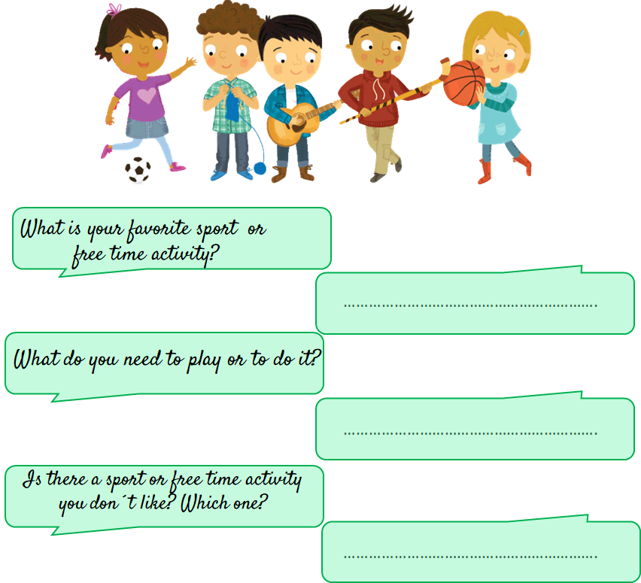

2. Observe the images and label them with the corresponding sports and activities.
- Observa las imágenes y etiquétalas con los deportes y actividades correspondientes.
A) Cricket B) Figure skating C) Swimming D) Go dancing E) Go camping F) Badminton G) Playing video games H) Collecting
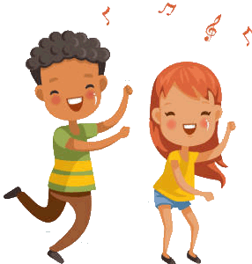
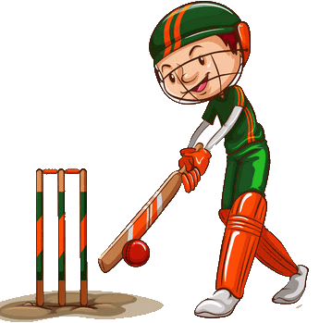
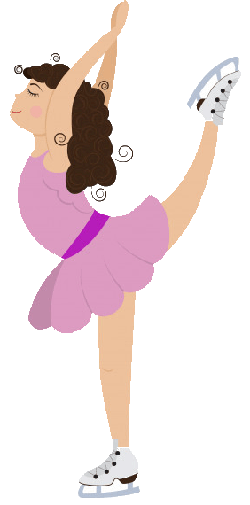
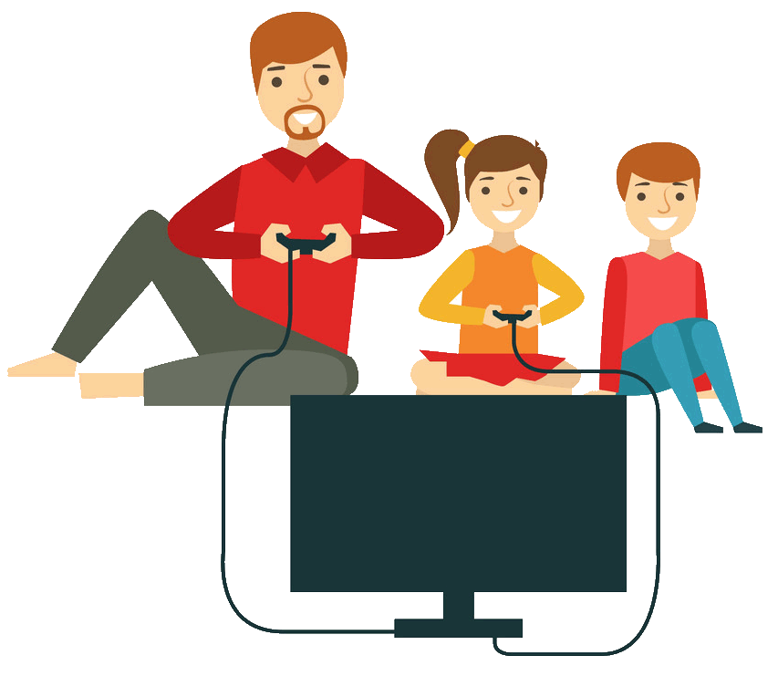
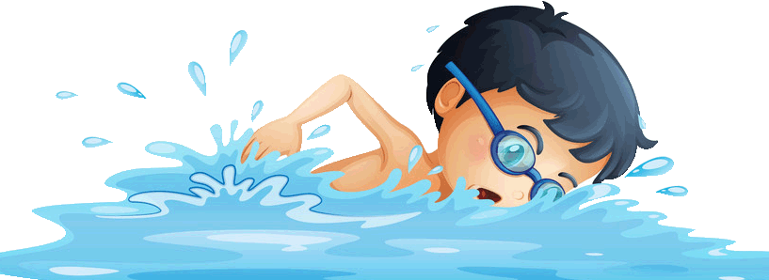
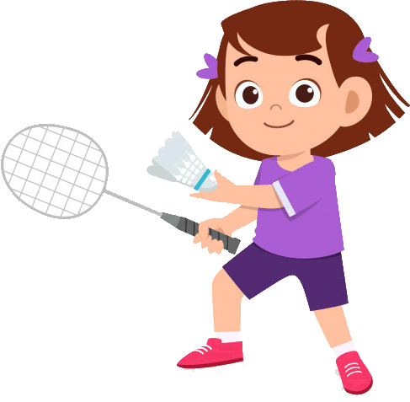
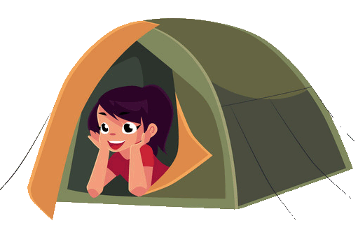

D B H A
G C F E

3. According to the previous activity, classify the sports and activities into the following categories. Write a ✓.
- De acuerdo a la actividad previa, clasifica los deportes y las actividades en las siguientes categorías. Escribe un ✓.
sports and activities | outdoor activity | team sport/activity | individual sport/activity | indoor activity
Cricket | ✓ | ✓
Figure skating |  | ✓ | ✓ | ✓
Swimming | ✓ | ✓ | ✓ | ✓
Go dancing | ✓ | ✓ | ✓ | ✓
Go camping | ✓ | ✓ | ✓
Badminton | ✓ |  | ✓ | ✓
Playing video games | ✓ | ✓ | ✓ | ✓
Collecting | ✓ |  | ✓ | ✓

4. Label the images with the correct words.
- Etiqueta las imágenes con las palabras correctas.
a) gloves b) skates c) bat d) ball e) helmet f) goggles g) net h) racket i) sneakers j) Stick

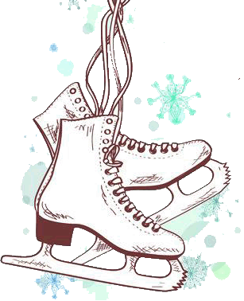 |  | 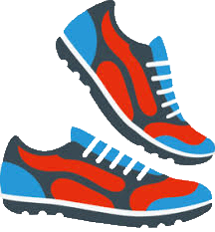 | 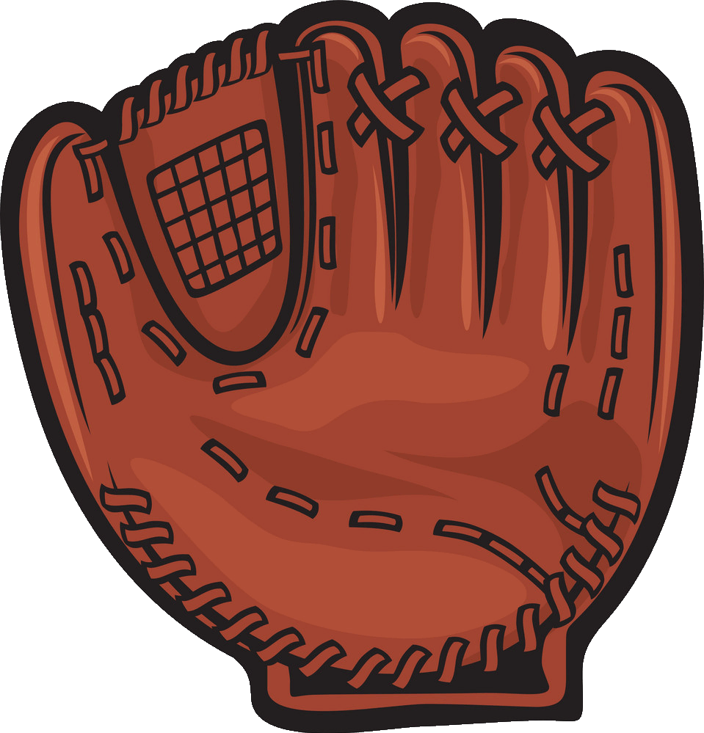 | 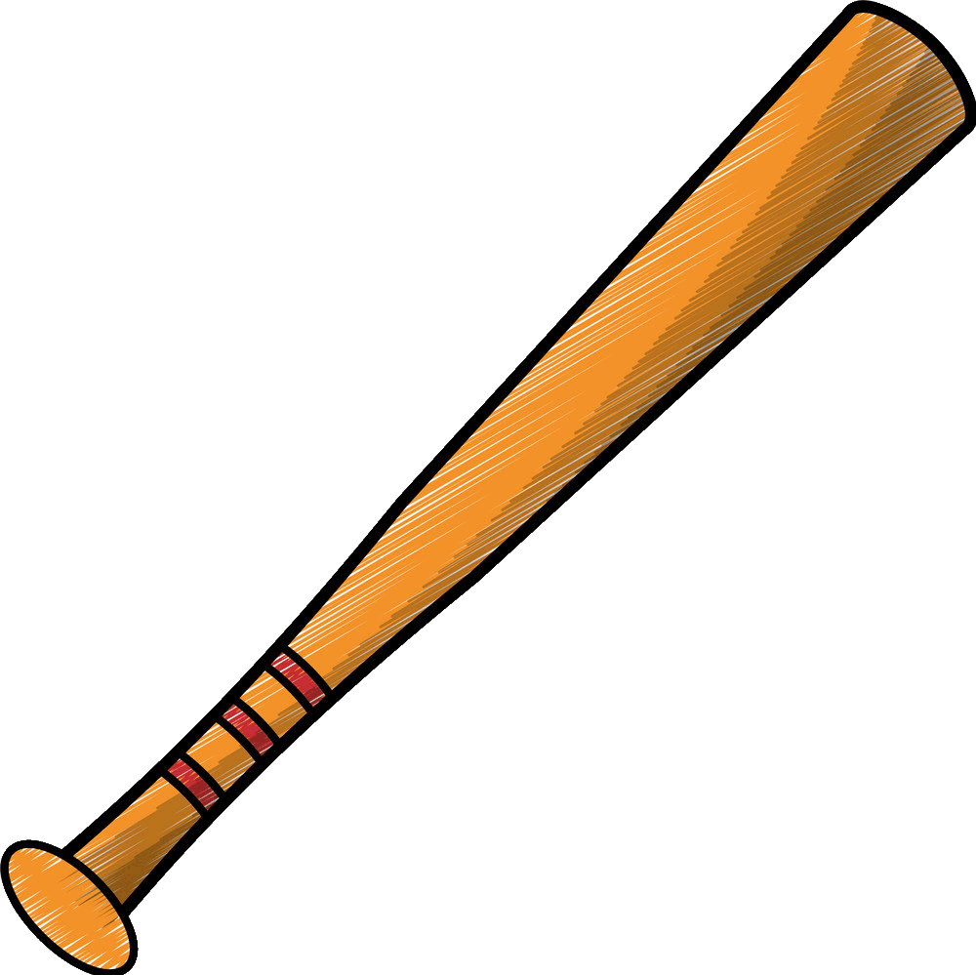
B | 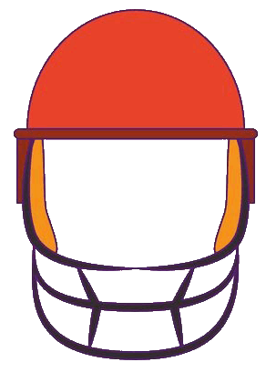  D | I | A | C
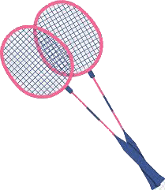 |  |  | 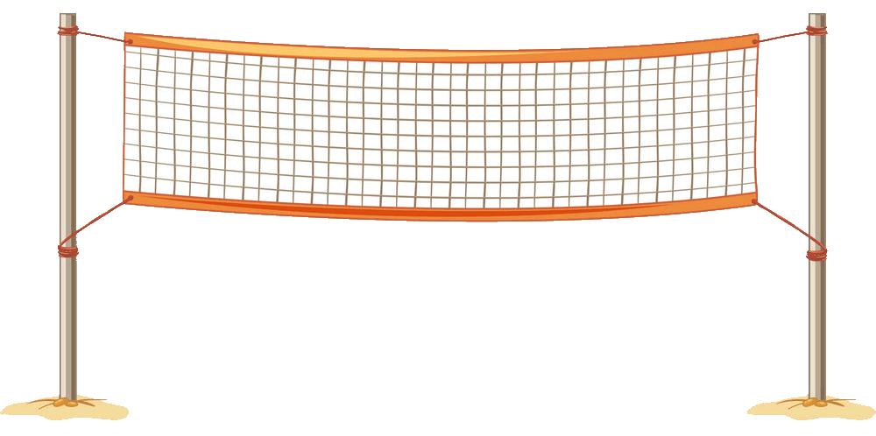 | 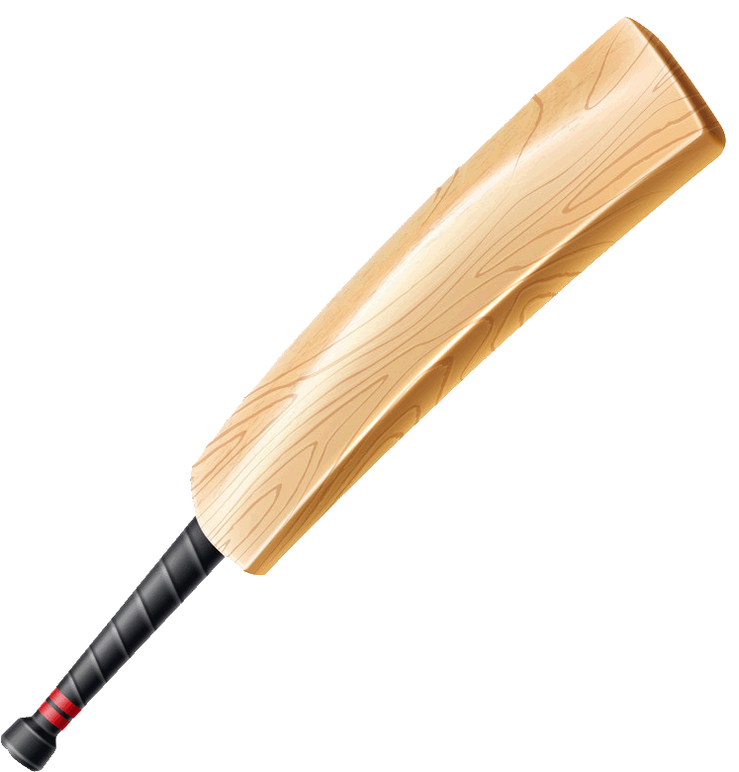
H | E | F | G | J

5. Read the following characteristics and write a sport for each one of them.
- Lee las siguientes características y escribe un deporte para cada uno de ellos.

RESPUESTA ABIERTA
Examples of answers:
- football
- baseball
- cricket
- badminton
- tennis

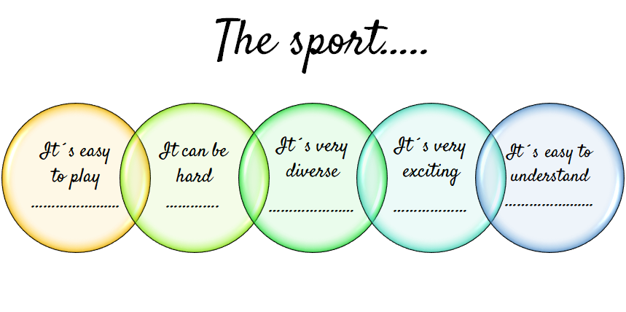

SECTION 2: LET'S PRACTICE
Women and Sport
- Read the text and underline all the sports you can find.
- Lee el texto y subraya todos los deportes que puedas encontrar.

Women and Sport
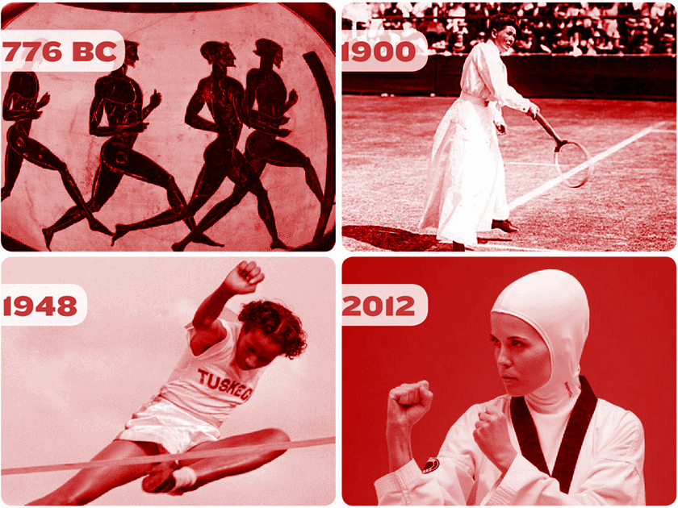
Changing attitudes? In the nineteenth century in Britain, sport was not considered a suitable pastime for a woman. It was associated with male physical strength and intense competition, whereas women were expected to be much gentler and less energetic. Middle-class women were, however, spectators at events like horse racing and cricket matches, and they did play slow games of tennis, badminton and croquet. If they played with men, the men were careful not to hit the ball too hard and to give the ladies every possible advantage. Richer women had the opportunity to take up sporting hobbies such as riding and hunting, as long as they behaved in a feminine manner. As women´s clothes became looser and lighter towards the end of the century, cycling became popular with women of all social classes. Special sportswear was designed for other games; it carefully hit the body's real shape so that women would remain respectable.

With the new century, many more women participated in a much wider range of sports - cricket, golf, hockey, and swimming, among others. On the whole, though, they played separately from men. And it is still true that mixed sports are common at the social level but not in competitions. Many women favor the development of mixed participation and believe that in many sports women could compete successfully with men if they had the same opportunities and training.

Text taken from: https://www.awesomestories.com/
vocabulary words
suitable: adecuado - strength: fuerza - pastime: pasatiempo - sportswear: ropa deportiva

- Read the text carefully and circle the correct word.
- Lee el texto cuidadosamente y encierra en un círculo la palabra correcta.
a) Leisure/sport/study was not considered a suitable pastime in the nineteenth century in Britain.
b) Women were considered much gentler and more/less/enough energetic than men.
c) Riding and hunting were sporting hobbies/duties/habits for richer women.
d) At the end of the nineteenth century, croquet/tennis/cycling became popular with women of all social classes.
e) In the 18th/19th/20th century more women participated in a great variety of sports like golf, hockey among others.
f) Middle- class women were participants/spectators/competitors at events like horse racing and football/basketball/cricket matches.

- Read the text again and complete the table.
- Lee el texto nuevamente y completa la tabla.

Century | Women´s sports
nineteenth | - Tennis  - Croquet  - Riding  - Badminton
twentieth | - Cricket  - Golf  - Swimming  - Hockey

- Read the following statement taken from the text “Women and Sport” and explain it. (english or spanish)
- Lee el siguiente enunciado tomado del texto “Women and Sport” y explícalo. (inglés o español).

RESPUESTA ABIERTA
Example of answer:
For me it means that men and women can have the same ability to perform a specific sport or activity, but women don't have the same opportunities to train than men, because of many social barriers therefore, they can't have the same level of performance.

“Many sport women could compete successfully with men if they had the same opportunities and training”.
…………………………………………………………………………………………………………………………………………………………………………………………………………………………………………………………………………………………………………………………………………………………………………………………………………………………………………………………………………………………………………………………………………………………………………………………………………………………………………………………………………………………………………………………………………………...

SECTION 3: LET´S CONSTRUCT AND APPLY OUR KNOWLEDGE
My sports and free time activities
- Match the equipment with the sport or activity. Complete the table.
- Relaciona el equipamiento con el deporte o actividad. Completa la tabla.

Equipment
- gloves b) tent c) bat d) ball e) helmet f) goggles
g) net h) racket i) sneakers j) stick k) skates l) computer m) shells

Sport / Activity | Letter | Sport / Activity | Letter
Figure skating | k | Go dancing | i
Swimming | f | Go camping | b
Badminton | h | Collecting | m
Playing video games | l | Cricket | j

- Look at the tables. Use these examples to complete exercise 3.
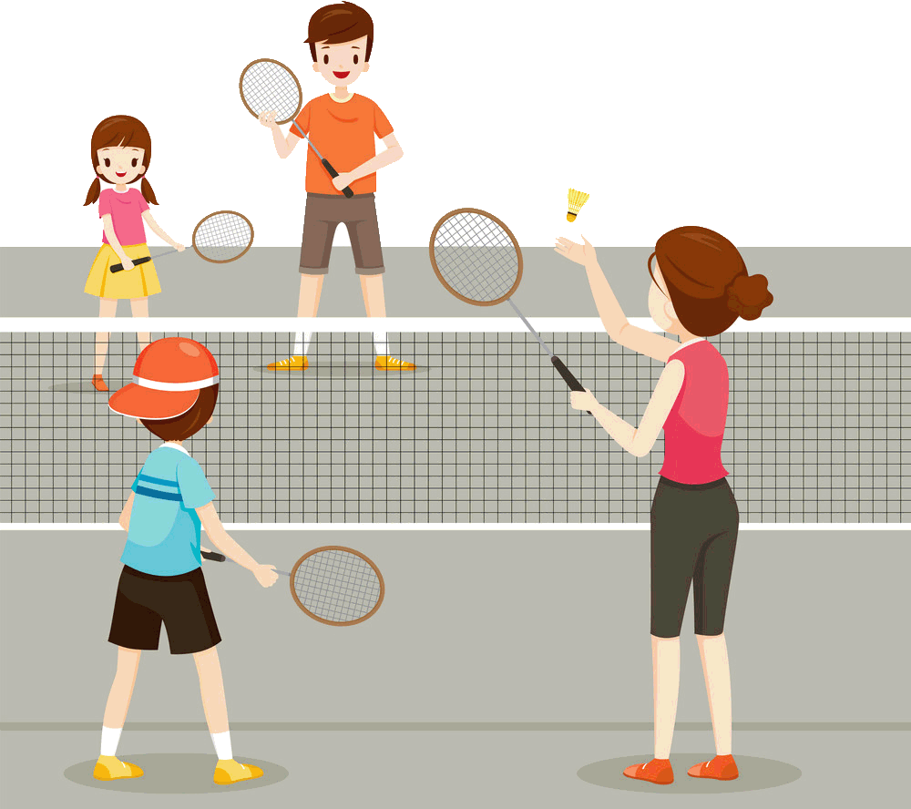
- Mira las tablas. Usa estos ejemplos para completar el ejercicio 3.
Name of the sport  Badminton | Equipment | - Badminton shoes  - Grip  - T-shirts and shorts  - Wrist band  - Headband
Picture of the sport  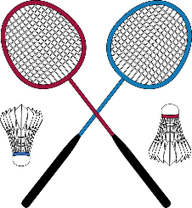 |  | - Badminton racket  - Shuttlecock
 | Place | - Rectangular indoor court
 | Rules | - A player must wait until his opponent is ready before serving.  - The feet of both players must remain in a stationary position until the serve is made. Your feet can not be touching the line at this time.  - It is not a fault if you miss the shuttle while serving.  - The shuttle cannot be caught and slung with the racket.  - A player cannot hold his racket near the net to ward off a downward stroke by his opponent or to interfere with his racket

Name of the activity  Collecting shells | Equipment | - A small shovel to dig deeper into the wet sand  - A small bucket or a cloth bag  - A mesh screen to rid sand or mud
 | Place | - Beach
Picture  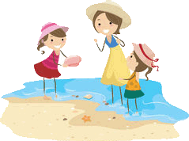 | Description | - Shell collecting, practice of finding and usually identifying the shells of mollusks, a popular avocation, or hobby, in many parts of the world. These shells, because of their bright colors, rich variety of shapes and designs, and abundance along seashores, have long been used for ornaments, tools, and coins.

- Choose one of the following sports or activities. Find out information about it and complete the table.
- Selecciona uno de los siguientes deportes o actividades. Encuentra información acerca de éste y completa la tabla.

RESPUESTA ABIERTA

Sports | Activities
Underwater Football | Collecting coins
Badminton | Drawing
Quidditch | Cooking

Name of the sport or free time activity |  | Equipment
Rules of the game or free time activity
Picture of the sport or free time activity

SECTION 4: EXTRA ACTIVITY
Crossword
1. Choose the correct word to fill in the blanks and complete the crossword!
- Selecciona la palabra correcta para completar los espacios y completar el crucigrama.

Friends - Cooking - Painting - Reading - Listening - Movies Restaurants - Skipping - Playing - Picnic

Across
- 3. I like ……playing………basketball.
- 6. María likes ……listening……. to music.
- 9. My Brother loves …painting……. pictures.
- 10. My mom likes …cooking… in the kitchen.
Down
- 1. I love ……reading…..
- 2. David enjoys watching..…movies….
- 4. She likes eating in….restaurants……
- 5. Felipe is playing with his …friends…..
- 7. She enjoys …skipping... with a rope.
- 8. They love having a …picnic… in the park

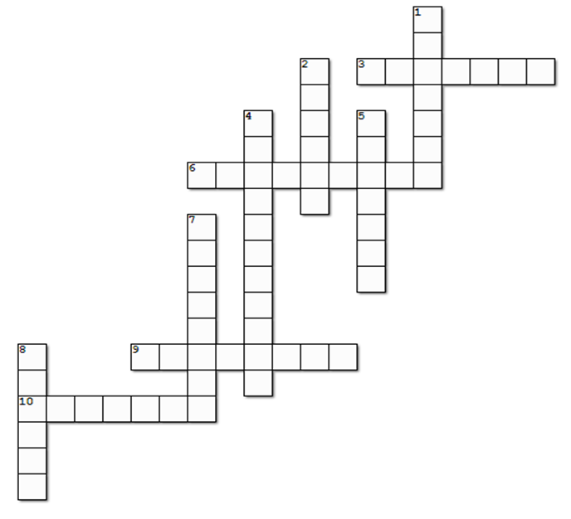

SECTION 5:
Digital Resources
Take a look at these links!
- https://www.healthlinkbc.ca/health-topics/
- Physical Activity for Children and Teens
- Helping Children With Disabilities Stay Active
- Helping Your Child Build Inner Strength

NO OLVIDAR REPASAR EL CONTENIDO CON UN ADULTO

