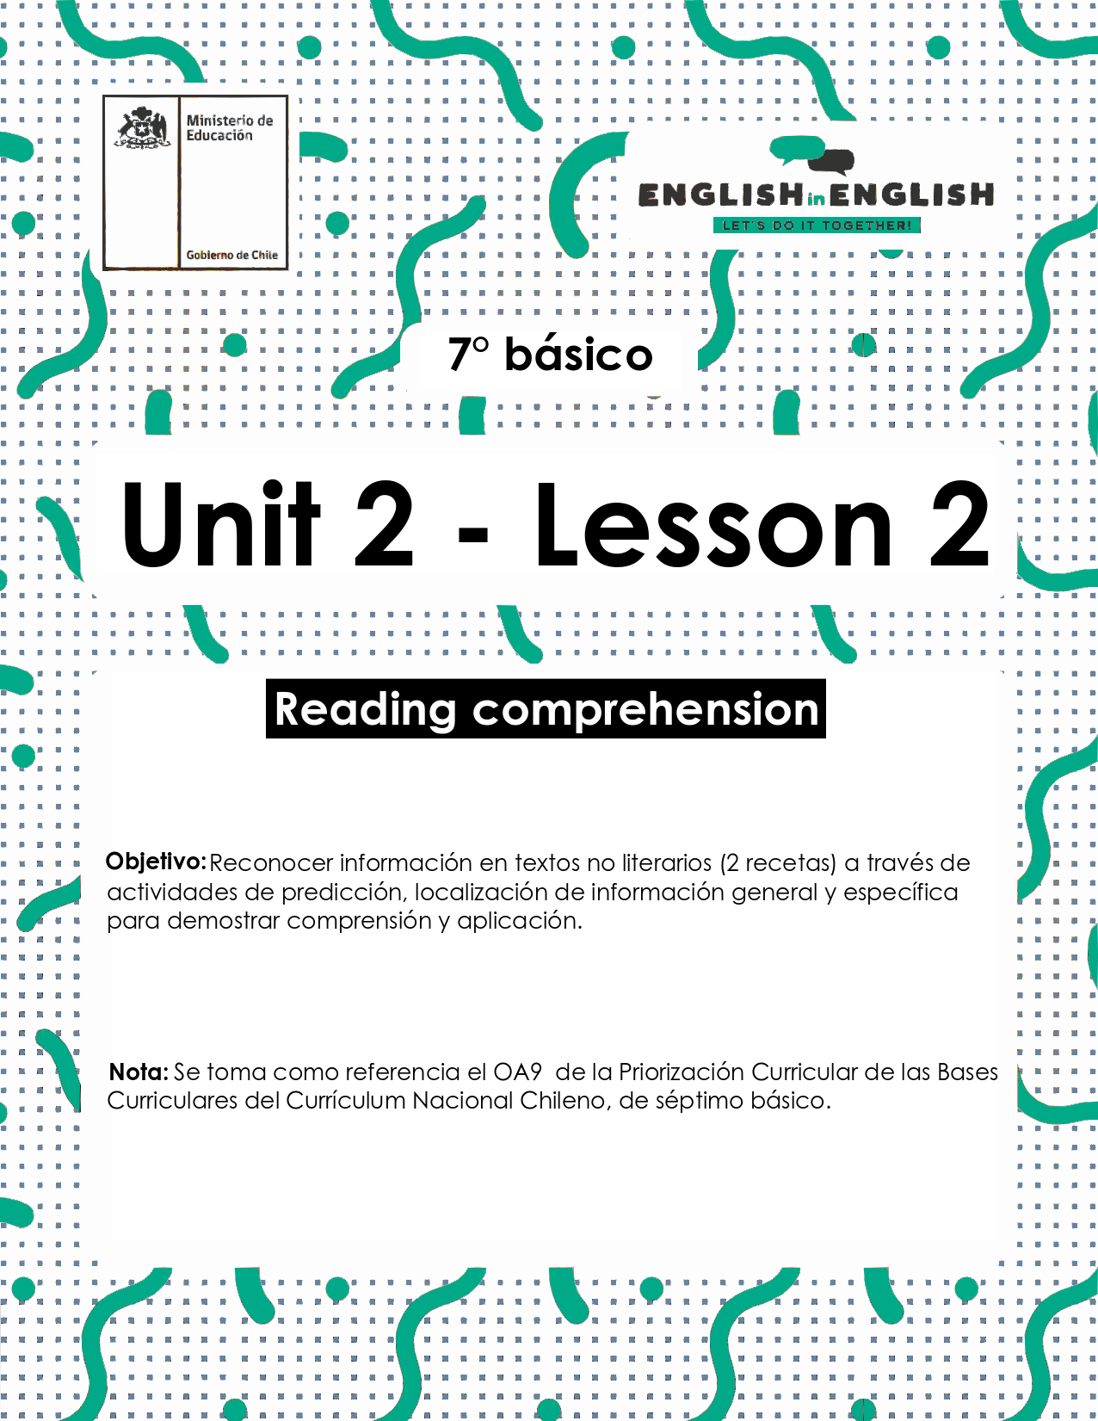

UNIT 2  
LESSON 2

## ÚTILES RECOMENDADOS:

* Texto del estudiante 7° básico.
* Cuaderno de inglés o 2 hojas en blanco.
* Lápiz grafito y goma.
* Diccionario de Inglés físico / online <https://dictionary.cambridge.org/es/diccionario/espanol-ingles/>

## SECTION 1: SETTING THE CONTEXT

## Cooking

**1. Observe the image and answer the questions.**

* Observa la imagen y responde las preguntas.

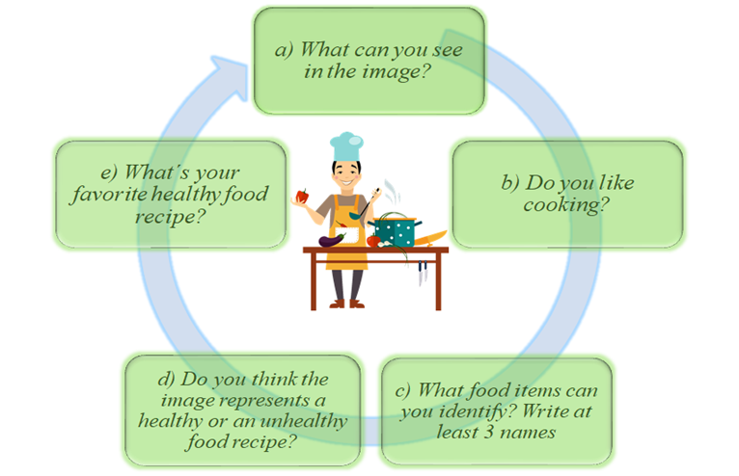

**2. Observe the images and match them with the corresponding verbs.**

* Observa las imágenes y únelas con los verbos correspondientes.

|  |
| --- |
| Cut - peel - mix - shape - heat - slice - place - cook - cover - serve |

|  |  |  |  |  |
| --- | --- | --- | --- | --- |
|  |  |  |  |  |
|  |  |  |  |  |
|  |  |  |  |  |
|  |  |  |  |  |

**3. What do you think you will read? Choose an alternative.**

* ¿Qué crees que leerás? elige una alternativa...

1. a story b) a recipe  c) an email  d) a letter 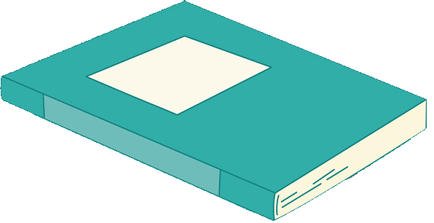

## SECTION 2: LET´S PRACTICE

## Recipes

**1. Read the texts quickly and answer the questions.**

* Lee los textos rápidamente y responde las preguntas.

1. What type of texts are these? __________________________________
2. Which one do you think is a healthy recipe? _______________________
3. Which one do you think needs more ingredients? ___________________

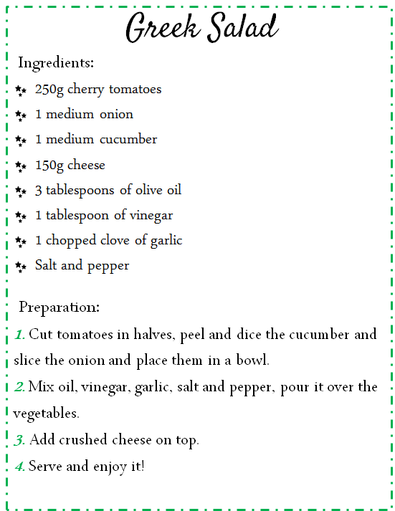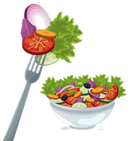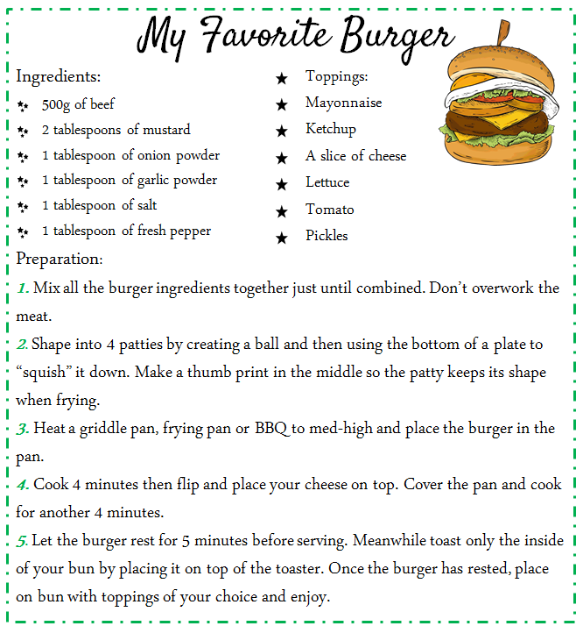

**Vocabulary**

|  |  |  |  |
| --- | --- | --- | --- |
| Tablespoon: cuchara sopera | patties: croquetas | squish: aplastar | bun: bollo |
| Toppings: aderezos | chopped: cortado en trocitos | crushed: aplastado | clove of garlic: diente de ajo |
| **Text taken from** [**tamaras-table.com/2017/01/17/ts-burger/**](https://tamaras-table.com/2017/01/17/ts-burger/)  [**https://en.islcollective.com/english-esl-worksheets/search/recipes**](https://en.islcollective.com/english-esl-worksheets/search/recipes) | | | |

**2. Read the texts again and underline all the food items you can find.**

* Lee los textos nuevamente y subraya todas las palabras relacionadas con alimentos que puedas encontrar.

3. **Read the recipe about Greek Salad and complete the sentences with the words from the box.**

* Lee la receta sobre Greek Salad y completa las oraciones con las palabras de la caja.

|  |
| --- |
| * **First** * **Second** * **Next** * **Finally** |
| Greek Salad  ***_________________***Cut tomatoes in halves, peel and dice the cucumber and slice the onion and place them in a bowl.  ***_________________***Mix oil, vinegar, garlic, salt and pepper, pour it over the vegetables.  ***_________________***Add crushed cheese on top.  ***_________________***Serve and enjoy your salad |

**4. Read the recipe about “My Favorite Burger” and complete the sentences with the corresponding verb.**

* Lee la receta sobre “My Favorite Burger” y completa las oraciones con el verbo correspondiente.

|  |
| --- |
| **Mix - shape - heat - place - cook** |

1. _______ a griddle pan, frying pan or BBQ to med-high.
2. _______ all the burger ingredients together just until combined.
3. Once the burger has rested _________ on bun with toppings of your choice.
4. Cover the pan and ________ for another 4 minutes.
5. ________ into 4 patties by creating a ball.

**5. Read both recipes (Greek Salad and My Favorite Burger) again and complete the table.**

* Lee ambas recetas (Greek Salad y My Favorite Burger) nuevamente y completa la tabla.

|  |  |  |
| --- | --- | --- |
| ***Questions*** | ***Greek Salad*** | ***My Favorite Burger*** |
| *How many ingredients are necessary? Write a number* |  |  |
| *Is this a healthy or an unhealthy recipe?* |  |  |
| *Does it require a lot of time preparation?* |  |  |
| *Does it use an oven?* |  |  |
| *What kind of vegetables are necessary? Write them* |  |  |

## SECTION 3: LET´S CONSTRUCT AND APPLY OUR KNOWLEDGE

## My own recipes

**1. Read the recipe “My Favorite Burger” again and make healthy changes to its ingredients and preparation.**

* Lee la receta “My Favorite Burger” nuevamente y haz cambios saludables a sus ingredientes y preparación.

|  |  |  |
| --- | --- | --- |
|  | **“My favorite burger” recipe** | **Healthy recipe** |
| ***Ingredients*** |  |  |
| ***Preparation*** |  |  |

**2. Choose your favorite food and write the recipe considering these aspects.**

* Elige tu comida favorita y escribe la receta considerando estos aspectos.



|  |
| --- |
| **Recipe** ………………………………………..  **Ingredients:**  ……………………………………………………………... ………………………………………………………...  ………………………………………………………........ ………………………………………………………...  ……………………………………………………………... ………………………………………………………...  ………………………………………………………........ ………………………………………………………...  **Servings**…………………………………………….  **Prep time**…………………………………………….    **Preparation**  ……………………………………………………………………………………………………………………………………………………………………………………………………………………………………………………………………………………………………………………………………………………………………………………………………………..  …………………………………………………………………………………………………………………………………………………………………………………………………………………………………………………………………………………………………………………………………………………………………………………………………………………………………………………………………………………………………………………………………………………… |

## SECTION 4: EXTRA ACTIVITY

## Describing my meal

**Look at the 2 cards about food and how to cook something. Choose one and describe it according to the information requested. Then you can share it with your family.**

* Mira las dos tarjetas sobre comida y como cocinarlas. Elige una y descríbela de acuerdo a la información requerida. Luego puedes compartirla con tu familia.

**Card 1**

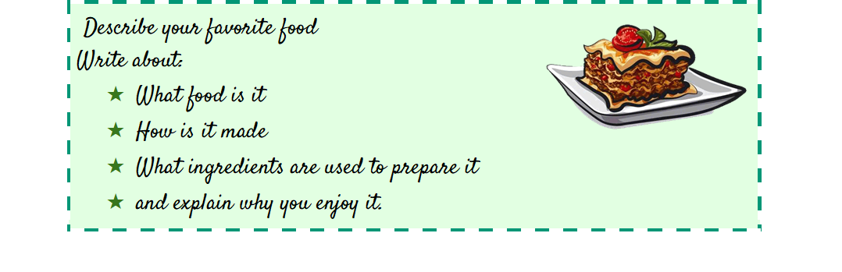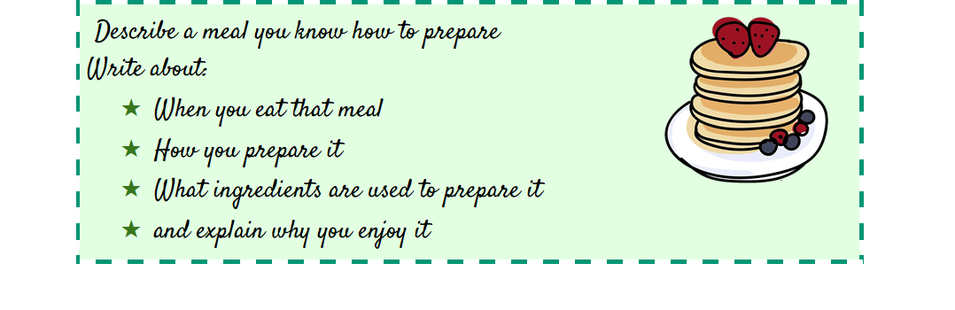

**Example**

**Card 2**

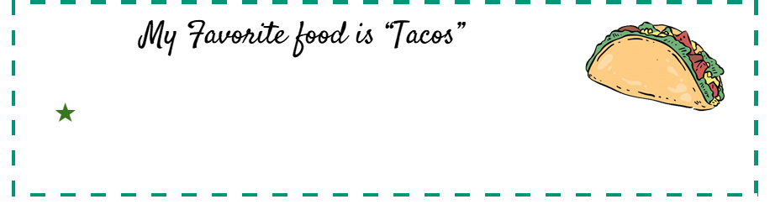

SECTION 5: DIGITAL RESOURCES

Take a look at this link!

* [*https://bdescolar.mineduc.cl/info/delicious-dairy-recipes-00045836*](https://bdescolar.mineduc.cl/info/delicious-dairy-recipes-00045836)

Share it with your friends through social media and  **eodp_chile /**  **Students in Action.**

## 

## NO OLVIDAR REPASAR EL CONTENIDO CON UN ADULTO