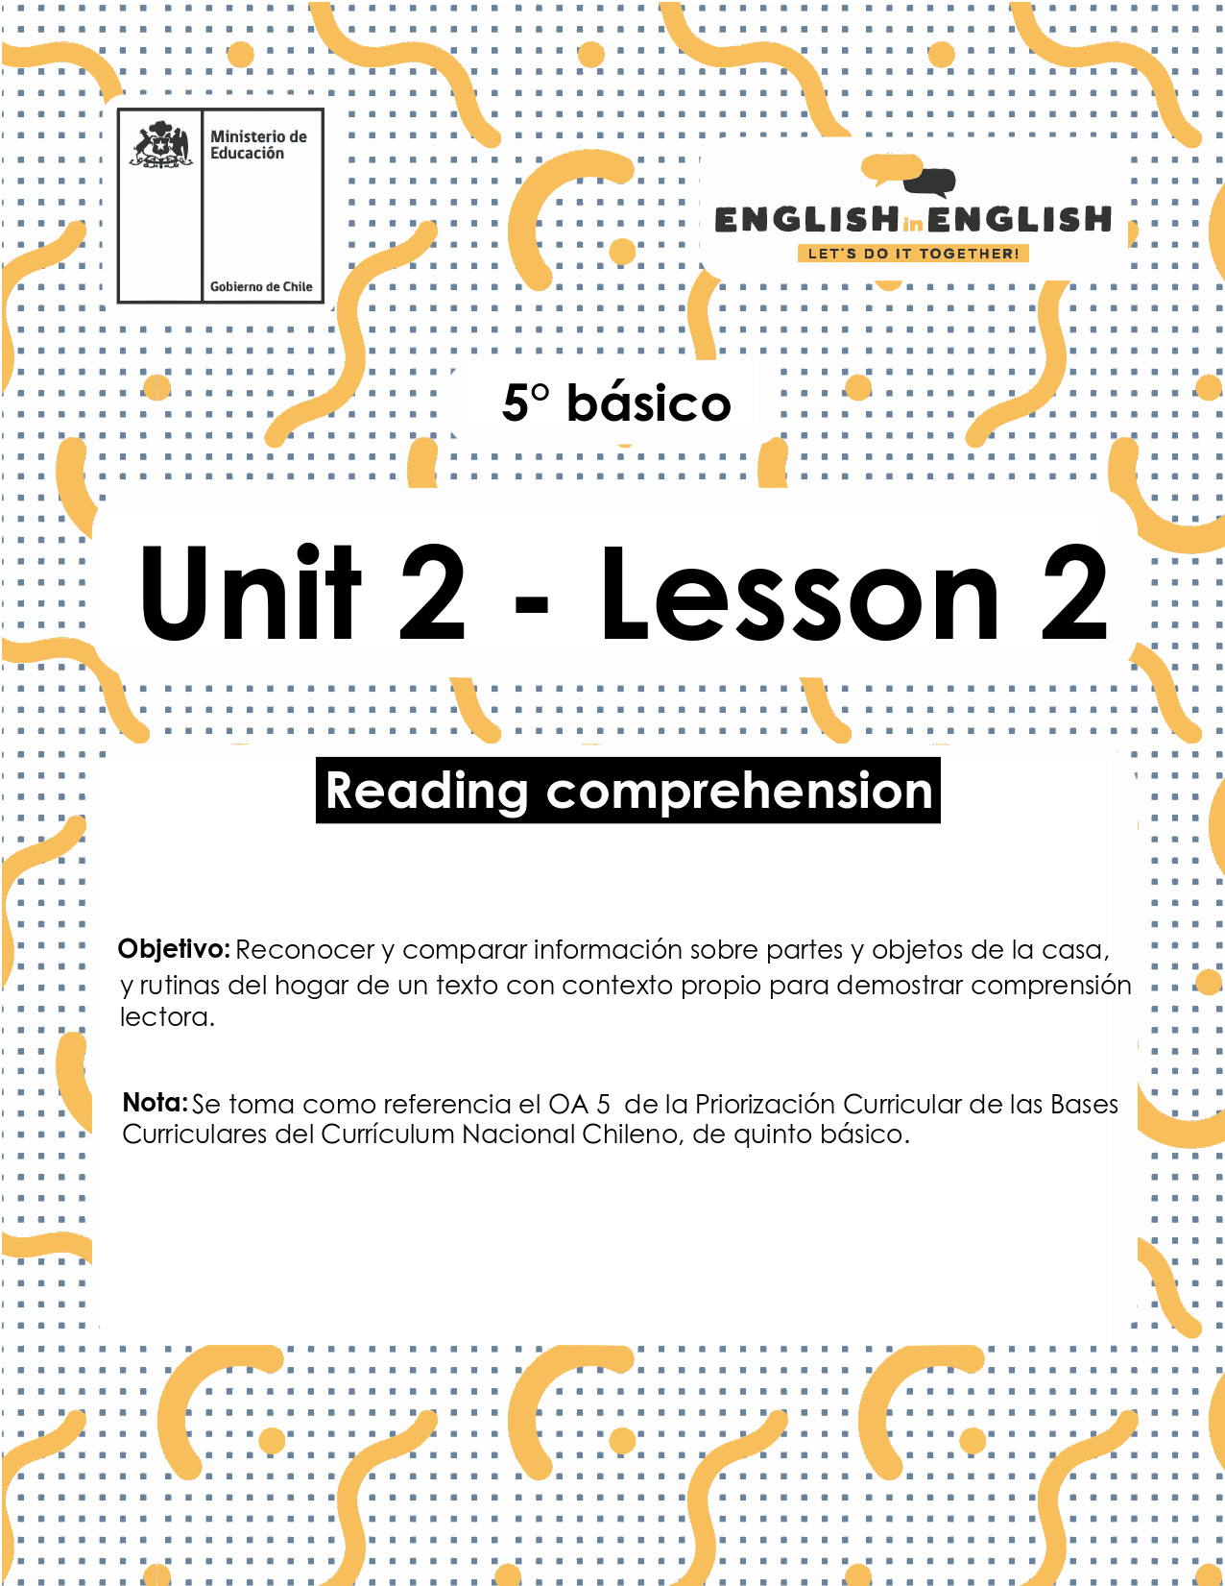

# UNIT 2 LESSON 2

## ÚTILES RECOMENDADOS:

* Texto del Estudiante 5° Básico
* Diccionario de Inglés físico / online <https://dictionary.cambridge.org/es/diccionario/espanol-ingles/>
* Cuaderno de inglés o 2 hojas en blanco.
* Lápiz grafito y goma.

## SECTION 1: SETTING THE CONTEXT

## “Parts of the house and house objects”

**1. Observe these houses and answer the questions.**

* Observa estas casas y responde las preguntas.

|  |  |
| --- | --- |
| Colección casas vector gratuito | 1. Which one is your favorite house?   _________________________   1. Which house is similar to your house?   _________________________   1. What is your favorite part of your house?   _________________________ |

**2. Use the words from the box to identify the parts of the house, according to the images.**

* Usa las palabras del cuadro para identificar las partes de la casa, de acuerdo a las imágenes.

|  |  |  |
| --- | --- | --- |
| Bathroom - Bedroom - Dining room - Garden - Kitchen - Living room | | |
|  |  |  |
|  |  |  |
|  |  |  |
|  |  |  |

**3. Match the objects of the house with the parts of the house that correspond.**

* Une los objetos de la casa con las partes de la casa que corresponda.

|  |  |
| --- | --- |
| A. Bed | 1. ____ Living room |
| B. Couch | 2. ____ Kitchen |
| C. Fridge | 3. ____ Garden |
| D. Plants | 4. ____ Dining room |
| E. Shower | 5. ____ Bedroom |
| F. Table and chairs | 6. ____ Bathroom |

**4. Observe the following chart of adverbs of frequency. We use these words to indicate how often we do some activities.**

* Observa con atención la tabla de adverbios de frecuencia.
* Usamos estas palabras para indicar cuan a menudo hacemos algunas actividades.

|  |  |  |  |
| --- | --- | --- | --- |
| **I** | **Always** | Tidy my room | 100%. La actividad se realiza siempre/ en todo tiempo o circunstancia. |
| **Usually** | Tidy my room | 70%. La actividad se realiza usualmente/ de manera habitual. |
| **Sometimes** | Tidy my room | 50%. La actividad se realiza a veces/ en ocasiones. |
| **Never** | Tidy my room | 0%. La actividad nunca se realiza. |

## SECTION 2: LET'S PRACTICE

## “Tamara and Pablo’s daily routines”

**1. Read about Tamara and Pablo’s daily routines.**

* Lee acerca de las rutinas diarias de Tamara y Pablo.

|  |  |
| --- | --- |
|  | Key Words:  **Comedy Shows:** Programas de Comedia  **Water:**  (v) Regar  **Boring:**  Aburrido |

**2. Read the text about Tamara and Pablo’s daily routine again and circle True (T) or False (F).**

* Lee las oraciones y selecciona Verdadero (T) o Falso (F).

a) Tamara doesn’t have a sister (T) (F)

b) Pablo usually goes to bed at 10 pm (T) (F)

c) Tamara’s computer is in the bedroom (T) (F)

d) Pablo always watches TV (T) (F)

e) Tamara usually does the dishes at home (T) (F)

f) Pablo never tidies his bedroom (T) (F)

**3. Complete Tamara and Pablo’s daily routines in the chart below. Follow the example.**

**Consider the activity (What?), the frequency (How often?), and the part of the house (Where?)**

* Completa las rutinas diarias de Tamara y Pablo en la tabla de abajo. Sigue el ejemplo.
* Considera la actividad (¿Qué?), la frecuencia (¿Cuán a menudo?), y la parte de la casa (¿Dónde?)

|  |  |  |  |  |
| --- | --- | --- | --- | --- |
|  | | **What?** | **How often?** | **Where?** |
| ***Tamara*** | *1.* | *Work on the computer* | *Usually* | *Bedroom* |
| *2.* |  |  |  |
| *3.* |  |  |  |
| *4.* |  |  |  |
| ***Pablo*** | *1.* |  |  |  |
| *2.* |  |  |  |
| *3.* |  |  |  |
| *4.* |  |  |  |
| *5.* |  |  |  |

**4. After reading about Tamara and Pablo’s daily routine, answer these questions about you.**

* Después de leer sobre la rutina diaria de Tamara y Pablo, responde estas preguntas sobre ti.

1. How often do you do your homework? I always do my homework.
2. How often do you tidy your bedroom? ____________________________
3. How often do you chat with your friends? __________________________
4. How often do you do the dishes in the kitchen? ______________________
5. How often do you water plants in the garden? _______________________

## SECTION 3: LET’S CONSTRUCT AND APPLY OUR KNOWLEDGE

## “Your home”

**1. Match the home routines with a part of the house. Then, create five sentences with the selection that you did. Follow the example.**

* Une la rutina del hogar con una parte de la casa. Luego, crea cinco oraciones con la selección que hiciste.
* Sigue el ejemplo.

|  |
| --- |
|  |
| Example: I do my homework in the living room. |
|  |
|  |
|  |
|  |
|  |

**2.** **Observe your home and fill out the circle with the number of parts of the house and house objects that you have.**

* Observa tu hogar y rellena el círculo con la cantidad de partes de la casa y objetos que tienes en tu hogar.

|  |  |  |
| --- | --- | --- |
| **Parts of the house.** | | |
| Bedroom | Kitchen | Living Room |
| Bathroom | Dining Room | Garden |

|  |  |  |
| --- | --- | --- |
| **House Objects.** | | |
| Bed | Shower | Couch |
| Table and chairs | Fridge | Plants |

**3.** **Create five sentences about the parts of the house and house objects that you have.**

* Crea cinco oraciones sobre las partes de la casa y objetos de la casa que tienes.

|  |
| --- |
| Example: I have one living room.  Example: I have three beds. |
|  |
|  |
|  |
|  |
|  |

## SECTION 4: SPONGE ACTIVITY

**1. Complete the following mind map with your own information about your home routines.**

* Completa el siguiente mapa mental con tu propia información sobre tus rutinas del hogar.

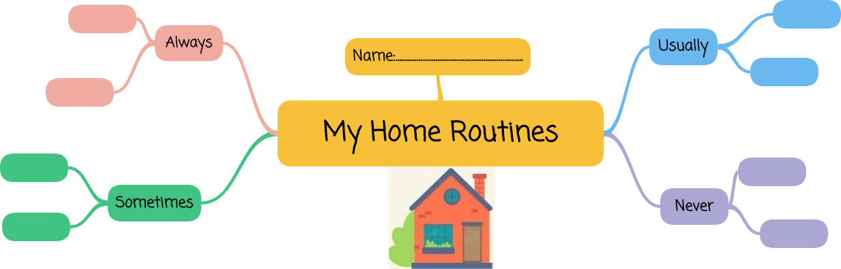

## 

## SECTION 5: DIGITAL RESOURCES

* Lee la historia bilingüe *“¡A jugar en casa! / We Play with Things Around the House!”* Disponible en la Biblioteca Digital Escolar (Mineduc). <https://bdescolar.mineduc.cl/info/a-jugar-en-casa-we-play-with-things-around-the-house-00045887>
* Practica el vocabulario de las rutinas del hogar con el siguiente juego online: <https://learnenglishkids.britishcouncil.org/word-games/daily-routines>

## 

## NO OLVIDAR REPASAR EL CONTENIDO CON UN ADULTO