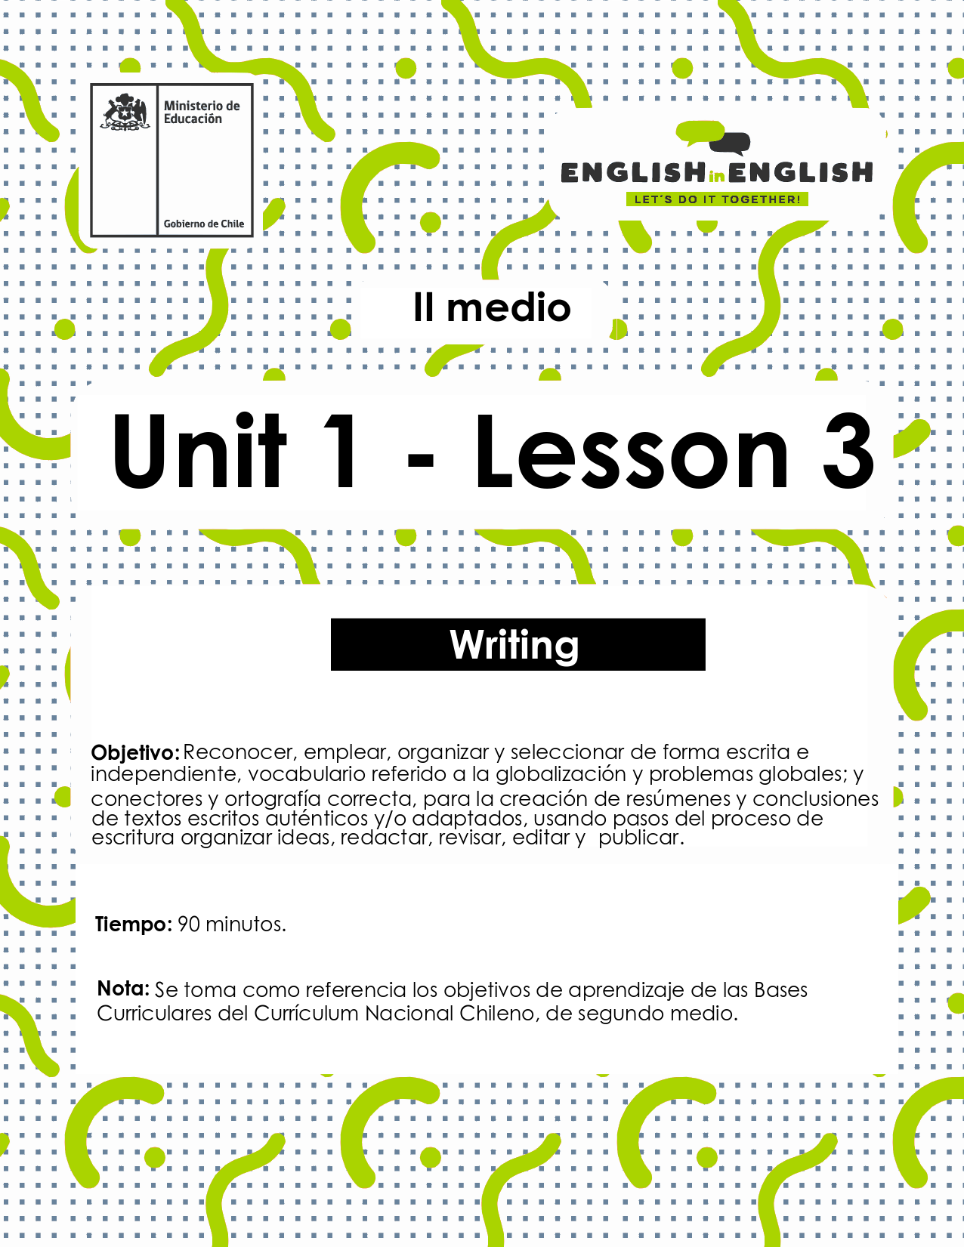

LESSON 3
WRITING

ACTIVITY 1
- Look at the global issues vocabulary and assign a score or rank to each issue.
- (4 being the most important and 0 representing least important)
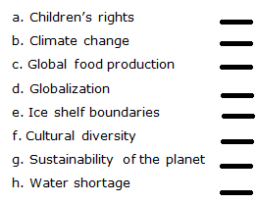

- Write reasons for your ranking.

(Source: Adapted from 2nd Graders Student’s Book)

ACTIVITY 2: WRITING WORKSHOP
- Now you will write a short paragraph summarizing information about globalization.
- Follow the steps below to help your writing and keep your ideas in order.

ORGANIZING IDEAS
- Before you start, take notes of the main ideas you have learned about globalization.
- Use the diagram below.
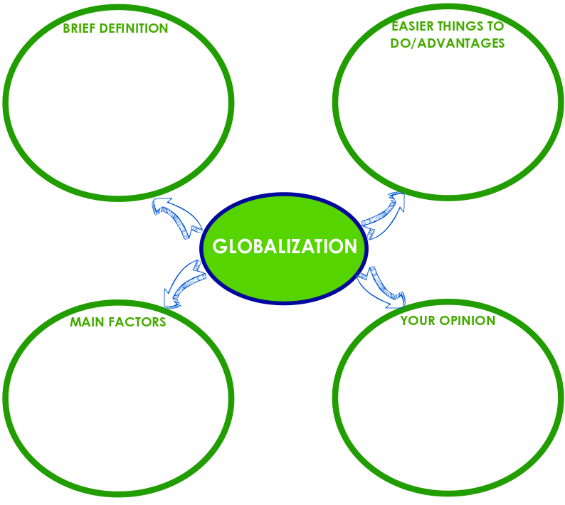

DRAFTING
- Now, that you know what you want to write about.
- Use your diagram to write a short paragraph (5 -7 sentences) about globalization.
(Source: Adapted from 2nd Graders Student’s Book)

REVISING
- Put the ideas together in one paragraph.
- Use the phrases in the boxes to introduce and link your ideas.
- Look for the meaning of words or phrases that you do not know.

EDITING AND PUBLISHING
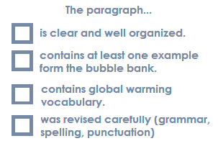
- Check for grammar, spelling and punctuation using the prompts box.

(Source: Adapted from 2nd Graders Student’s Book)

ACTIVITY 3: Prewriting
- Read the following text.
- Then complete the “sequence organizer” to summarize the main events in the story.
- Do not complete the last row of the chart yet.
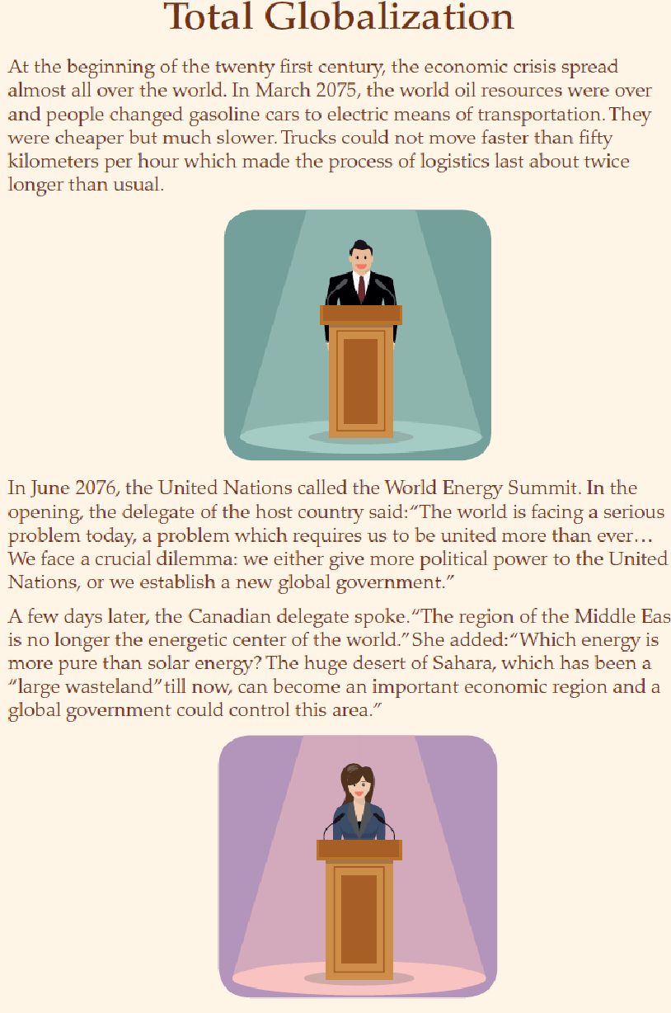
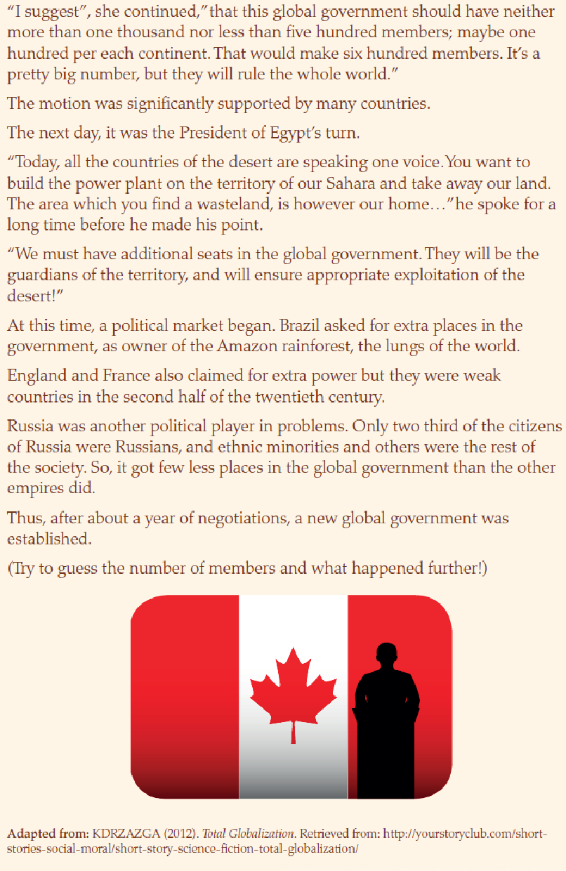
(Source: Taken from 2nd Graders Student’s Book)

- Think about some possible further events to continue the story.
- Fill in the last row of the chart with your ideas.
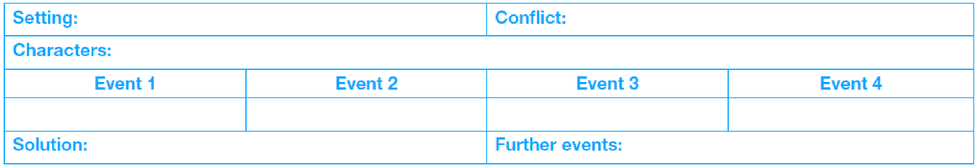

DRAFTING
- Write some sentences summarizing the main events in the story, and two or three sentences describing how you think the story continued.

1.

2.

3.

4.

5.

6.
(Source: Taken from 2nd Graders Student’s Book)

CONNECTORS
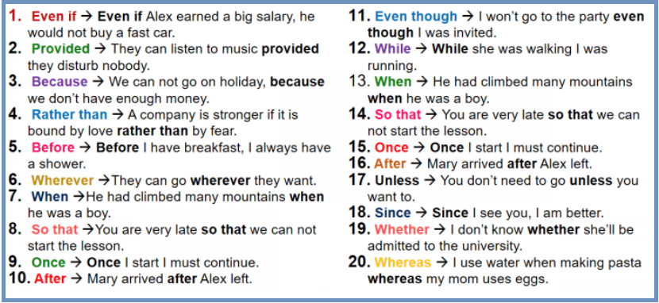
- Connectors or linking words are very helpful to connect ideas.
- Here are the most common connectors and its example:
(Source: Adapted from www.myenglishteacher.eu)

REVISING
- Put the sentences together into different paragraphs.
- Use connectors to express the sequence of events and link your ideas, adding words to make them more interesting to read.
- Use the story as an example.

Paragraph 1

Paragraph 2

EDITING
- Check for grammar, punctuation and spelling mistakes, using the Editor´s Marks on the list.

- Is clear and well organized.
- Includes connectors to link the ideas in each paragraph.
- Includes a final paragraph narrating further events.
- Has only a few / some spelling, punctuation and grammar mistakes.

- Write the final version of the summary, including the possible ending you created.

(Source: Adapted from 2nd Graders Student’s Book )

PUBLISHING

- Take a picture of your summary.
- Exchange it with some of your classmates using mobile phone messages.
- Read your classmates’ summaries and provide feedback to them.
- Focus on the strengths and give positive suggestions to improve their weaknesses.
SPONGE ACTIVITY
- Now that you have worked on this worksheet, related to globalization:
- What does globalization mean to you?
- Brainstorm all the words and phrases you associate with globalization and write them down in the bubbles.

