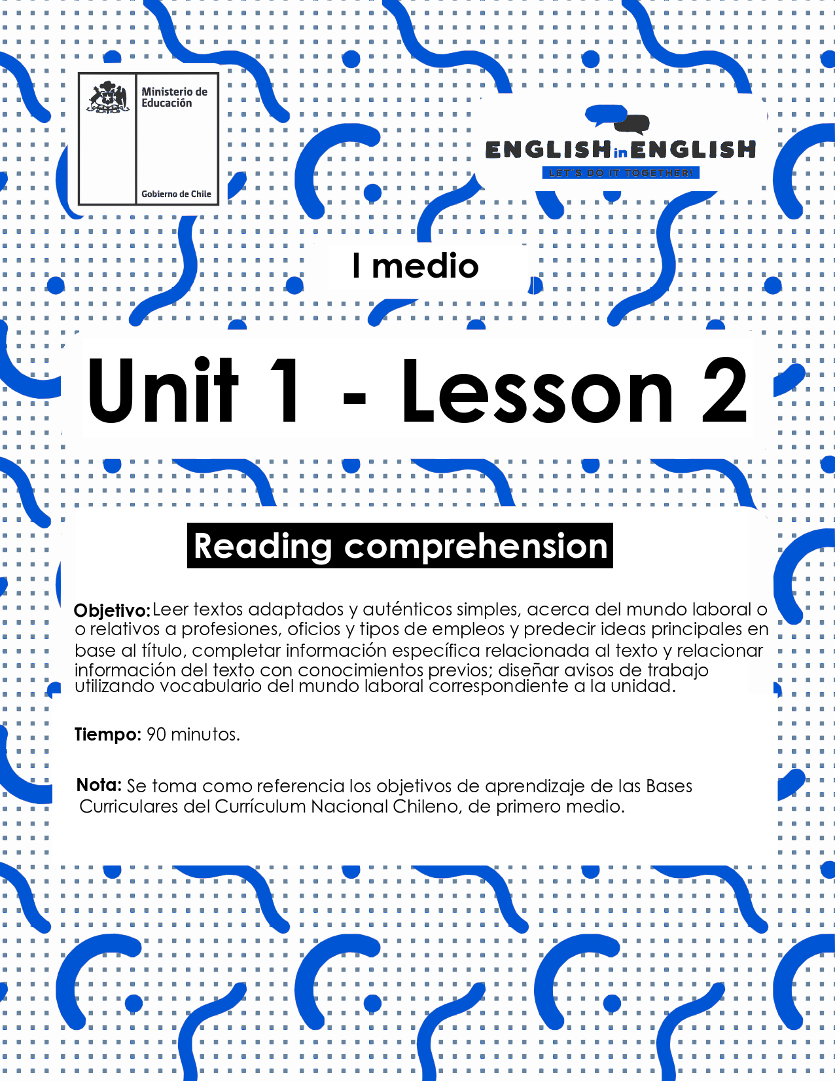

WEEK 2
READING COMPREHENSION
ACTIVITY 1: GETTING READY
- Read the following questions and reflect on them. Then, text two friends and ask them the questions to complete the chart.

 | What job would you love to have? Why? | Which skills or characteristics you need to develop this job?
Friend 1
Friend 2

- Read these three business cards carefully. In your own words, write a job description for each person.
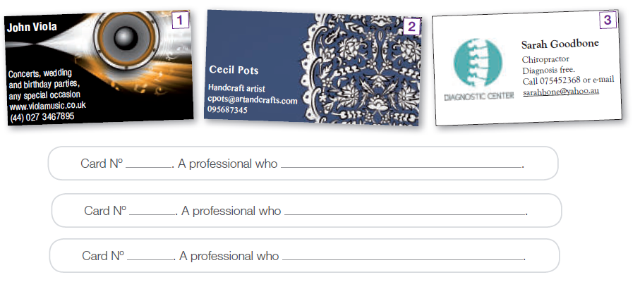

(Source: Original material and 1st Graders’ Student’s Book)
- After reading the previous business cards, answer the following questions.
- Where can you find printed job advertisements?

- What information do you usually find in business cards?

- In what section of the newspaper would you look for job advertisements?

- What do you need to know before applying to a job?

- What do you think is the best way to get a job?

(Source: 1st Graders’ Student’s Book)
ACTIVITY 2: READING
- Read the advertisements below.
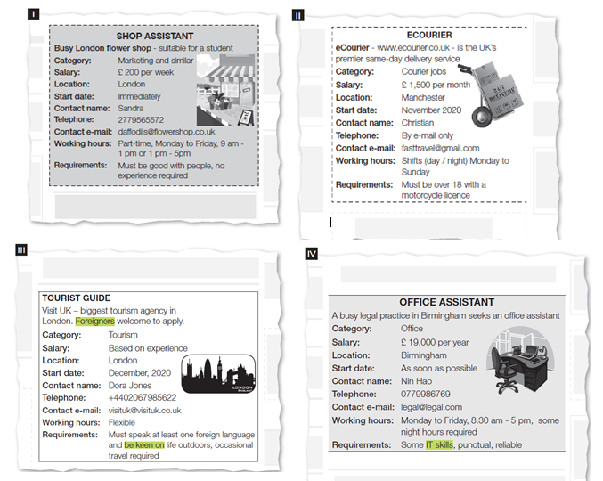
- According to the previous reading, identify the job (I – IV) for a candidate (a – f) who:
a) Likes traveling and getting to know the country.
b) Loves working indoors using IT skills.
c) Doesn’t want to work nights and weekends.
d) Would love to do something that will let him / her meet people.
e) Doesn’t have any experience.
f) Wants some flexibility to keep on studying.
(Source: 1st Graders’ Teacher’s Book)
ACTIVITY 3: AFTER YOU READ
Based on the examples from activity 2, design your own job advertisement. Make sure you include the same categories but￼ adding new information.

Think you are looking for a job. What would you expect from it in order to apply? I would suggest including an example.

ACTIVITY 4: SPONGE ACTIVITY
Imagine you are looking for a job, list the personal characteristics or abilities you have, using the letters of your name. You can use the Pictionary for extra help.
- Example: SUE → S: sociable, U: unique, E: empathic
LETTERS OF YOUR NAME | CHARACTERISTIC

(Source: Original material)

EXTRA: PICTIONARY

