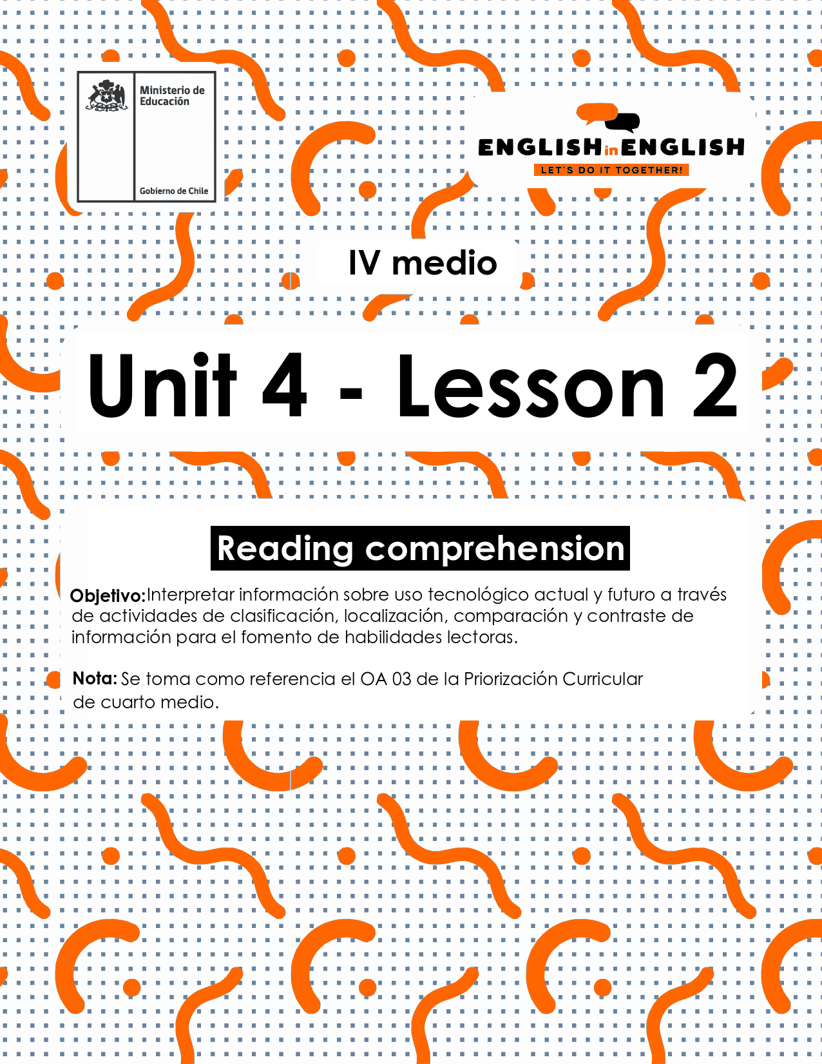

UNIT 4
LESSON 2

ÚTILES

- Texto del estudiante de 4° medio.
- Diccionario de inglés.
- Lápices.
- Cuaderno de asignatura.

SECTION 1: SETTING THE CONTEXT

Hello Students, welcome back to lesson 2. In this lesson we will rehearse reading comprehension skills by considering the topic of technological gadgets.
- Look at the following pictures of gadgets that failed in the market and answer the questions:
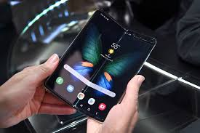
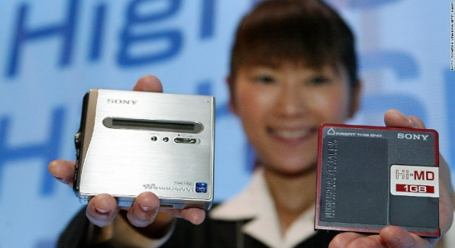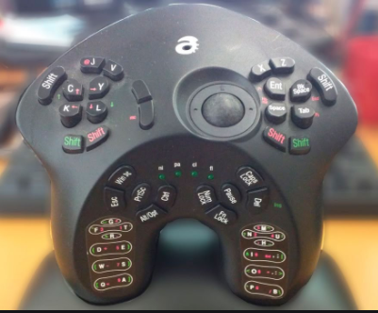
a) What do you think those gadgets were created for?

b) What do you think these gadgets have in common?

C) Would you use any of these gadgets? Why/why not?

D) Why do you think they failed in the market?

E) Do you think it would be possible someone could make them useful? Please explain.

- Complete the text with the words on the box.
If necessary, use your dictionary to look up any words that you do not know.
download | batteries | computer | message
headphones | touch | keyboard | photos

Tablet computer
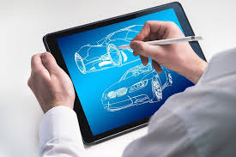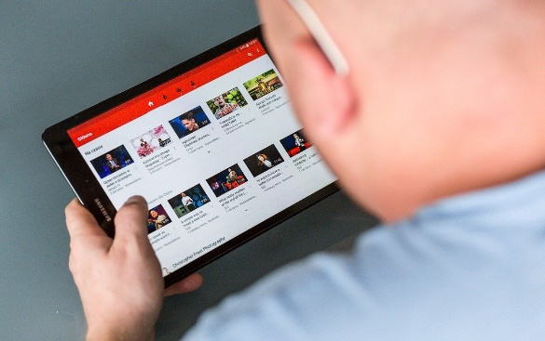
A tablet (a)________ is a small handheld computer with a flat (b)_______ screen. The most popular are iPads and Androids, which allow users to access the web, (c)__________ applications, view (d) _________ and videos, play games and read eBooks, newspapers, and anything on the Internet. You can also plug in external (d)_____________ and listen to music. All tablets have rechargeable (e)_______ with an average life of about ten hours in standby mode so it isn’t necessary to switch off the power button. Tablets do not usually have a (f)_________; if you want to write a (g)_________, you tap letters and symbols on the screen. You don’t need to set up the tablet when you first open the box
– just turn it on.
Taken and adapted from Tune Up Student’s Book 12th Grade

SECTION 2: LET’S PRACTICE
- Read the following text about incredible gadgets and complete the exercises:

4 Incredible gadgets that really shouldn’t have failed.
By Mark Myerson on May 16, 2019, 5:45 pm EDT under Daily Digest
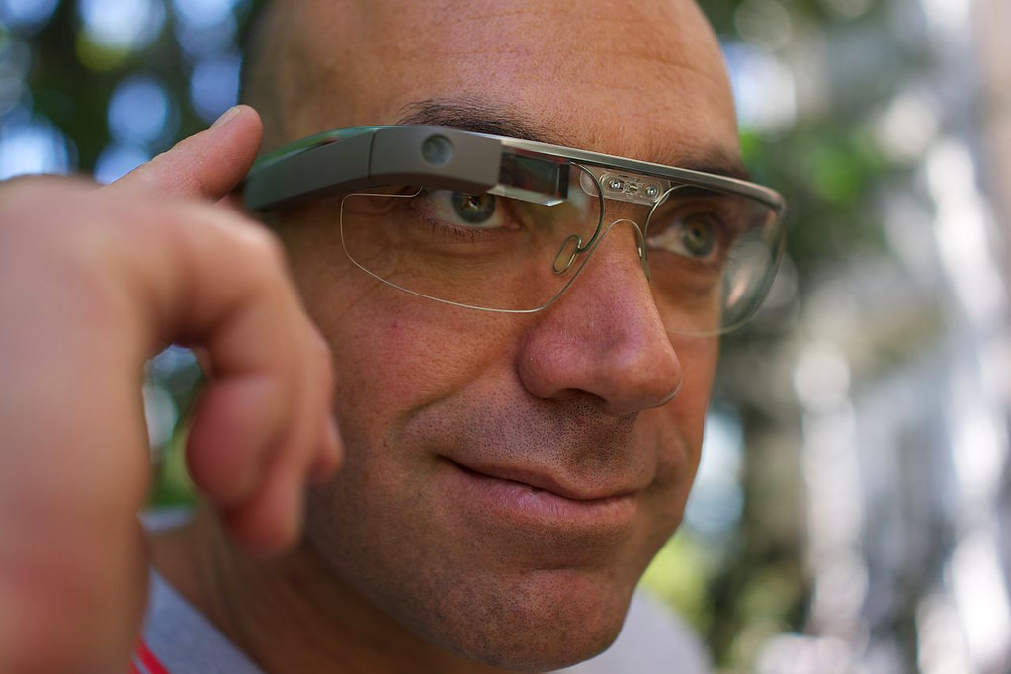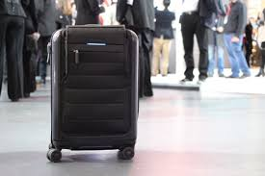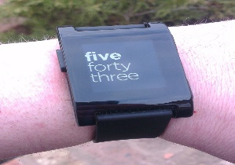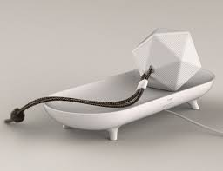

The design and technology world is full of innovation. Unfortunately, not all ideas are well received. Maybe the consumer just wasn’t ready, but these incredible gadgets just failed to succeed.
Why do gadgets fail? Usually it’s due to competition, being overpriced, or failing to meet the needs of consumers. But for every fantastic product, there are plenty that fail. Here are four incredible gadgets that unfortunately failed:
Google Glass AR Glasses
Google’s first step into augmented reality was cool, but too advanced. The consumer version died back in 2015, thanks to limited demand and high pricing. However, the Explorer Edition lives on in the commercial world.
Died: July 2015.
BlueSmart Series 2 Smart Luggage
BlueSmart company produced suitcases with incredible features, such as GPS tracking and device charging. Sadly, regulations banned those power banks.
Died: May 2018
Otto Smart Digital Door Lock
The Otto digital lock allowed people to enter their house without keys thanks to wireless connectivity. Unfortunately, the product was hugely overpriced.
Died: December 2017.

Pebble Smartwatch
Pebble is maybe the greatest success and failure story of all time. This company created a smartwatch with fantastic battery life that broke records on the web. But, eventually, people bought and preferred the Apple smartwatch and other big companies’ names.
Died: December 2016
However, instead of feeling sad about the past, we are looking forward to these future devices:
Google Visual Assistant Artificial Intelligence Projector
This device could operate like a Google smart speaker, with the addition of visuals. You would only need to ask to watch a movie or see live traffic.
Walnut Personal Health Toy
It might be called a toy, but Walnut actually has a very serious purpose. The device contains sensors that test your blood sugar, grip strength, and hand tremors—useful for folks concerned about their health.
Lumigrids Cycling Projector Light
This ingenious bike light beams a blue grid onto the road ahead. This helps to alert drivers and highlight bumps in the road.
(Source: https://thegadgetflow.com/blog/incredible-gadgets-concept-designs/

- In your own words, explain the reason why these gadgets failed: (answer may vary)

- Google Glass AR Glasses: _________________________________

- Pebble Smartwatch: ______________________________________

- Otto smart digital door lock: ___________________________________

- Read the text again and state True (T) or False (F):

- ___ Generally, gadgets mainly fail because of technology trends and consumers' needs.
- ___ All technology ideas are well received.
- ___ The BlueSmart Luggage failed because its power bank did not work properly.
- ___ The Otto digital Look allowed using wireless connectivity.
- ___ The Pebble Smartwatch had a low battery life.

- Read the text again and label the following gadgets:
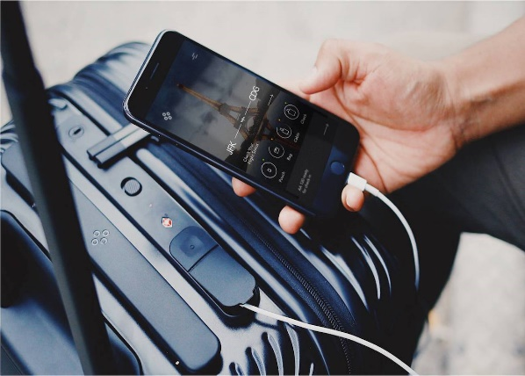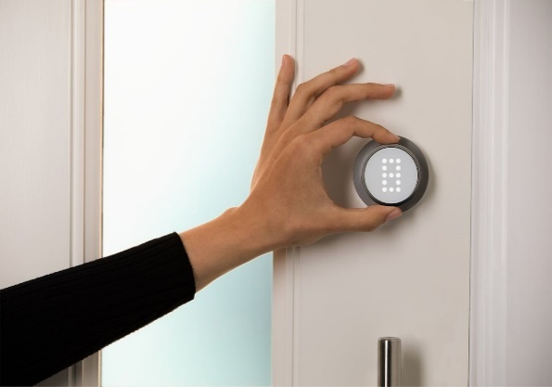
1_______________________________ 2 _____________________________
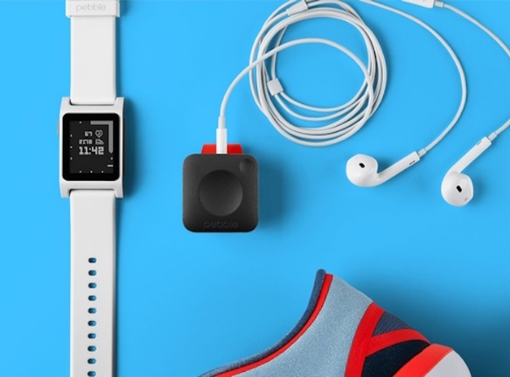
3 _________________________________ 4 ____________________________

- Read and answer the following:

- Which gadget(s) from the past would you bring back to life?

- Why would you do it?

- Which ones do you think would be the most popular one(s)? Please explain.

d. Is there any other gadget you believe might help humans to have a
more comfortable and interesting life? Please explain.

SECTION 3: LET´S CONSTRUCT AND APPLY OUR KNOWLEDGE

- For this week project. You need to give reasons for the failure of some gadgets.

- Look at the following pictures and think about the possible reason for the failure of these gadgets.
Gadget 1: Video Game Gadget 2: Voice recorder
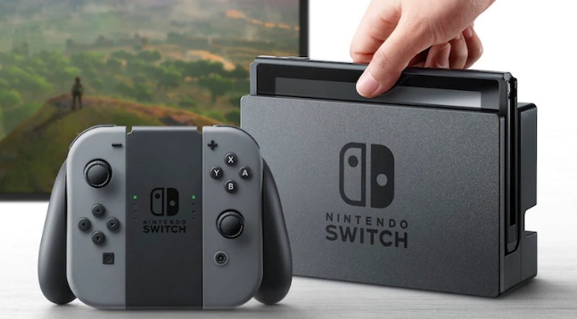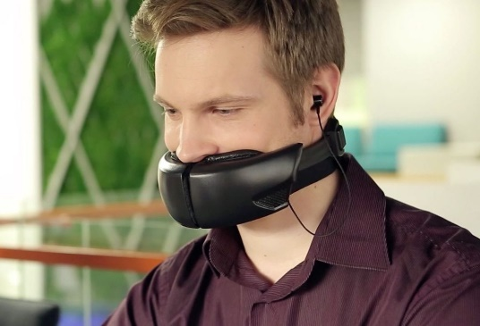
Gadget 3: Toothpick Gadget 4: Lipstick Pendrive

- Now, write the reason you think they did not work in the market

Gadget 1 did not work because ________________________

Gadget 2 did not work because ________________________

Picture 3 did not work because ________________________

Picture 4 did not work because ________________________

- Finally, select one of these gadgets and explain how you would make it work:
I think gadget ____ would work if ________________________________________________________________________________________________________________________________

SECTION 4: Extra activity

- Do you know what an acrostic poem is? Well, an acrostic poem is a poem where certain letters in each line spell out a word or phrase.

Can you complete this acrostic poem with GADGET related words? Once you finish read it as a poem

G is for Good
A is for A
D is for D
G is for G
E is for E
T is for T

