UNIT 3
LESSON 4

ÚTILES

- Texto del estudiante de 4° medio.
- Diccionario de inglés.
- Lápices.
- Cuaderno de asignatura.

SECTION 1: SETTING THE CONTEXT

Hello students! Welcome back to lesson 3! In this lesson we will be reviewing the contents from this lesson and previous units.

- Look at the pictures and answer these questions
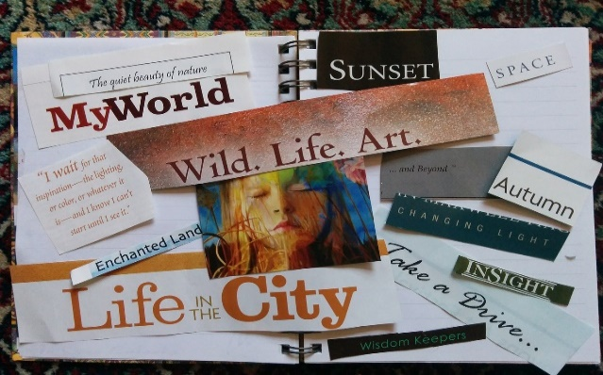

- Can you name the social media websites from the image?

- Can you name different types of artistic manifestations?

- Can you describe one distinctive aspect of your generation?

- Can you write the days of the week?

- Can you write 5 different music genres?

- Can you write 3 plays from theater?

- Can you name 3 well-known Chilean movies?

(Source: original activity)

- The Fringe festival in Edinburgh is the biggest Performing arts festival in the world. Every August artists from all over the world go to Edinburgh to perform their talents. Look at the following pictures and label them.

Edinburgh – pantomime – cinema – graffiti – weekly calendar – dance – theater – street artists - acrobatic- stand-up comedy

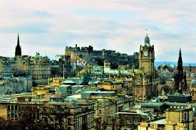
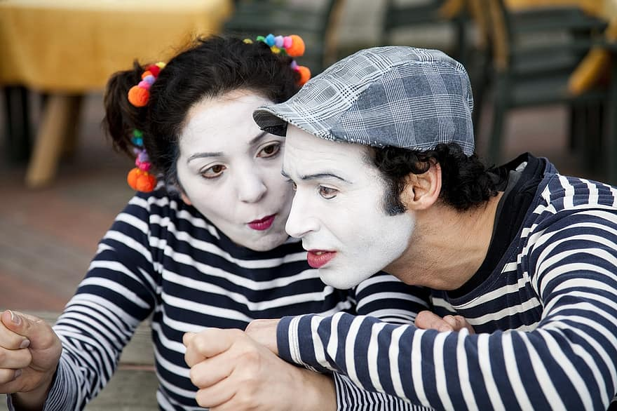 | 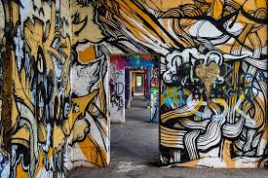
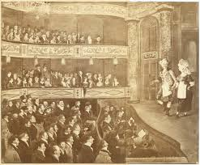 | 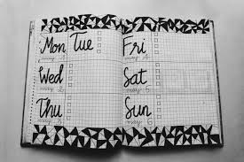
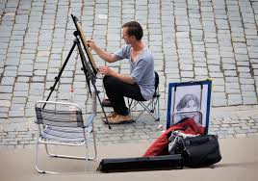
(Source: original activity)

SECTION 2: LET´S PRACTICE

- Participating in TV programs can be a great chance of changing someone's life for different reasons and purposes. Read the following texts.
a. Ann, a housewife says “I need money to buy a new house for my family. I do not have a college degree so winning this TV show could help me to get money easily and in a short period of time. I have been doing some exercise and dieting to be ready for any physical contest. I will miss my kids a lot, but the sacrifice is worth it.”

b. Bell, a journalist says “I have applied to many TV channels and radios, but I have not been able to get a job. I am sure if I get into de program, I will get the job of my dreams! I want to be known by people and win an Emmy Award before I am 30 years old.”

c. Phill, a plumber says “I love television, so I decided to participate at a reality show to have the experience of a lifetime. I do not care if I must take part in dangerous contests or give up thinks like hot water or clean clothes. My goal is to get money and fame at any price!

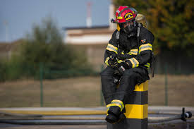 | d. Jim, a firefighter says “I love helping people, and right now my community needs a new equipment for our Fire station. If I win the TV program, I will be able to buy what we need and to start a campaign to enrol more volunteers. I am just keeping all my fingers crossed!  (Source: original texts)

- Read and tick the correct statement according to the texts
Who wants to...? | Ann | Bell | Phill | Jim
win an international prize?
make a dream come true?
get money fast?
buy new equipment to help the community?
help his/her family?

- Are you for or against the reasons given by Ann, Bell, Phill and Jim about applying and participating in the TV show? Complete two sentences.

- I am for __________ ´reasons because_______________________________.
b. I am against ________´reasons because_______________________________.
- Answer the following questions based on the information from activity 3:

- Do you think money is a valid reason to enter a reality show? Why/Why not?

.
- Do you think that people who enter reality shows are role models for their community? Why/Why not?

- Would you support your parents if they wanted to enter a reality show? Would it be embarrassing? Why/Why not?

- Do you think that participating in a reality show would help you to get your dream job? Why/Why not?

SECTION 3: LET´S CONSTRUCT AND APPLY YOUR KNOWLEDGE

- Congratulations!!! You are one of the finalists to win the reality show “YOUR BEST WEEK”. Our judges will pay special attention to your final performance, therefore, be interesting, creative, original and coherent in your ideas.
For the first challenge you must create a visual representation of your generation focusing on the uses you give to social media on a WEEK.

For this, follow these steps:

- First, describe your favorite social media and explain your choice.

- Then, describe the social media use for Monday, Tuesday, Wednesday and so on.
- Finally, describe how this social media relates to your generation.

Template for social media use over a week:
Social media | Monday | Tuesday | Wednesday | Thursday | Friday
Morning

Evening

- For the second and last challenge, you must be very creative and original because this is about your ART manifestation. Therefore,

- First, think about a WHOLE WEEK of arts just for you...
- Then complete the template with art manifestations.
- Create a poster to promote your WEEK of ARTS as if it were a festival.

Template for your week of art manifestations:
Events | Monday | Tuesday | Wednesday | Thursday | Friday
Morning

Evening

EXTRA ACTIVITY:

Do you remember your favourite reality show or TV show? Please write down the reason(s) why you liked it so much. Do not forget to include the name, location, setting(s), participants and requirements related to that TV show.

.

