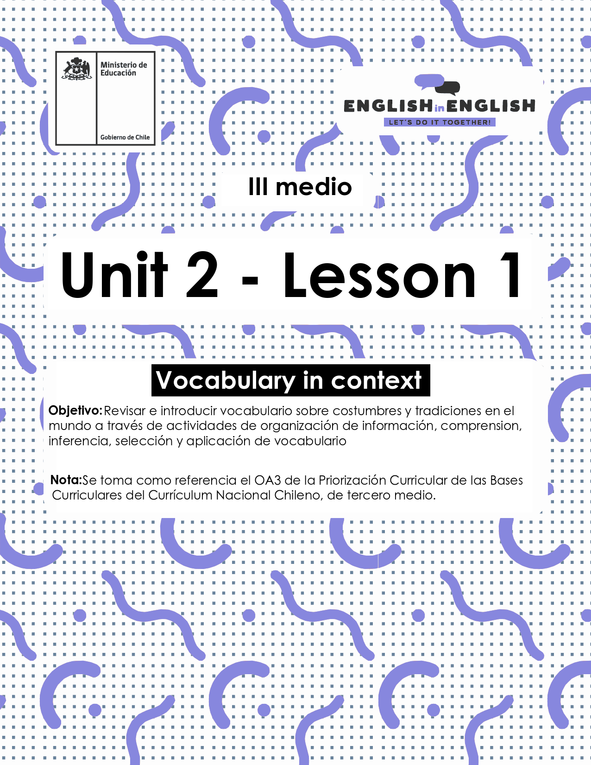

UNIT 2
LESSON 1

ÚTILES

- Texto del estudiante de 3° medio.
- Diccionario de inglés.
- Lápices.
- Cuaderno de asignatura.

ICONS FOR ACTIONS

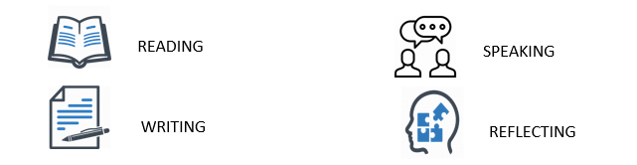

SECTION 1: SETTING THE CONTEXT:

Vocabulary: Traditions and food

- Look at the following images and match the words with their corresponding definition.
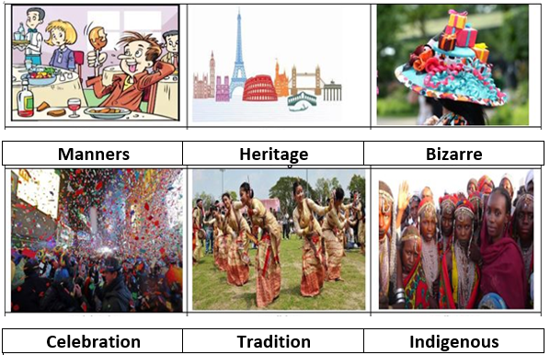

- A _CELEBRATION_ refers to the action of celebrating an important day or event.
- _________________ refers to the ways of behaving toward people, specifically to ways that are socially correct and show respect for others in social settings.
- _________________ refers to something or someone naturally existing in a place or country rather than arriving from another place.
- _________________ is something or someone that is very strange or unusual.

- __________________ refers to features belonging to the culture of a particular society, such as traditions, languages, or buildings, that were created in the past and still have historical importance.
- ___________________ is a belief, principle, or way of acting that people in a particular society or group have continued to follow for a long time.

- Let's classify some vocabulary! Can you classify these synonyms (or related words) in the chart below?

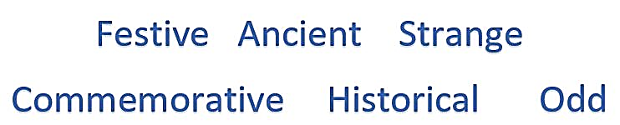

Celebration | Bizarre | Traditional

- Do you like traditional food?
  - Can you write the list of ingredients for these Chilean traditional recipes?
  - If you don´t know you can ask your family.
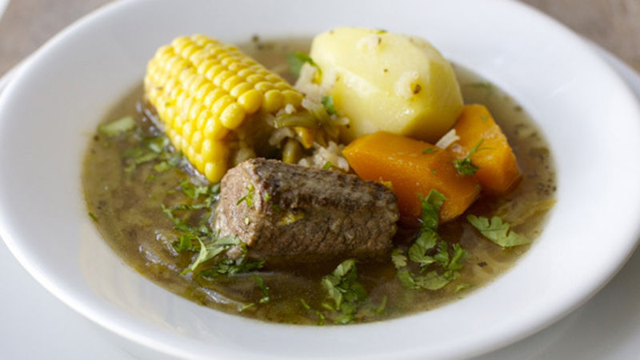 | 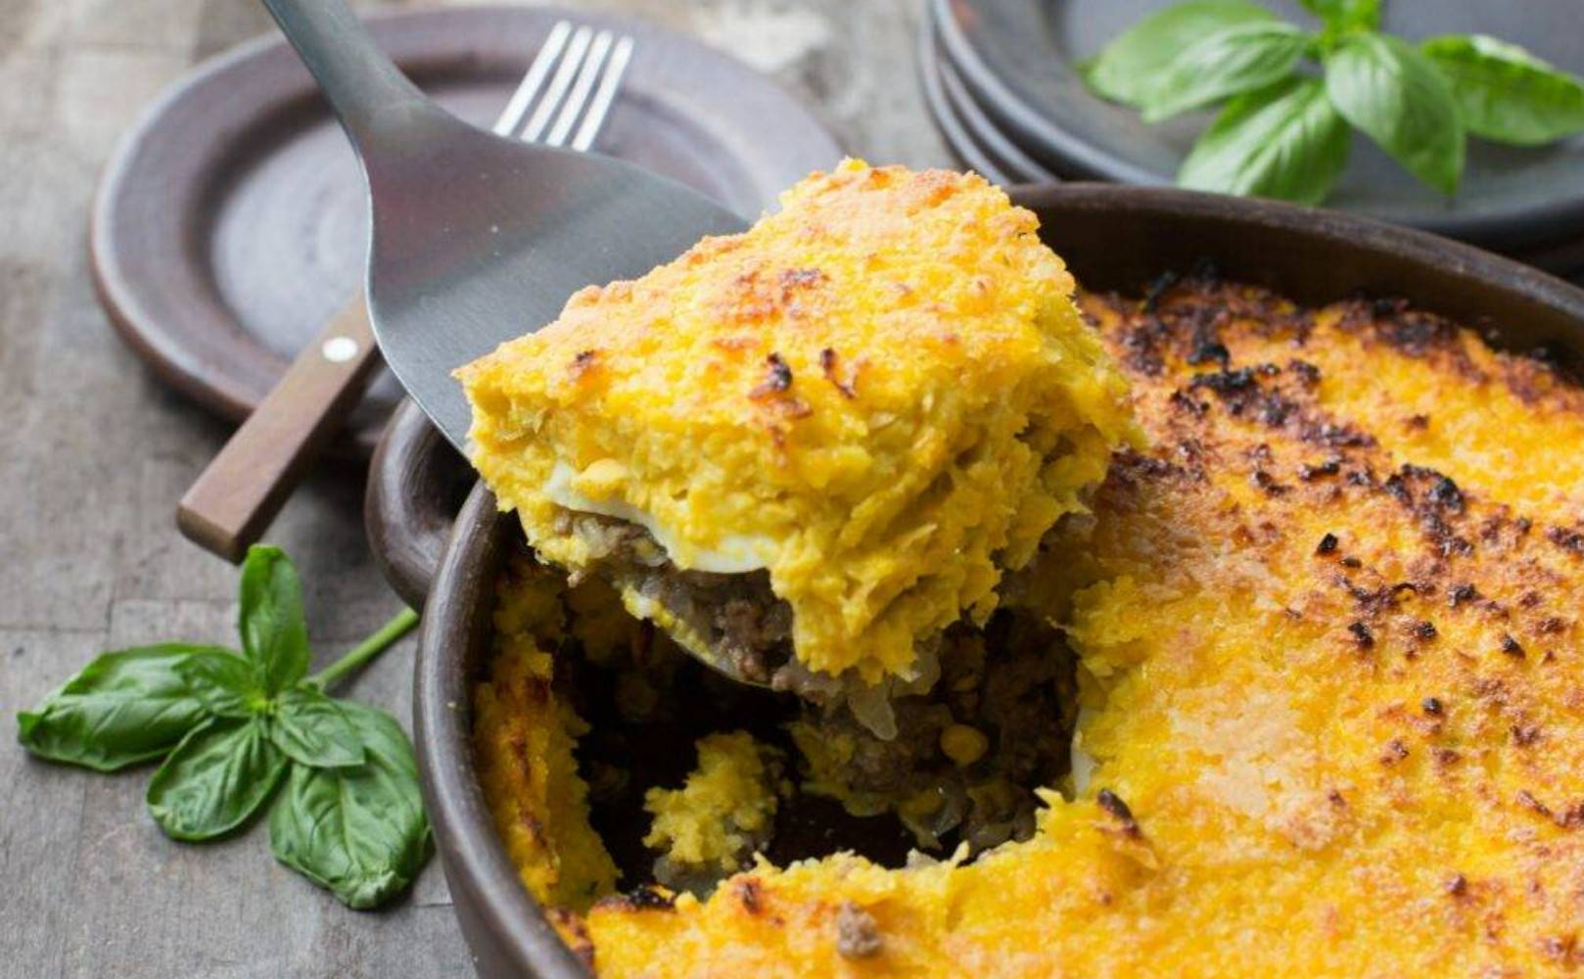
Ingredients for Chilean Cazuela  · beef  · vegetable oil  · onion, cut into quarters  · teaspoon oregano  · teaspoon ground cumin  · Salt and pepper  · ------------------------------  · ------------------------------  · ----------------------------- | Ingredients for sweetcorn pie  · beef  · chicken  · vegetable oil  · ------------------------------  · ------------------------------  · ------------------------------  · ------------------------------  · ------------------------------  · ------------------------------

SECTION 2: LET´S PRACTICE

- Once you have already started working on this Unit, what about unscrambling the following words?
DOD | ODD

MNAENSR

TANICNE

NDITEGERN

ZBIEZAR

ETEHIGR

- Odd man out: cross out the word that does not belong to the group:
- Example: Have fun – celebrate - get bored - have a blast

- Food - poison - meal - snack
- New - historical - ancient - antique
- Misbehaviour - manners - habits - good attitudes

- Have a look at the following sentences and circle according to the meaning of the statement in bold:
- Observing local traditions and customs refers to:
- Looking at people celebrating their culture.
- Obeying local customs according to people's beliefs.
- Looking for certain local urban stories.

- Historical monuments should be kept safe means:
- They need to be taken care of by every person in any community.
- They do not have to be protected or maintained.
- They are made just to give cities a different look.

- Culture is whatever people do anytime and anywhere as they have grown up inside a specific community talks about:
- Festivals
- Celebrations
- Heritage

- Locals may come at midday to pick up their Chinese food portion reflects that “_______ are coming to get some Asian food by 12.00 PM.”
- People
- Shops
- One person

- Talking about traditions/customs and food, what do you think about the following?
- Do you think the sentences below are traditions or facts (things happening according to specific situations)?
- Fill in with T for tradition and F for fact.

- ___ Chilean people go to fondas and parties at national festivities in September.
- ___ Eating too much traditional Mexican food like tacos or enchiladas can be dangerous for your body.
- ___ The more calories you eat daily, the more you will gain weight.
- ___ People in Chiloe believe that Caleuche and el Trauco belong to their own history and heritage.

SECTION 3: LET´S CONSTRUCT AND APPLY OUR KNOWLEDGE

- Let’s use the vocabulary you learnt during this worksheet.
- Complete the text using the words from previous activities.
- There are many options you can use if you pay attention to activity 1-C:
People all over the world have different _______and customs. They all _________their own important dates or events in the most varied ways. Some may appear __________ or odd to you, but it is probably because your own culture is different. The important thing is to understand that differences make us unique, and cultural differences should open your eyes to other different realities.
In Chile, for example, we ________ our national holidays with barbeques, empanadas, and different social gatherings. Some kids play typical games and fly kites. Usually, we meet with our family and sometimes with friends in a _______ environment. However, in Venezuela, even though the national holidays are a ______ event, they don’t celebrate in such a big way like Chileans do. | 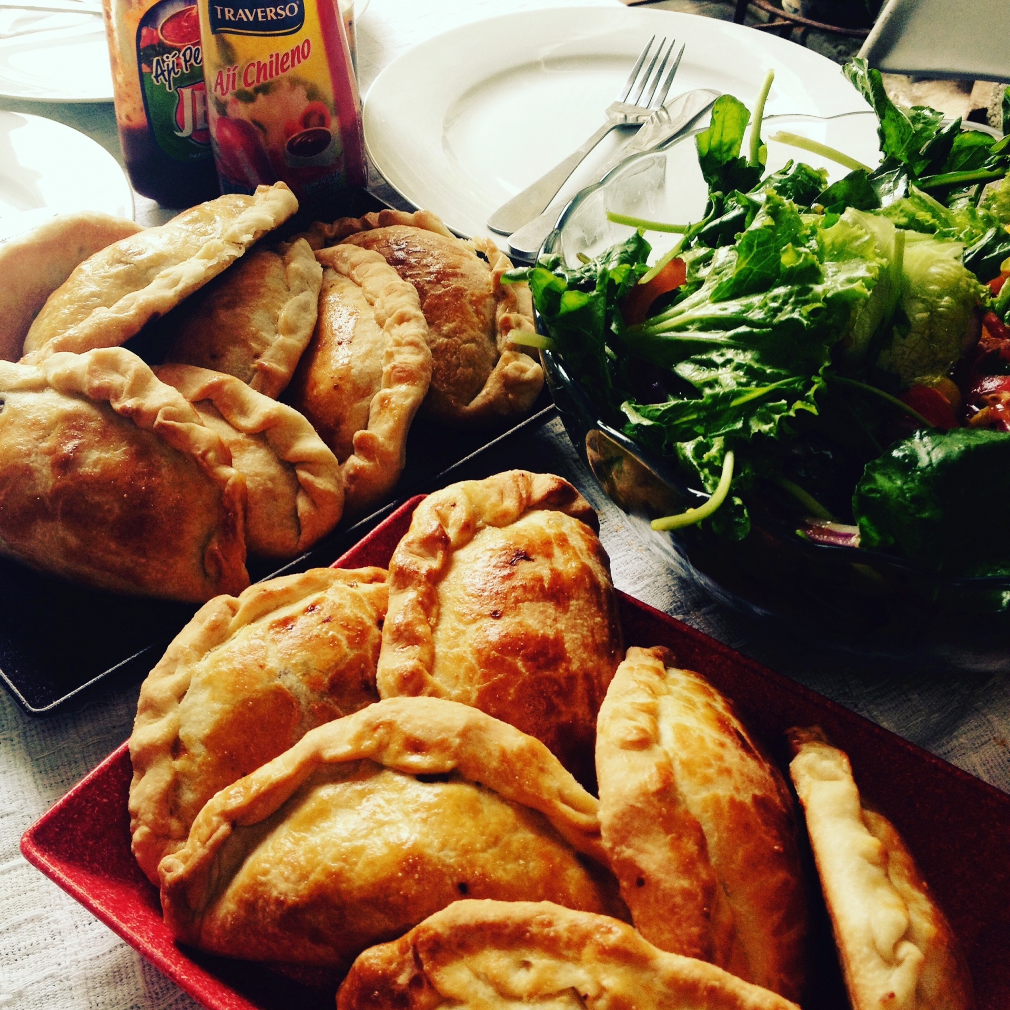
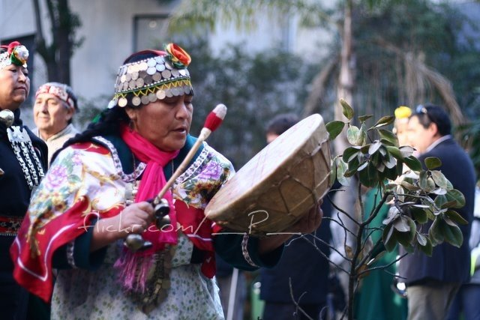 | There are _________celebrations that are also important and very festive. Mapuches, for example, celebrate “We Tripantu”, which is the Mapuche New Year _________, and it is an ancient ________ that has survived until these days. “We Tripantu” is celebrated during June, unlike the common New Year’s Eve in December.
While in December people have dinner and gather with their family to receive the new year, Mapuches celebrate in June to welcome the new year with a social gathering where the elders teach the young the ancient ________ and Mapuche ________. Then, when the sun comes up, they bathe in a river or lake. Different, right? But that’s the great thing about ___________, we can all learn about different cultures and understand that these differences are the richness of our society”.

9.Now it’s your turn to write.
- Can you describe some traditions or celebrations in Chile or in other parts of the world?
- Maybe traditions from your own family?
Place | Celebration | Date | Family tradition
My family | Christmas | December 24th | Dad cooks Christmas dinner and we meet with my relatives at midnight to open presents and eat Christmas bread

SECTION 4: SPONGE ACTIVITY

- Now let’s put the description into sentences, you can follow this example:
- “In my family there is a tradition. For Christmas, on December 24th, my dad cooks the Christmas dinner, and we meet with my relatives to open presents and eat Christmas bread”.

In __________, there is a _____________. For _____________, on __________________________________________________________,_______________________________________________________________________________________________________________.

In __________, there is a _____________. For _____________, on __________________________________________________________,_______________________________________________________________________________________________________________.

