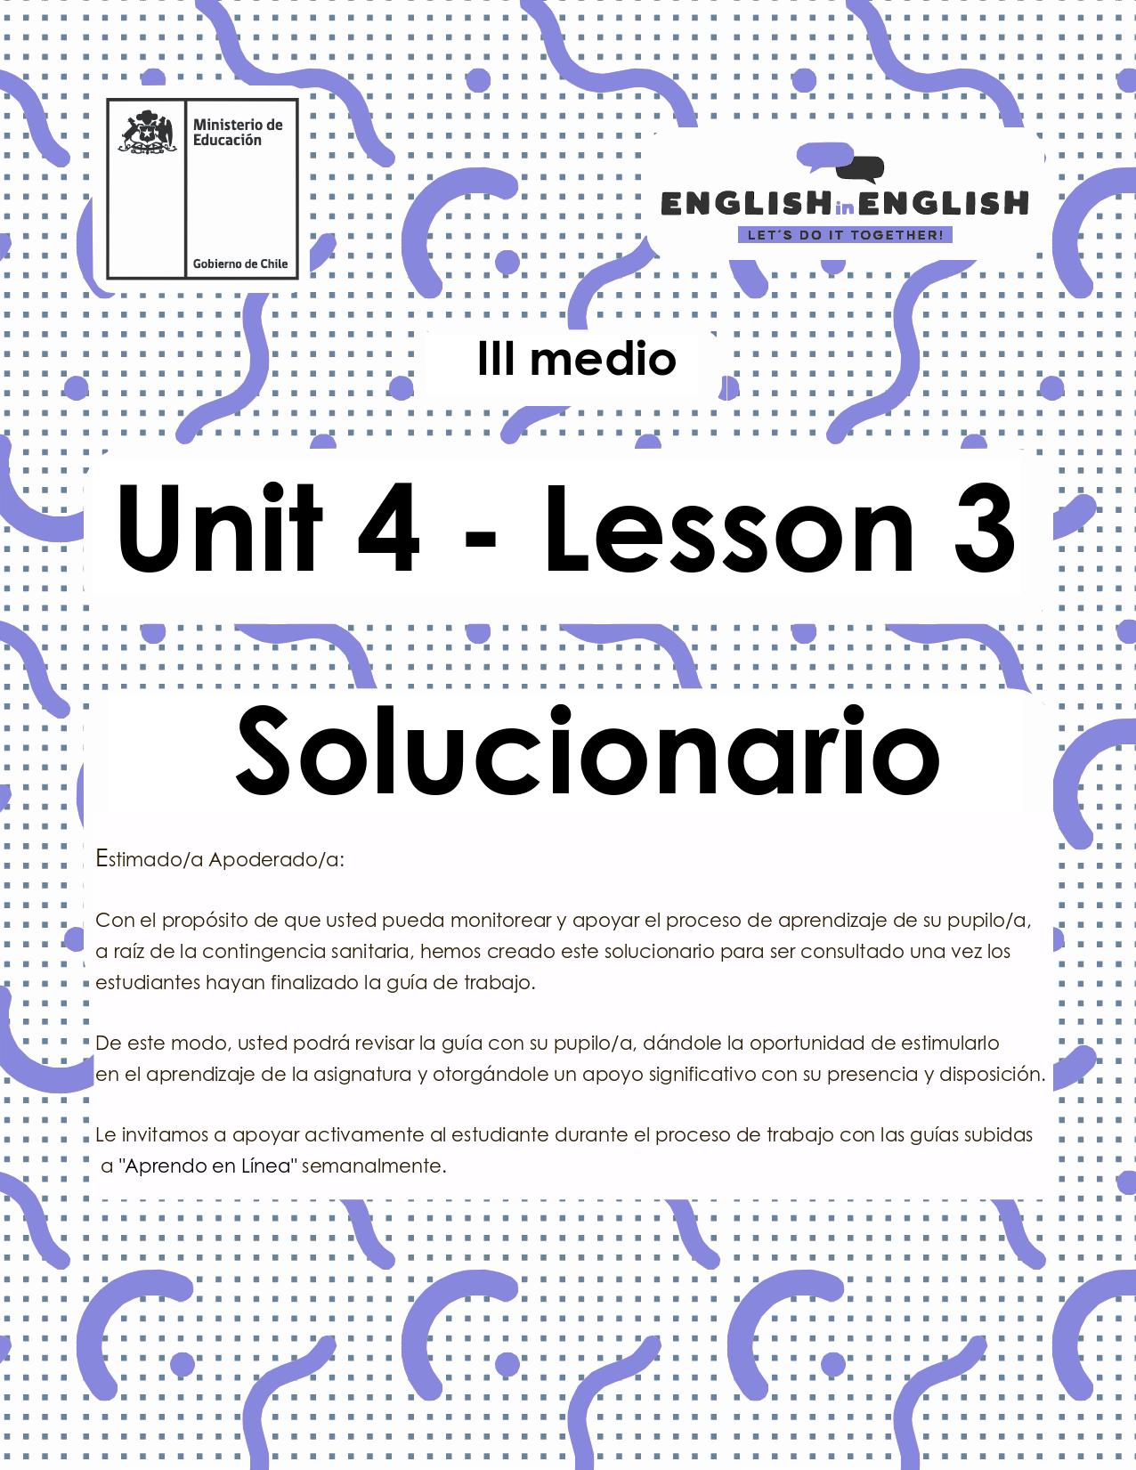

UNIDAD 4
LESSON 3

GUÍA PARA USAR EL SOLUCIONARIO

- ¿Qué es un solucionario?
- Un solucionario incluye las respuestas a todas las preguntas y actividades.
- Algunas de las preguntas tienen más de una posible respuesta.
- Algunas de las preguntas tienen una sola respuesta.

- ¿Cómo revisar mis respuestas?
- Encontrarás títulos en los encabezados de los ejercicios que dicen “answers” en respuestas cerradas, y en el caso de respuestas abiertas encontraras un encabezado indicando “answers may vary”.

- Las respuestas en ejercicios de verdadero falso, llenado de tablas, unión de letras y dibujos, etc. pueden estar en:
- Negrita
- Subrayado
- Sombreado con colores de formato de guía (purpura, verde, naranjo)
- Encerradas en círculos
red
- Destacadas
- Tachadas

- Ejemplos de respuestas se ilustran a continuación:
I) What is the first thing you think of when you look at it? Why?
Answers may vary.
Example: Art, music, painting. Because there are different people doing these activities.

II) Find the words to complete the sentences using the picture clues. For extra help you can use the Pictionary at the end.

a. The artists used materials like rubber, plaster and styrofoam to make their art.
b. Pomaire pottery is mainly made of clay. Don´t forget to visit this magical village!

SECTION 1: SETTING THE CONTEXT

Hello Students, welcome back to lesson 3. In this lesson we will rehearse our writing skills by creating a fictious volunteer programme that considers your interest and ideas.
- In Chile, there are different international volunteer opportunities for people interested in helping others without receiving an economic retribution. Read the following charts with Volunteer opportunities and fill in the gaps with words from the box.
Services- Everyone- Protests- Skills- Emergencies- Nature

Volunteer Opportunities
GREENPEACE
Area of volunteer programme | World and Nature protection
Objective | working for a green and peaceful future for Everyone
Logo or Motto of the programme

Activities they do | They do street campaigning, event management, lectures, petitions, Protests, and fundraising

REDCROSS
Area of Volunteer programme | Health Services
Objective | to deliver vital services – from providing relief and support to those in crisis, to helping you be prepared to respond in Emergencies.
Logo or Motto of the programme | Sleeves Up. Hearts Open. All Inn.
Activities they do | provide compassionate care, donate blood, teach life-saving Skills, among others
Adapted from https://www.redcross.org/volunteer/become-a-volunteer.html and https://workfor.greenpeace.org/volunteer/

- Look at the following pictures about the National Volunteer Centre (NVC) from PIAP in Chile and answer the following questions.
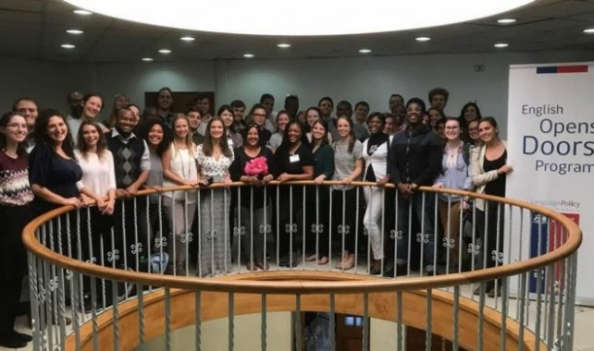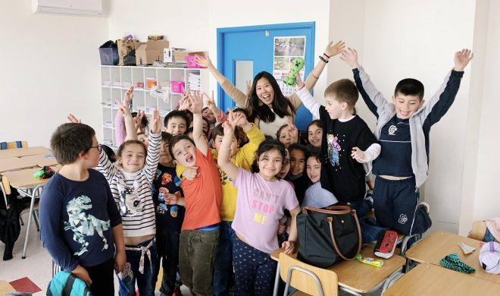
Answers may vary
- What do you think the National Volunteer Center (NVC) do in Chile?

Think they help students practise English and know more about their countries.

- Can you guess the number of volunteers the programme brings to Chile every year?

50 or 70 yearly.

- Can you guess the nationalities the volunteers come from?

Americans, British, Australians and New Zealanders.

D) Can you guess some requirements volunteers need to comply with to be accepted at CNV?
I think they must have a college degree and some teaching experience.

E) Why do you think these volunteers come to Chile?
Because Chile is a safe and beautiful country.

- In the last week worksheet, you created an acrostic poem with the word VOLUNTEER. Now, you need to create three sentences with the following acronym.
Answers may vary
National | Example:  The National volunteer center is a good programme for Chile as it supports education in Chilean schools.
Volunteer | To be a volunteer you need to have time and dedication to support others
Center | The center of volunteers in open over the school term

SECTION 2: LET´S PRACTICE

- Read the following text and check if you guessed correctly in the previous exercise. If not, please correct your answers:
The National Volunteer Center is an educational volunteer programme, and part of the English Opens Doors Program, supported by the Chilean Ministry of Education and the United Nations Development Programme-Chile. The National Volunteer Center recruits native and near-native English speakers from all over the world with the objective of working as teaching assistants in Chilean classrooms, specifically to help students’ listening and speaking skills. The volunteering programme lasts for 6 months, although they can extend for the time they want, and most of them stay for a full year because they love the experience. The motto of the programme is “Dare to share!” because they know that sharing is caring.
Every volunteer works with a Chilean teacher of English, helping them creating activities for their classroom. They also help to increase their students’ motivation to learn and use English because they only use this language to interact with them.
Volunteers also assist their teachers and students with other initiatives of the English Opens Doors Program, such as debates, English Weeks for students, and English Camps.
Volunteers teach and encourage the study of English while living with Chilean host families and interacting with members of the local community. Up to this date, the National Volunteer Center has helped over than 25.000 students!
Texto adaptado de http://centrodevoluntarios.cl/the-english-opens-doors-program/

- Answer the following questions based on the reading:

- What type of work do volunteers do with the Chilean students?
They assist and support students and teachers in schools

- How long is the volunteer programme?
The volunteering programme lasts for 6 months, although they can extend for the time they want
- What do you think “Dare to share? means”

This means that you are able to share your experiences with others
- Why do you think volunteers motivate students by using English?

Because the learning of English is important
- What are the three activities that volunteers help with?

debates, English Weeks for students, and English Camps
- Why do you think that volunteers live with host families?
Because they get immersed in the culture of the country

- Imagine that you apply to have a volunteer from the National Volunteer Center in your school, then answer the following questions:
Answers may vary
- How would a volunteer benefit your English classes?
They would bring culture and new traditions.

- How many students would the volunteer benefit?
All the students at my school.

- What semester would be the best time to have a volunteer? Why?
The first and second one. That way students might interact and practice all the school year.

- What extra activities does your school have that the volunteer would help you with? For example, English day, English week, Debates tournament
English Festivals, Sport matches, Spelling bee and Public speaking contests.

- Why is your local community good for a volunteer?
Because we are very generous and friendly people. We love to share and welcome everybody here.

- Having a good and attractive motto is an excellent way to promote a volunteer program. What do you think these mottos are from?
Read the following mottos and write the area of volunteer work they belong to.
Answers may vary.
Mottos | Volunteer work area
The last step, the most important | e.g. Health services
Nurture peace, global disarmament and non-violence | United Nations/ Social Foundation for non-violence
One of the greatest gifts you can give is your time to them | Social Foundation for Education
It takes hands to build a house, but it takes hearts to build a home | Foundations supporting the projects on Child Rights

SECTION 3: LET´S CONSTRUCT AND APPLY OUR KNOWLEDGE.

- For this week final project, you will create a fictious volunteer programme by considering your interest and ideas of activities to support people in your country.
Answers may vary

- Start by brainstorming all your interest to design a volunteer programme. Take a couple of minutes and select one

Examples:

Education Animal Care Youth homeless

Poverty elderly people support in catastrophe

- Give a reason for your choice:

I am interested in creating a social action volunteer programme because I believe everybody should have the best opportunities to study and make their dreams come true no matter social condition

- Create a programme overview by considering the lasting of the implementation, activities included, resources to be used, people and sponsors involved, etc. You can also add pictures or drawings to make your programme attractive.
Answers may vary

(Add the Title of you volunteer programme)

Area of volunteer programme | Social action
Objective | To help people reach their objectives despite their social background.
Logo and Motto of the programme | Never stop dreaming!
Country of implementation | Chile
Lasting of the implementation | All year rounds
Number of people the programme will help | 100
Resources needed | Professionals, technicians, equipment, sponsors, budget.
Key Sponsors | Universities, enterprises, banks.
Key activity 1 | Support students to finish high school
Description | Give them chances of attending school
Key activity 2 | Guide them to discover their preferences related to their prospective jobs/occupations.
Description | Provide tests and workshops related to different job fields.
Key activity 3 | Get scholarships to pay for educational institutions.
Description | Get enough money to pay for studies, materials, accommodations and health insurance.

Add Photos or drawings from your programme

SECTION 4: SPONGE ACTIVITY

Complete the chart with the activities the pictures show. Answers may vary
REDCROSS | PIAP Volunteer Programme | GREENPEACE
Example:  Compassionate care | Help teachers and students practice English. | Protection of endangered species.
Solidarity | Promote tolerance and respect among people. | Planting trees and bushes.
Help the elderly and people in need | Contribute to Chilean education | Protect the environment

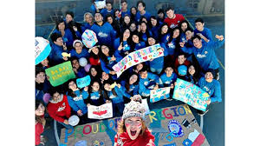 |  | 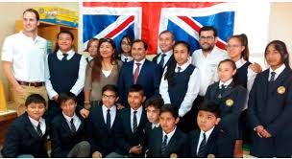
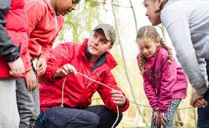 | 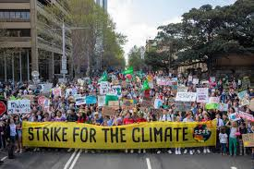 | 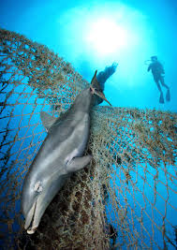
 | 