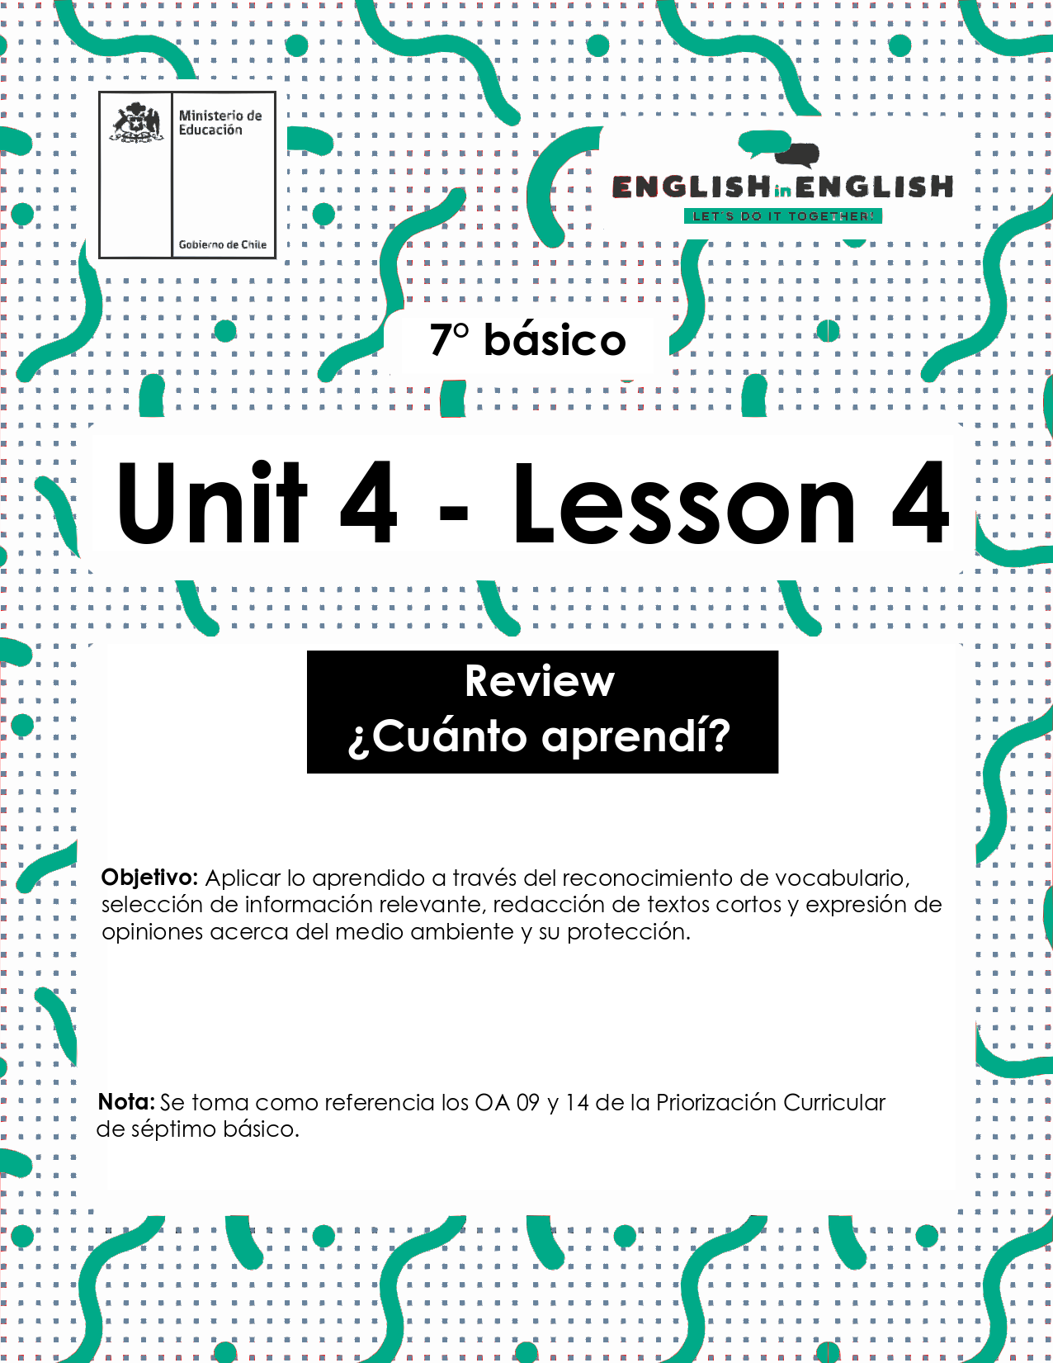

UNIT 4
LESSON 4

ÚTILES RECOMENDADOS:
- Texto del estudiante 7° básico.
- Cuaderno de inglés o 2 hojas en blanco.
- Lápiz grafito y goma.
- Diccionario de Inglés físico / online https://dictionary.cambridge.org/es/diccionario/espanol-ingles/

SECTION 1: SETTING THE CONTEXT
Our environment
1. Read this statement and answer.
- Lee este enunciado y responde.
“Take care of the environment and
it will take care of you”
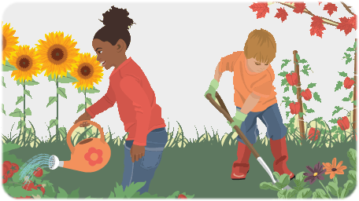

A. How can you help to take care of the environment? Give 2 examples.
……………………………………………………………………………..
……………………………………………………………………………..
B. Why is it important to take care of the environment?
……………………………………………………………………………..
C. What environmental problems do you know? Mention 2.
……………………………………………………………………………..
……………………………………………………………………………..

2. Identify the possible solutions for the corresponding environmental problems. Match them.
- Identifica las posibles soluciones para los correspondientes problemas medioambientales. Relaciónalos.
Possible solutions
- Use renewable energy
- Protect wetlands
- Plan trees near bodies of water
- Create biodiversity action plans
- Replace fossil fuels with solar and wind energy
- Separate residential zones from noisy places like airports.
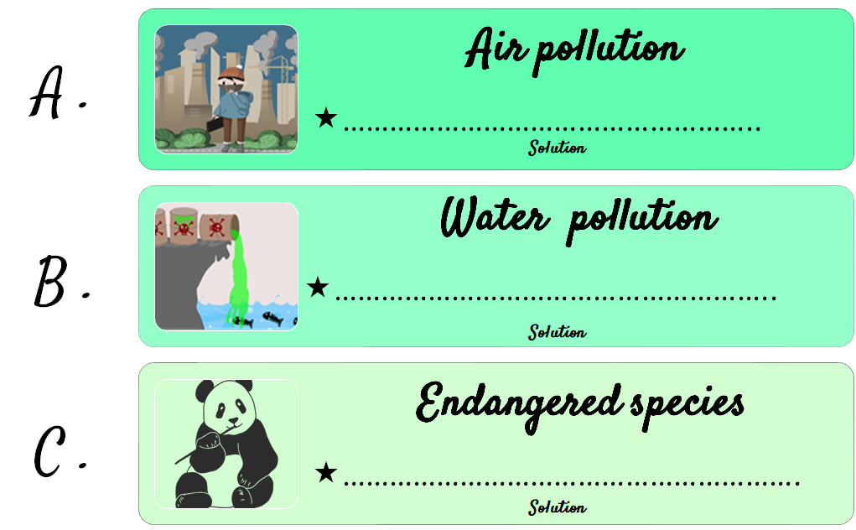

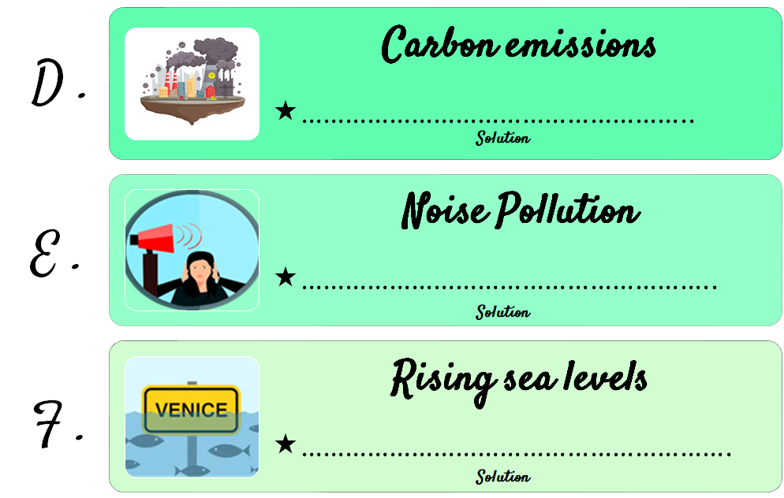

3. Read the following statements and mark them as (G) good or (B) bad for the environment.
- Lee los siguientes enunciados y márcalos como buenos (G) o malos (B) para el medio ambiente.

______ | a-People who buy plastic bags could keep on doing so.
______ | b-Cars could emit less carbon dioxide by using other types of fuel.
______ | c-Urban areas could throw more waste in the sea.
______ | d-People should donate old clothes and books.
______ | e-We should buy toxic products such as motor oil and pesticides.
______ | f-Set up a compost container at home.

SECTION 2: LET'S PRACTICE
Why should we recycle?
1. Before reading the text, answer the questions.
- Antes de leer el texto, responde las preguntas.

2. Read the text.
- Lee el texto.
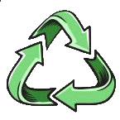
Why should you recycle? If everyone reduced, reused, and recycled, we could make Earth's resources go an awful lot further. Recycling saves materials, reduces the need to landfill and incinerate, cuts down pollution, and helps to make the environment more attractive. It also creates jobs, because recycling things takes a bit more effort than making new things. Recycling doesn't just save materials: it saves energy too. Manufacturing things uses a lot of energy from power plants—and hungry power plants generally make global warming worse. We can save a surprising amount of energy by recycling. If you recycle a single aluminum can you save about 95 percent of the energy it would take to make a brand new one. That's enough energy saved to power your television for about 3 hours! You'll often hear people say that over half the trash we throw away can be recycled. Looking at the chart below, you can see that we currently recycle somewhere between 30–90 percent of the various different materials we use. Just imagine if everyone were recycling most of their garbage: together, we'd be making a tremendous reduction in the amount of raw materials and energy we use—and doing a lot of good for the planet.
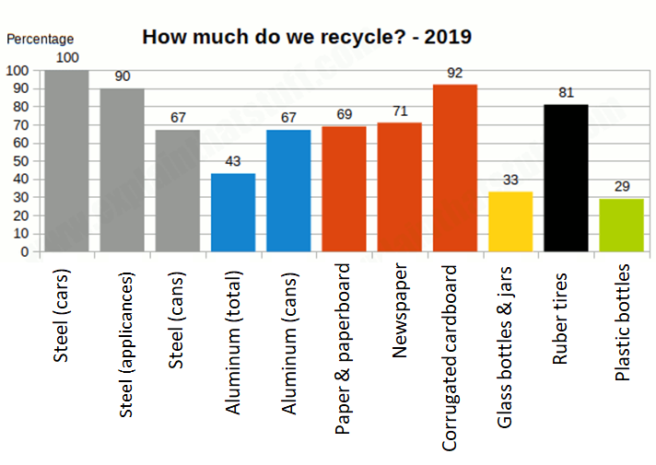
https://www.explainthatstuff.com/recycling.html
Vocabulary:
raw materials: materias primas go an awful lot further: ir mucho más lejos

3. Decide if these sentences are Correct (C) or Incorrect (I) according to the text.
- Decide si estas oraciones son correctas (C) o incorrectas (I) de acuerdo al texto.
________ | - Humans should recycle to make the environment more attractive
________ | - Power plants increase global warming
________ | - Humans recycle between 20 to 40 percent of different materials
________ | - Newspapers are the most recycled materials by people
________ | - Plastic bottles are the less recycled materials
________ | - Recycling just saves materials

4. Complete the drawing with information from the text.
- Completa el dibujo con información del texto.
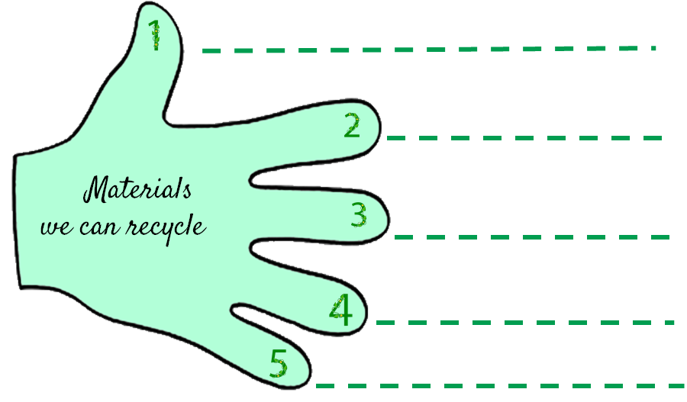

SECTION 3: LET´S CONSTRUCT AND APPLY OUR KNOWLEDGE
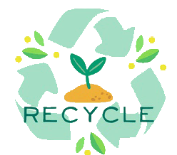
How green am I?

- Complete the organizer.
- Completa el organizador.

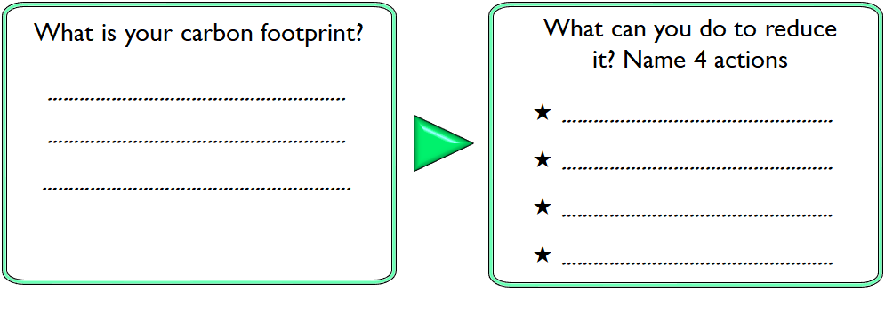
- Complete the chart about how to reduce your carbon footprint.
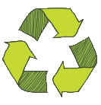
  - Completa el cuadro acerca de cómo reducir tu huella de carbono.
 | Reduce | Reuse | Recycle
Definition
Examples at home
Examples at school

- Answer the questions.
  - Responde las preguntas.

HOW GREEN ARE YOU?

- Do you sort out glass, paper, plastic bottles and cans?
- Yes, always
- Sometimes
- Never
- Do you buy fair trade products or organic or local food?
- Yes, always
- Sometimes
- Never
- Do you use your own shopping bags?
- Yes, always
- Sometimes
- Never
- Do you recycle light bulbs and used batteries?
- Yes, always
- Sometimes
- Never
- Do you always dispose of garbage in a proper way?
- Yes, always
- Sometimes
- Never
- Do you bother picking up other people´s litter?
- Yes, always
- Sometimes
- Never
- Do you switch off the lights when you leave a room?
- Yes, always
- Sometimes
- Never
- Do you switch off other electric appliances at night? (TV, computer…)
- Yes, always
- Sometimes
- Never
- Do you put on warmer clothes when it's cold instead of putting on the heating?
- Yes, always
- Sometimes
- Never
- Do you have showers instead of baths?
- Yes, always
- Sometimes
- Never
- Do you close the tap while you brush your teeth?
- Yes, always
- Sometimes
- Never
- Do you leave the fridge door closed when you do the cooking?
- Yes, always
- Sometimes
- Never

Points | Yes, always |  | 3
 | Sometimes |  | 2
 | Never |  | 1
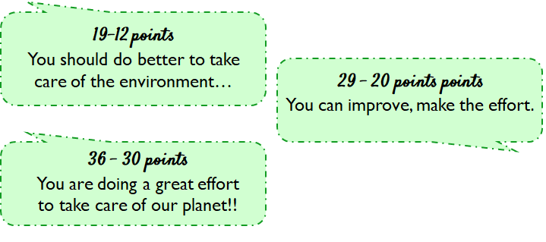

SECTION 4: EXTRA ACTIVITY
3 R’s Poster
1. According to the three R’s to protect the environment against global warming, design a poster using the 3 R’s and the imperative form of the verbs: “reduce, reuse and recycle”.

- De acuerdo a las 3 R’s para proteger el medio ambiente contra el calentamiento global, diseña un póster usando las 3 R’s y la forma imperativa de los verbos: “reduce, reuse and recycle”.
Example:
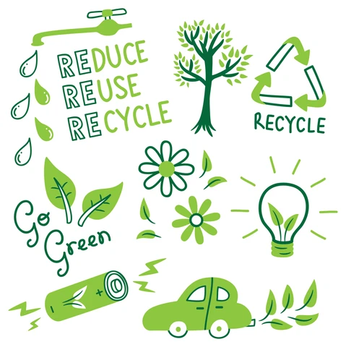

SECTION 5:
Digital Resources
Take a look at these links!
- https://bdescolar.mineduc.cl/info/cleaning-up-the-earth-00046337
- https://learnenglishkids.britishcouncil.org/word-games/environment
- https://www.nationalgeographic.org/education/
- https://www.nationalgeographic.org/education/resource-library/?q=&page=1&per_page=25&subjects=Conservation
- https://kids.britannica.com/kids/article/environment/399445
- http://www.recycling-guide.org.uk/
- https://bdescolar.mineduc.cl/info/recycling-earths-resources-00046329

NO OLVIDAR REPASAR EL CONTENIDO CON UN ADULTO

