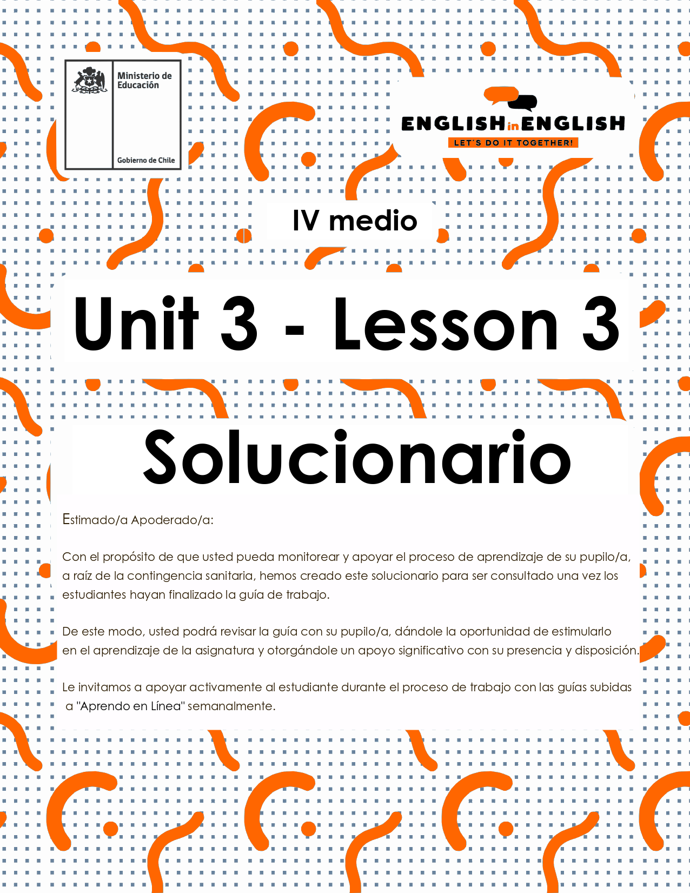

UNIT 3
LESSON 3

GUÍA PARA USAR EL SOLUCIONARIO

- ¿Qué es un solucionario?
- Un solucionario incluye las respuestas a todas las preguntas y actividades.
- Algunas de las preguntas tienen más de una posible respuesta.
- Algunas de las preguntas tienen una sola respuesta.

- ¿Cómo revisar mis respuestas?
- Encontrarás títulos en los encabezados de los ejercicios que dicen “answers” en respuestas cerradas, y en el caso de respuestas abiertas encontraras un encabezado indicando “answers may vary”.

- Las respuestas en ejercicios de verdadero falso, llenado de tablas, unión de letras y dibujos, etc. pueden estar en:
- Negrita
- Subrayado
- Sombreado con colores de formato de guía (purpura, verde, naranjo)
- Encerradas en círculos
red
- Destacadas
- Tachadas

- Ejemplos de respuestas se ilustran a continuación:
I) What is the first thing you think of when you look at it? Why?
Answers may vary.
Example: Art, music, painting. Because there are different people doing these activities.

II) Find the words to complete the sentences using the picture clues. For extra help you can use the Pictionary at the end.

a. The artists used materials like rubber, plaster and styrofoam to make their art.
b. Pomaire pottery is mainly made of clay. Don´t forget to visit this magical village!

SECTION 1: SETTING THE CONTEXT

Hello students! Welcome back to lesson 3! In this lesson we will be writing and learning about reality shows and advertising with the purpose to apply for a reality show activity. So, read and answer the following questions:

- Do you remember what a reality show is? Please explain.

Answers may vary.
Yes, I do. It is a TV program that shows unscripted situations among small groups of people.

- Do you like this type of TV program? Why/why not?

Answers may vary.
Yes, I do. I like the way this kind of TV program shows people and situations.

- If you had the chance, would you participate in a reality show? Please justify your answer.

Answers may vary.
Yes, I would. I love experiencing extreme situations and meeting new people.

- Can you name 5 types of reality shows? (for example, animals)

Answers may vary.
Documentary- social experiment-travel-extreme sports-court shows.

5. Are you for or against participating in a reality show? Complete the chart with some of your ideas:

I am for reality shows as... | I am against reality shows as...
Example: participants can make good money if they win. | Example: they do not respect participants 'privacy.
They are a good opportunity to become famous or be recognized as a celebrity. | All the situations shown are fake and based on commercial criteria.
Participants can get good job offers. | Mass media will interfere and chase every aspect of the participants' life.

6. Tania wants to participate in a reality show about fashion, but she is struggling to complete the application form. Imagine you are Tania´s best friend and give her a hand.
Name: Tania Barrientos
Age: 16 years old
Nationality: Chilean
Hobbies: drawing, painting and making clothes.
Why are you interested in this reality show?
Because I want to be a famous fashion designer!
Why would you be a good candidate?
Because I love fashion and have some experience designing and making clothes.
How would you describe your personality?
I am very creative and friendly. I love designing new clothes and making my own outfits.

SECTION 2: LET´S PRACTICE

7. In the last worksheet we invited you to imaginarily promote a reality show program about sports. Well, you have received many applications back. Read three of them and fill in the table to select ONLY one of them. Then give your reasons.

Candidate 1:
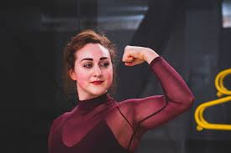 | Gina Pereira, 24 years old, college student. She loves extreme sports and adventures. She is allergic to meat protein and certain remedies. She wants to get into the TV show as she needs money to pay for her university studies. She considers herself as a perseverant and friendly woman. She loves sports, but she is afraid of heights.
Candidate 2:
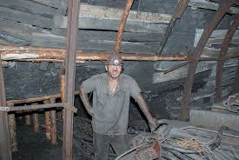 | Benjamin Romero, 35 years old, miner. He likes to meet people and take morning walks. He suffers from diabetes, so he has a very strict diet. He declares he is a hardworking and kind man. He believes he can overcome anything. He wants to win to be famous and appear on mass media. He is a fan of football, and he plays in an amateur league.

Candidate 3:
Mariana López, 52 years old, retired. Sports have been her life passion. She is very athletic and fit. She wants to get into the TV show to show that age is not a barrier for having a healthy life. She considers herself as an active and friendly woman. She is flexible and fast, although she commented being unable to lift heavy weight. She is also interested in knitting and painting.

Tick this table to select one candidate:
Does the candidate…. | Candidate 1 | Candidate 2 | Candidate 3
like sports? | x | x | x
have a good health? |  |  | x
have a suitable personality for the show? | x | x
mention his/her interests, hobbies? |  | x | x

Why have you selected this candidate? Please explain by using the prompts in BLUE.
I have selected this candidate:
Answers may vary.
Gina Pereira because she is young, healthy and loves extreme sports. Also, I think her motivation to participate will help her win

8. The process of application to a reality show is long and exhaustive. Marco is a producer who always pays attention to certain aspects. Read and answer the questions:
“As the producer of the Teenage challenge program, I choose candidates that have and describe a variety of interests in their applications like sports, music, art, writing and so on. This is important to see how diverse they are. I also pay attention to the way the ideas are structured in the application. I mean, no grammar or typo problems, and all the answers are appropriate. I also look for creativity and originality in their applications. For example, pictures, drawing or any form of art that shows that the applicant can showcase their interests and ideas in creative and different ways”.
- What are the three main aspects that this producer focuses on?
1: Interests
2: The structure of ideas
3: Creativity and Originality
- Why do you think it’s important to showcase a variety of interests in a reality show?
Answers may vary.
It is important because you show diversity
- Why do you think he focuses on the way the applicants structure their ideas?
Answers may vary.
He focuses on that as the structure of ideas unveils aspects of thinking and education.

- Why do you think it is important to showcase any type of art form in this application?
Answers may vary.
Because art is an important expression of human emotion

SECTION 3: LET´S CONTRUCT AND APPLY YOUR KNOWLEDGE

Now it is time to apply all your knowledge about reality shows from this lesson. For this, imagine that you will apply for a reality show called “The best week”.
The best week is about doing only your favorite activity or experiencing your best interest, so you desperately want to enter this reality show.
Follow these steps to create a strong application

- First, introduce yourself, who are you and why do you think you would be a good candidate for the reality show?
Answers may vary.
Hello, I am Romina Salas. I am 17 years old and I am from Chile. I am a good candidate for the reality show because I am clever, active and hard-working. I also love freedom.

- Mention some of your interests. Why are they meaningful and important to you?
Answers may vary.
My main interests are taking care of my body and mind. This is very important for me because I think it is essential to be healthy and live well.

- Discuss some of your abilities. What can you do best? What would you like to show?
Answers may vary.
I am very good at drawing and painting. The best I can do is drawing with watercolours. My friends always say that I can create wonderful portraits and landscapes. I would love to show some of my artistic skills in paining.

- Look at your application once more and look for any mistakes in your writing and share it with a classmate.

Answers may vary.
I have looked at it and I have revise it twice.

