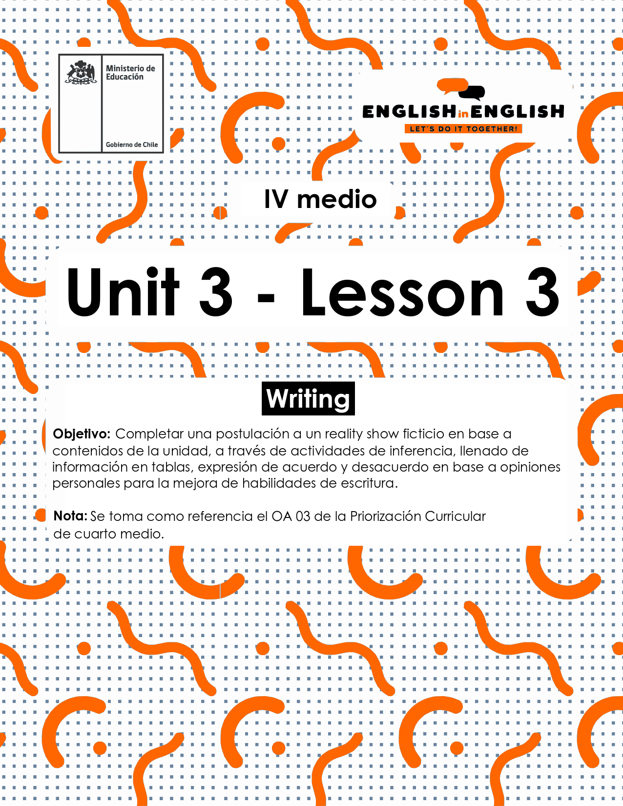

UNIT 3
LESSON 3

ÚTILES

- Texto del estudiante de 4° medio.
- Diccionario de inglés.
- Lápices.
- Cuaderno de asignatura.

SECTION 1: SETTING THE CONTEXT

Hello students! Welcome back to lesson 3! In this lesson we will be writing and learning about reality shows and advertising with the purpose to apply for a reality show activity. So, read and answer the following questions:

- Do you remember what a reality show is? Please explain.

- Do you like this type of TV program? Why/why not?

- If you had the chance, would you participate in a reality show? Please justify your answer.

- Can you name 5 types of reality shows? (for example, animals)

5. Are you for or against participating in a reality show? Complete the chart with some of your ideas:

I am for reality shows as... | I am against reality shows as...

6. Tania wants to participate in a reality show about fashion, but she is struggling to complete the application form. Imagine you are Tania´s best friend and give her a hand.
Name: Tania Barrientos
Age: 16 years old
Nationality: Chilean
Hobbies: …………………………………
Why are you interested in this reality show?.................................................
Why would you be a good candidate?............................................
How would you describe your personality? ……………………………

SECTION 2: LET´S PRACTICE

7. In the last worksheet we invited you to imaginarily promote a reality show program about sports. Well, you have received many applications back. Read three of them and fill in the table to select ONLY one of them. Then give your reasons.
Candidate 1:
Gina Pereira, 24 years old, college student. She loves extreme sports and adventures. She is allergic to meat protein and certain remedies. She wants to get into the TV show as she needs money to pay for her university studies. She considers herself as a perseverant and friendly woman. She loves sports, but she is afraid of heights.

Candidate 2:
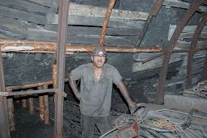 | Benjamin Romero, 35 years old, miner. He likes to meet people and take morning walks. He suffers from diabetes, so he has a very strict diet. He declares he is a hardworking and kind man. He believes he can overcome anything. He wants to win to be famous and appear on mass media. He is a fan of football, and he plays in an amateur league.
Candidate 3:
Mariana López, 52 years old, retired. Sports have been her life passion. She is very athletic and fit. She wants to get into the TV show to show that age is not a barrier for having a healthy life. She considers herself as an active and friendly woman. She is flexible and fast, although she commented being unable to lift heavy weight. She is also interested in knitting and painting.

Tick this table to select one candidate:
Does the candidate…. | Candidate 1 | Candidate 2 | Candidate 3
like sports?
have a good health?
have a suitable personality for the show?
mention his/her interests, hobbies?
Why have you selected this candidate? Please explain by using the prompts in BLUE.
I have selected this candidate:
BECAUSE HE/SHE LIKES SPORTS

8. The process of application to a reality show is long and exhaustive. Marco is a producer who always pays attention to certain aspects. Read and answer the questions:
“As the producer of the Teenage challenge program, I choose candidates that have and describe a variety of interests in their applications like sports, music, art, writing and so on. This is important to see how diverse they are. I also pay attention to the way the ideas are structured in the application. I mean, no grammar or typo problems, and all the answers are appropriate. I also look for creativity and originality in their applications. For example, pictures, drawing or any form of art that shows that the applicant can showcase their interests and ideas in creative and different ways”.

- What are the three main aspects that this producer focuses on?
1:
2:
3:
- Why do you think it’s important to showcase a variety of interests in a reality show?

- Why do you think he focuses on the way the applicants structure their ideas?

- Why do you think it is important to showcase any type of art form in this application?

SECTION 3: LET´S CONTRUCT AND APPLY YOUR KNOWLEDGE

9. Now it is time to apply all your knowledge about reality shows from this lesson. For this, imagine that you will apply for a reality show called “The best week”.
The best week is about doing only your favorite activity or experiencing your best interest, so you desperately want to enter this reality show.
Follow these steps to create a strong application

- First, introduce yourself, who are you and why do you think you would be a good candidate for the reality show?

- Mention some of your interests. Why are they meaningful and important to you?

- Discuss some of your abilities. What can you do best? What would you like to show?

- Look at your application once more and look for any mistakes in your writing and share it with a classmate.

