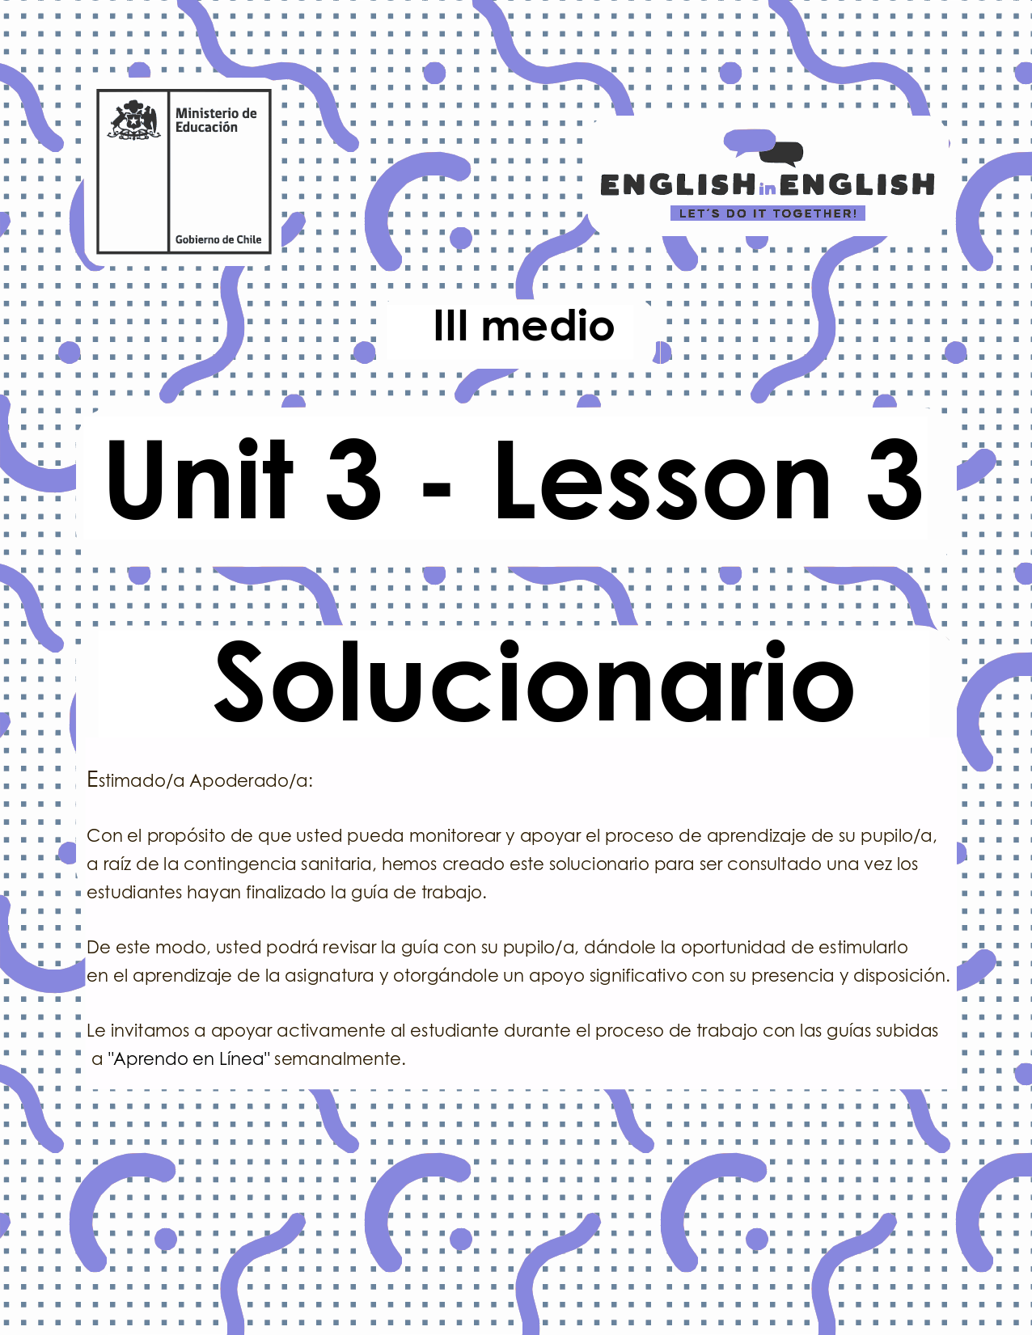

UNIT 3
LESSON 3

GUÍA PARA USAR EL SOLUCIONARIO

- ¿Qué es un solucionario?
- Un solucionario incluye las respuestas a todas las preguntas y actividades.
- Algunas de las preguntas tienen más de una posible respuesta.
- Algunas de las preguntas tienen una sola respuesta.

- ¿Cómo revisar mis respuestas?
- Encontrarás títulos en los encabezados de los ejercicios que dicen “answers” en respuestas cerradas, y en el caso de respuestas abiertas encontraras un encabezado indicando “answers may vary”.

- Las respuestas en ejercicios de verdadero falso, llenado de tablas, unión de letras y dibujos, etc. pueden estar en:
- Negrita
- Subrayado
- Sombreado con colores de formato de guía (purpura, verde, naranjo)
- Encerradas en círculos
red
- Destacadas
- Tachadas

- Ejemplos de respuestas se ilustran a continuación:
I) What is the first thing you think of when you look at it? Why?
Answers may vary.
Example: Art, music, painting. Because there are different people doing these activities.

II) Find the words to complete the sentences using the picture clues. For extra help you can use the Pictionary at the end.

a. The artists used materials like rubber, plaster and styrofoam to make their art.
b. Pomaire pottery is mainly made of clay. Don´t forget to visit this magical village!

SECTION 1: SETTING THE CONTEXT:
Hello students! welcome back to lesson 3. In this lesson we will rehearse our writing skills.
1.Let´s start by looking at the following picture and answering these questions:
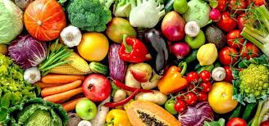
- Have you ever been on a diet? Why/why not?
Answers may vary.
Yes, I have. The doctor advised me to do so.
No, I have not. I love eating all kind of food.

- Did it work for you? Please explain.
Answers may vary.
Yes, it did. I lost almost 5 kilograms.
No, it did not. It is hard for me to reduce and change the number of foods I eat daily.

- Name 10 food you consume while dieting. (look that the picture for reference)
Answers may vary.
Milk- garlic-carrot-grapes-bread-meat- corn-broccoli-avocado-pasta

- What is your opinion about vegan and vegetarian diets?
Answers may vary.
I think vegan and vegetarian diets are ok as everybody needs different eating habits.

2. Read the following statements about dieting and tick if you agree (A) or disagree (D)
Answers:
Statements | A | D
- Drinking plenty of water helps you boost your brain fitness. | x
- If you have not managed to lose weight previously, you will probably never do it. |  | x
- Generally, metabolism and body flexibility decrease with age. | x
- Reducing carbohydrates daily will make you feel healthy and get good sleeping. | x
- Eating fat and high calorie snacks regularly will prevent feeling stressed. |  | x

3. By considering the previous exercise, read the statements again, and write down the reason(s) why you agree or disagree with some of them. Follow the given pattern.
Answers:

I agree with sentence _a_ because Neuroscience has proved the brain needs water to work properly.

I disagree with sentence_e_ because fats and high calorie snacks are dangerous for the nervous system.

4.- If you had to select some piece of information to include in a weekly diet scheme, which of the following would you include? why?
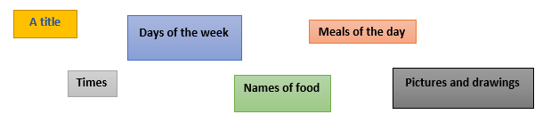
Answers:
Example:
I would include the days of the week to organize the scheme with a clear structure.
I would include meals of the day to follow a balanced diet.
I would include times for snacks and work outs.

SECTION 2: LET´S PRACTICE

5. Some people say that diets are not good for a healthy lifestyle because they cut some vital resources that our body needs. However, a balanced and well-prepared diet can be beneficial for your health. Here are three examples of balanced diets:
Omnivorous diets and tips:
- Drink fat-free, low-fat milk, or water instead of sugary drinks. We recommend at least 5 or 6 glasses of water a day.
- Eat at least five servings a day of fruits and veggies.
- Choose a variety of protein foods, like lean meat and poultry, seafood, beans, soy products, and nuts.
- Eat whole grains (like whole-wheat bread, brown rice, and oatmeal), which provide fiber to help you feel full, so you can avoid sugary snacks.
- Eat breakfast. Studies show that people who eat breakfast do better in school, tend to eat less throughout the day, and are less likely to be overweight.
- Pay attention to portion sizes.
- Limit eating out and choose smaller sizes at fast-food restaurants. Avoid supersizing even if it feels like better value.
- Don't take diet pills or supplements, stick to a diet and exercise.
Texto adaptado de https://kidshealth.org/en/teens/dieting.html#:~:text=The%20best%20way%20to%20diet,sweets%2C%20and%20other%20junk%20food.

Vegetarian diets and tips:
All vegetarians, especially individuals who don't eat any animal products, need to be sure they get enough iron, calcium, vitamin D, vitamin B12, and zinc. Here are some meals and types of food where you can get proteins if you are in a vegetarian diet:
- Omelettes made with vegetables such as asparagus, broccoli, mushroom, sweet peppers, and onions – serve with whole grain bread or toast and a glass of milk or fortified soy milk.
- Burritos or tacos made with black beans or refried beans.
- Stir fries made with tofu, vegetables, and nuts – enjoy with whole wheat couscous or brown rice.
- Salads made with leafy greens, chickpeas, nuts, vegetables, pasta, rice, couscous or quinoa.
- Falafels and hummus made with chickpeas served with whole grain pita bread and salad, sweet peppers or carrots.
- Peanut or almond butter on whole wheat or multigrain bagels with banana or apple slices- with a glass of calcium fortified orange juice.
- Soups made with lentils, beans, and vegetables – serve with whole grain bread or crackers.
- Pizza topped with vegetables.
- Vegetarian lasagna.
- Soy milk smoothies with a banana, frozen berries and a splash of orange juice.
Texto adaptado de: https://www.unlockfood.ca/en/Articles/Adolescents-teenagers/Meal-planning-for-the-vegetarian-teen.aspx

Vegan diet and tips:
- Drinking one cup of soymilk fortified with vitamin B12, calcium, and vitamin D each day can go a long way towards giving you the nutrition that might otherwise be lacking in a vegan diet. And if you were to drink two cups, you would really be covered.
- A daily supplement with vitamin B12, vitamin D, iodine, iron, and zinc is also a good idea. There are many available—you can get one at any grocery store.
- You should get some omega-3s in your daily diet. A tablespoon of canola oil or a teaspoon of flaxseed oil on some bread is a good way, and walnuts are also a good source.
- Other than that, it is important to eat yellow and green vegetables daily for vitamin A, iron, and calcium, and to eat legumes for protein, zinc, and folate.
- It is a good idea for vegetarian teens, and especially teenage girls, to make sure they eat a food that has a large amount of vitamin C with at least two meals each day, especially meals with legumes. This is because vitamin C greatly increases iron absorption of plant foods. Some foods that are high in vitamin C per typical serving are orange juice and grapefruit juice, oranges, broccoli, strawberries, grapefruit, yellow peppers, and red peppers.
Texto adaptado de: https://veganhealth.org/teens/
Now that you have read about different types of diets to have a balanced eating, let’s talk about your eating habits:
- How many days a week do you eat vegetables and fruits?
Answers may vary.
I do it every day!
- What type of vegetables do you eat?
Answers may vary.
I eat all kind of vegetables.
- Do you drink the recommended amount of water a day?
Answers may vary.
Sometimes. I also drink lemonade and some soft drinks.
- Do you pay attention to portion sizes?
Answers may vary.
No, I do not/ Yes, I do
- Do you eat grains and legumes? Yes, I do.
Answers may vary.
Yes, I do / No, I don’t
- What type of grains and legumes do you like?
Answers may vary.
I like rice and lentils.

- Why do you think pasta and bread are not mentioned in these diet tips?
Answers may vary.
Because they contain too many carbohydrates.

- Do you have any tip you would like to add?
Answers may vary.
Yes, I do. Reducing salt and sugar intake.

6. There are some countries that have a completely different eating style. For example, in Asia people eat rice with vegetables and fish soup for breakfast, and then for lunch they have a small bite or a sandwich. Answer the following questions about you:
- What is your ideal breakfast?
Answers may vary.
My ideal breakfast is juice and bread

- Do you think people should have a big meal for dinner? Why / why not?
Answers may vary.
Because eating a big meal before sleeping can affect your relaxation process.

- Would you follow the type of Asian diet mentioned above? Why / Why not?
Answers may vary.
I would not follow the Asian diet as I am used to my personal diet

- What type of food would you ban from a diet and why?
Answers may vary.
I would ban bread and fat

- What snacks would you recommend and why?
Answers may vary.
Carrots, apples and peanut butter

7. Re-read the three text about Omnivorous, vegetarian and vegan diet in exercise 5, then include key food in the following table. Keep in mind that you can repeat some food.
Answers:
Omnivorous | Vegetarian | Vegan
Answers may vary.  - Fish  - Nuts  - Seafood | - Mushrooms  - Chickpeas  - Apples | - Legumes  - Broccoli  - Strawberries

SECTION 3: LET´S CONSTRUCT AND APPLY YOUR KNOWLEDGE

8. Now it is time to apply all your knowledge about healthy eating. For this, imagine that you are asked to create a weekly diet scheme to keep your classmates healthy over a week of quarantine. Follow these steps to construct this scheme

- Add a title to your scheme
- Think about a type of diet you would like your classmates to follow (omnivorous? Vegetarian? Vegan? A mix of them?)
- Complete the scheme with food
- Add colors and some drawings to make it attractive

Answers:
TITLE: My weekly diet
 | Monday | Tuesday | Wednesday | Thursday | Friday
Breakfast | Apples and juice | Kiwi and juice | Banana and milk | Pineapple and juice | Tea, eggs and bread
Lunch | Salad and chicken | Beef and salad | Fish and salad | Legumes | Pasta and tomato sauce
Snack | Carrots and hummus | Apples and peanut butter | Nuts and a yogurt | Grapes and berries | Raising and nuts
Dinner | Salad and omelet | Salad and burger | Salad and French fries | Salad and chicken | Salad and hotdogs

EXTRA ACTIVITY:
- What about other extra tips you would like to mention? Write them down: (For example: try to work out three times weekly).
Answers may vary.
✓ Drink plenty of fluids.
✓ Practice some Mindfulness.
✓ Find time to relax.
✓ Reduce salt and sugar intake.

