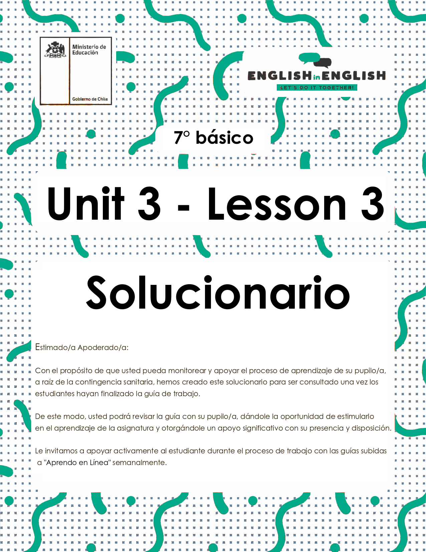
UNIT 3
LESSON 3

GUÍA PARA USAR EL SOLUCIONARIO

- ¿Qué es un solucionario?
- Un solucionario incluye las respuestas a todas las preguntas y actividades.
- Algunas de las preguntas tienen más de una posible respuesta.
- Algunas de las preguntas tienen una sola respuesta.

- ¿Cómo revisar mis respuestas?
- Encontrarás los títulos:
- Respuestas
- Respuestas abiertas

- Las respuestas pueden estar en:
- Negrita
- Subrayado
- Sombreado con colores
- Encerradas
- Destacadas
- Tachadas

- Ejemplos:

- Respuesta abierta
- Example: They are surfing internet / They are camping. / They are painting. / etc.

- Respuestas:
- Fiona plays hockey, netball, tennis and football.

SECTION 1: SETTING THE CONTEXT
Free time activities
1. Observe the images and answer.
- Observa las imágenes y responde.
1. What are the people doing?
Respuesta abierta.
Example: They are surfing internet / They are camping. / They are painting. / etc.
2. Do you like doing these activities? Why or why not?
Respuesta abierta.
Example: Yes, because I enjoy doing these activities.

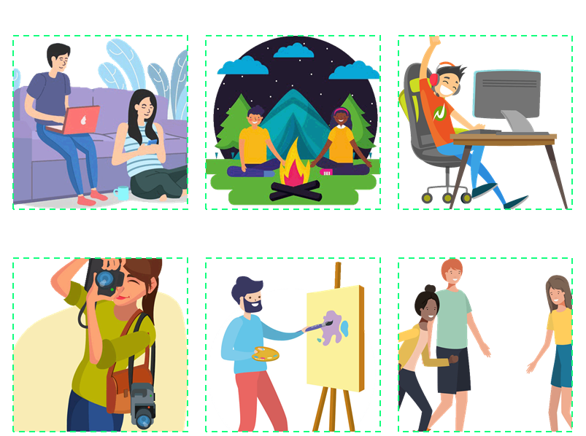

2. How many free time activities can you identify? Write them.
- ¿Cuántas actividades de tiempo libre puedes identificar? Escríbelas.

Playing video games - taking photographs - meeting friends - painting –
surfing the internet - go camping

Respuestas:
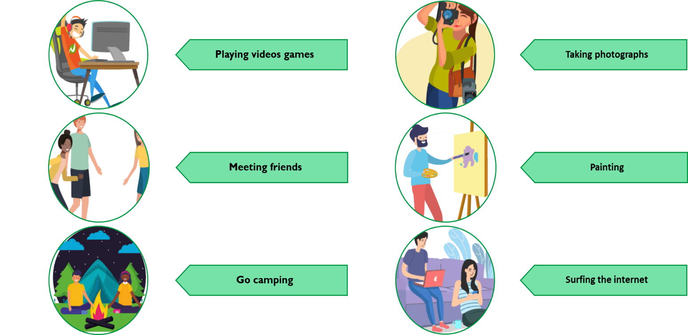

3. What do you do with your friends during your free time? Complete the organizer with activities you like to do with your friends in your free time.
- ¿Qué haces con tus amigos durante tu tiempo libre? Completa el organizador con actividades que te gusten hacer con tus amigos en tu tiempo libre.
Respuesta abierta.
Examples:

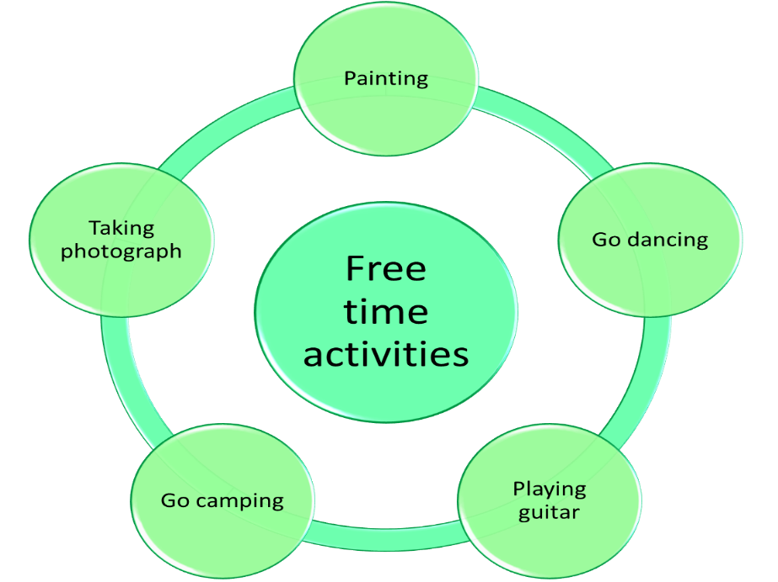

SECTION 2: LET'S PRACTICE
How do you spend your free time?
- Before reading the texts, make a list of three popular free time activities you know.
- Antes de leer los textos, haz una lista con 3 actividades de tiempo libre populares que conozcas.
Respuesta abierta.
Example:
- Playing video games
- Playing football
- Collecting cans

- Read the texts carefully.
- Lee los textos cuidadosamente.

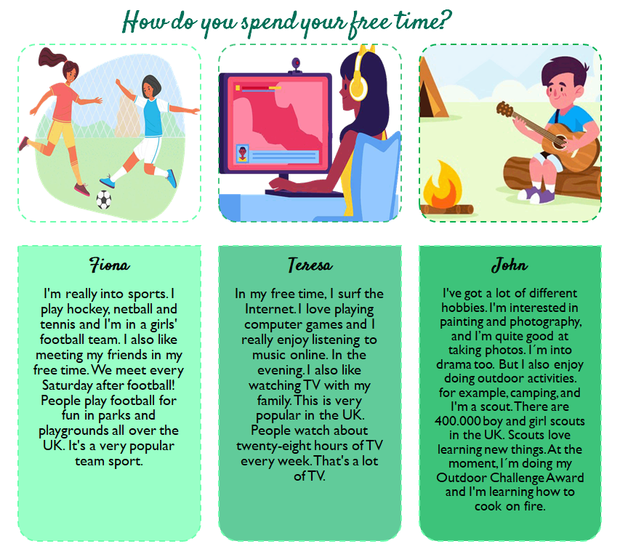

Texts taken and adapted from
https://en.islcollective.com/english-esl-worksheets/vocabulary/likes-and-dislikes/likes-and-dislikes-free-time-activities/97558

- Read the texts and complete these sentences.
- Lee los textos y completa estas oraciones.
Respuestas:
- Fiona plays hockey, netball, tennis and football.
- In Fiona's free time she also likes meeting her friends.
- John is a scout.
- John has lots of different hobbies.
- John is good at taking picture, but he also enjoys doing outdoor activities.
- Teresa enjoys listening to music online and watching TV with her family.

- Complete the table with information from the texts.
- Completa la tabla con información de los textos.
Respuestas:
Person | Free time activities
Fiona | - Playing football  - Meeting friends
Teresa | - Surfing the internet  - Playing computer games online  - Listening to music online
John | - Painting  - Photography
SECTION 3: LET´S CONSTRUCT AND APPLY OUR KNOWLEDGE
In my free time, I...

- Write the free time activity according to the description.
- Escribe la actividad de tiempo libre de acuerdo con la descripción.

Playing video games - Collecting shells - Play guitar -
Go camping - Go dancing - Listening to music - Painting - Photography

Respuestas:

Free Time Activity | Description
Go camping | James needs a tent and sleeping bag.
Playing video games | Teresa needs a computer and joystick.
Collecting shells | I go to the beach to look for them.
Listening to music | My sister likes pop music.
Photography | You need a camera or a cell phone.
Go dancing | Fiona and her friends like K-Pop choreography.
Painting | Mike likes to use many colors.
Play guitar | John needs a musical instrument.

- Complete the table with the information from the boxes and write a sentence using the information from the table.
- Completa la tabla con la información desde los cuadros y escribe una oración usando la información de la tabla.

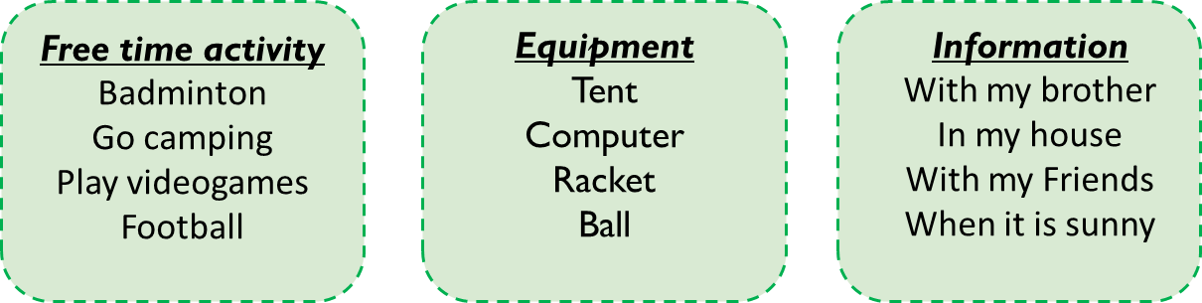
Respuestas:
Example:
Information / Day | Saturday | Tuesday | Wednesday | Friday
Equipment | tent | computer | ball | racket
Free time activity | go camping | play video games | football | badminton
Other information | when it is sunny | with my brother | with my friends | in my house

Respuestas abiertas.
Examples: * On Saturday, I use my tent to go camping when it is sunny.

1. On Tuesday, I use the computer to play video games with my brother.

2. On Wednesday, I use the ball to play football with my friends.

3. On Friday, I use the racket to play badminton in my house

- Choose a free time activity and write a paragraph using the information from previous activities and from the example.
- Elige una actividad de tiempo libre y escribe un párrafo usando la información de las actividades anteriores y el ejemplo.

Respuesta abierta.

Example:
Gina  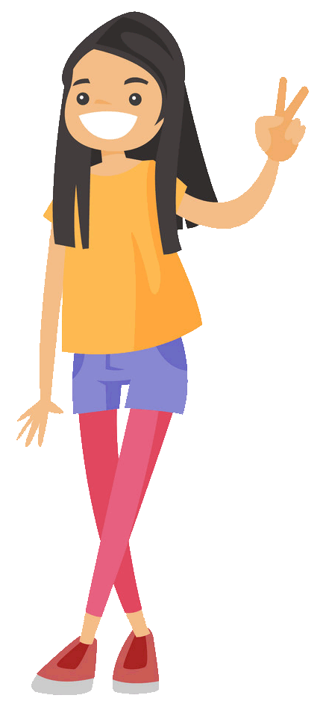 | “My name is Gina, I´m 13 years old.  In my free time, I play basketball with my friends on Tuesdays and Thursdays.  I collect postcards, I have 230 postcards.  On Saturday with my sister we like to dance at home and listen to pop music.”

Your name  ……………………………….  Image | - My name is...  - I´m...  - In my free time I...  - I collect...  - I like...  …………………………….…………………………. …………………………………………………….….  …………………………………….………………….  …………………………………………….………….  ……………………………………………..…………

SECTION 4: EXTRA ACTIVITY
Getting to know you
1. Ask your friends (4) the following questions, then write a short report according to the answers you got.
- Haz las siguientes preguntas a 4 amigos/as, luego escribe un breve reporte de acuerdo a las respuestas obtenidas.
Respuestas abiertas.
Examples:

Questions |  |  | friend 1 | friend 2 | friend  3 | friend 4
- Do you practice sports? |  |  |  | x | x | x
- Do you prefer outdoor activities? |  |  |  | x | x | x
- Do you enjoy reading fiction or non-fiction books? |  |  |  |  | x
- Do you like to spend time with your family and friends? |  |  | x | x | x
- Do you spend more than 2 hours doing your free time activities? |  |  |  |  | x | x
- Do you like to do housework? |  |  | x | x
 | Example: Report | Report
- Most of my friends practice sports.
- 3 of my friends prefer outdoor activities.
- 1 of my friends enjoys reading books.
- Most of my friends spend time with their families and friends.
- 2 of my friends spend more than 2 hours doing free time activities.
- A few of my friends like to do housework.

Few of my friends: algunos de mis amigos.
Most of my friends: la mayoría de mis amigos.
SECTION 5:
Digital Resources
Take a look at these links!
- https://learnenglishkids.britishcouncil.org/word-games/free-time-1
- https://learnenglishkids.britishcouncil.org/word-games/free-time-2

NO OLVIDAR REPASAR EL CONTENIDO CON UN ADULTO

