UNIT 4
LESSON 1

ÚTILES RECOMENDADOS:
- Texto del estudiante 7° básico.
- Cuaderno de inglés o 2 hojas en blanco.
- Lápiz grafito y goma.
- Diccionario de Inglés físico / online https://dictionary.cambridge.org/es/diccionario/espanol-ingles/

SECTION 1: SETTING THE CONTEXT
The Environment

- Answer the following questions.
- Responde las siguientes preguntas.

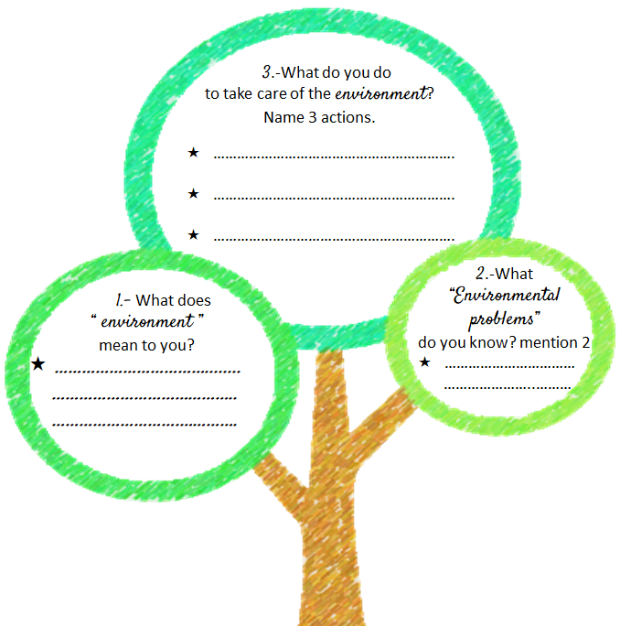

- Write the correct word or concept below the image.
- Escribe la palabra o el concepto correcto debajo de la imagen.

- environment B. global issues C. save the planet
D. carbon emission E. rising sea levels F. global warming
G. flood H. pollution I. greenhouse effect

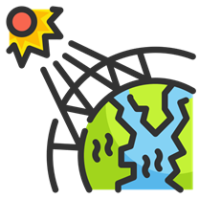 | 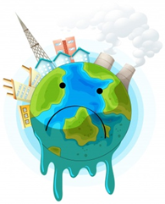 | 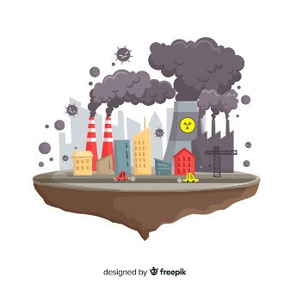
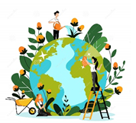 | 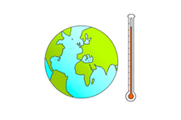 | 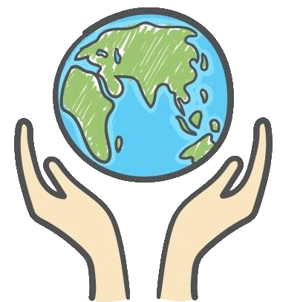
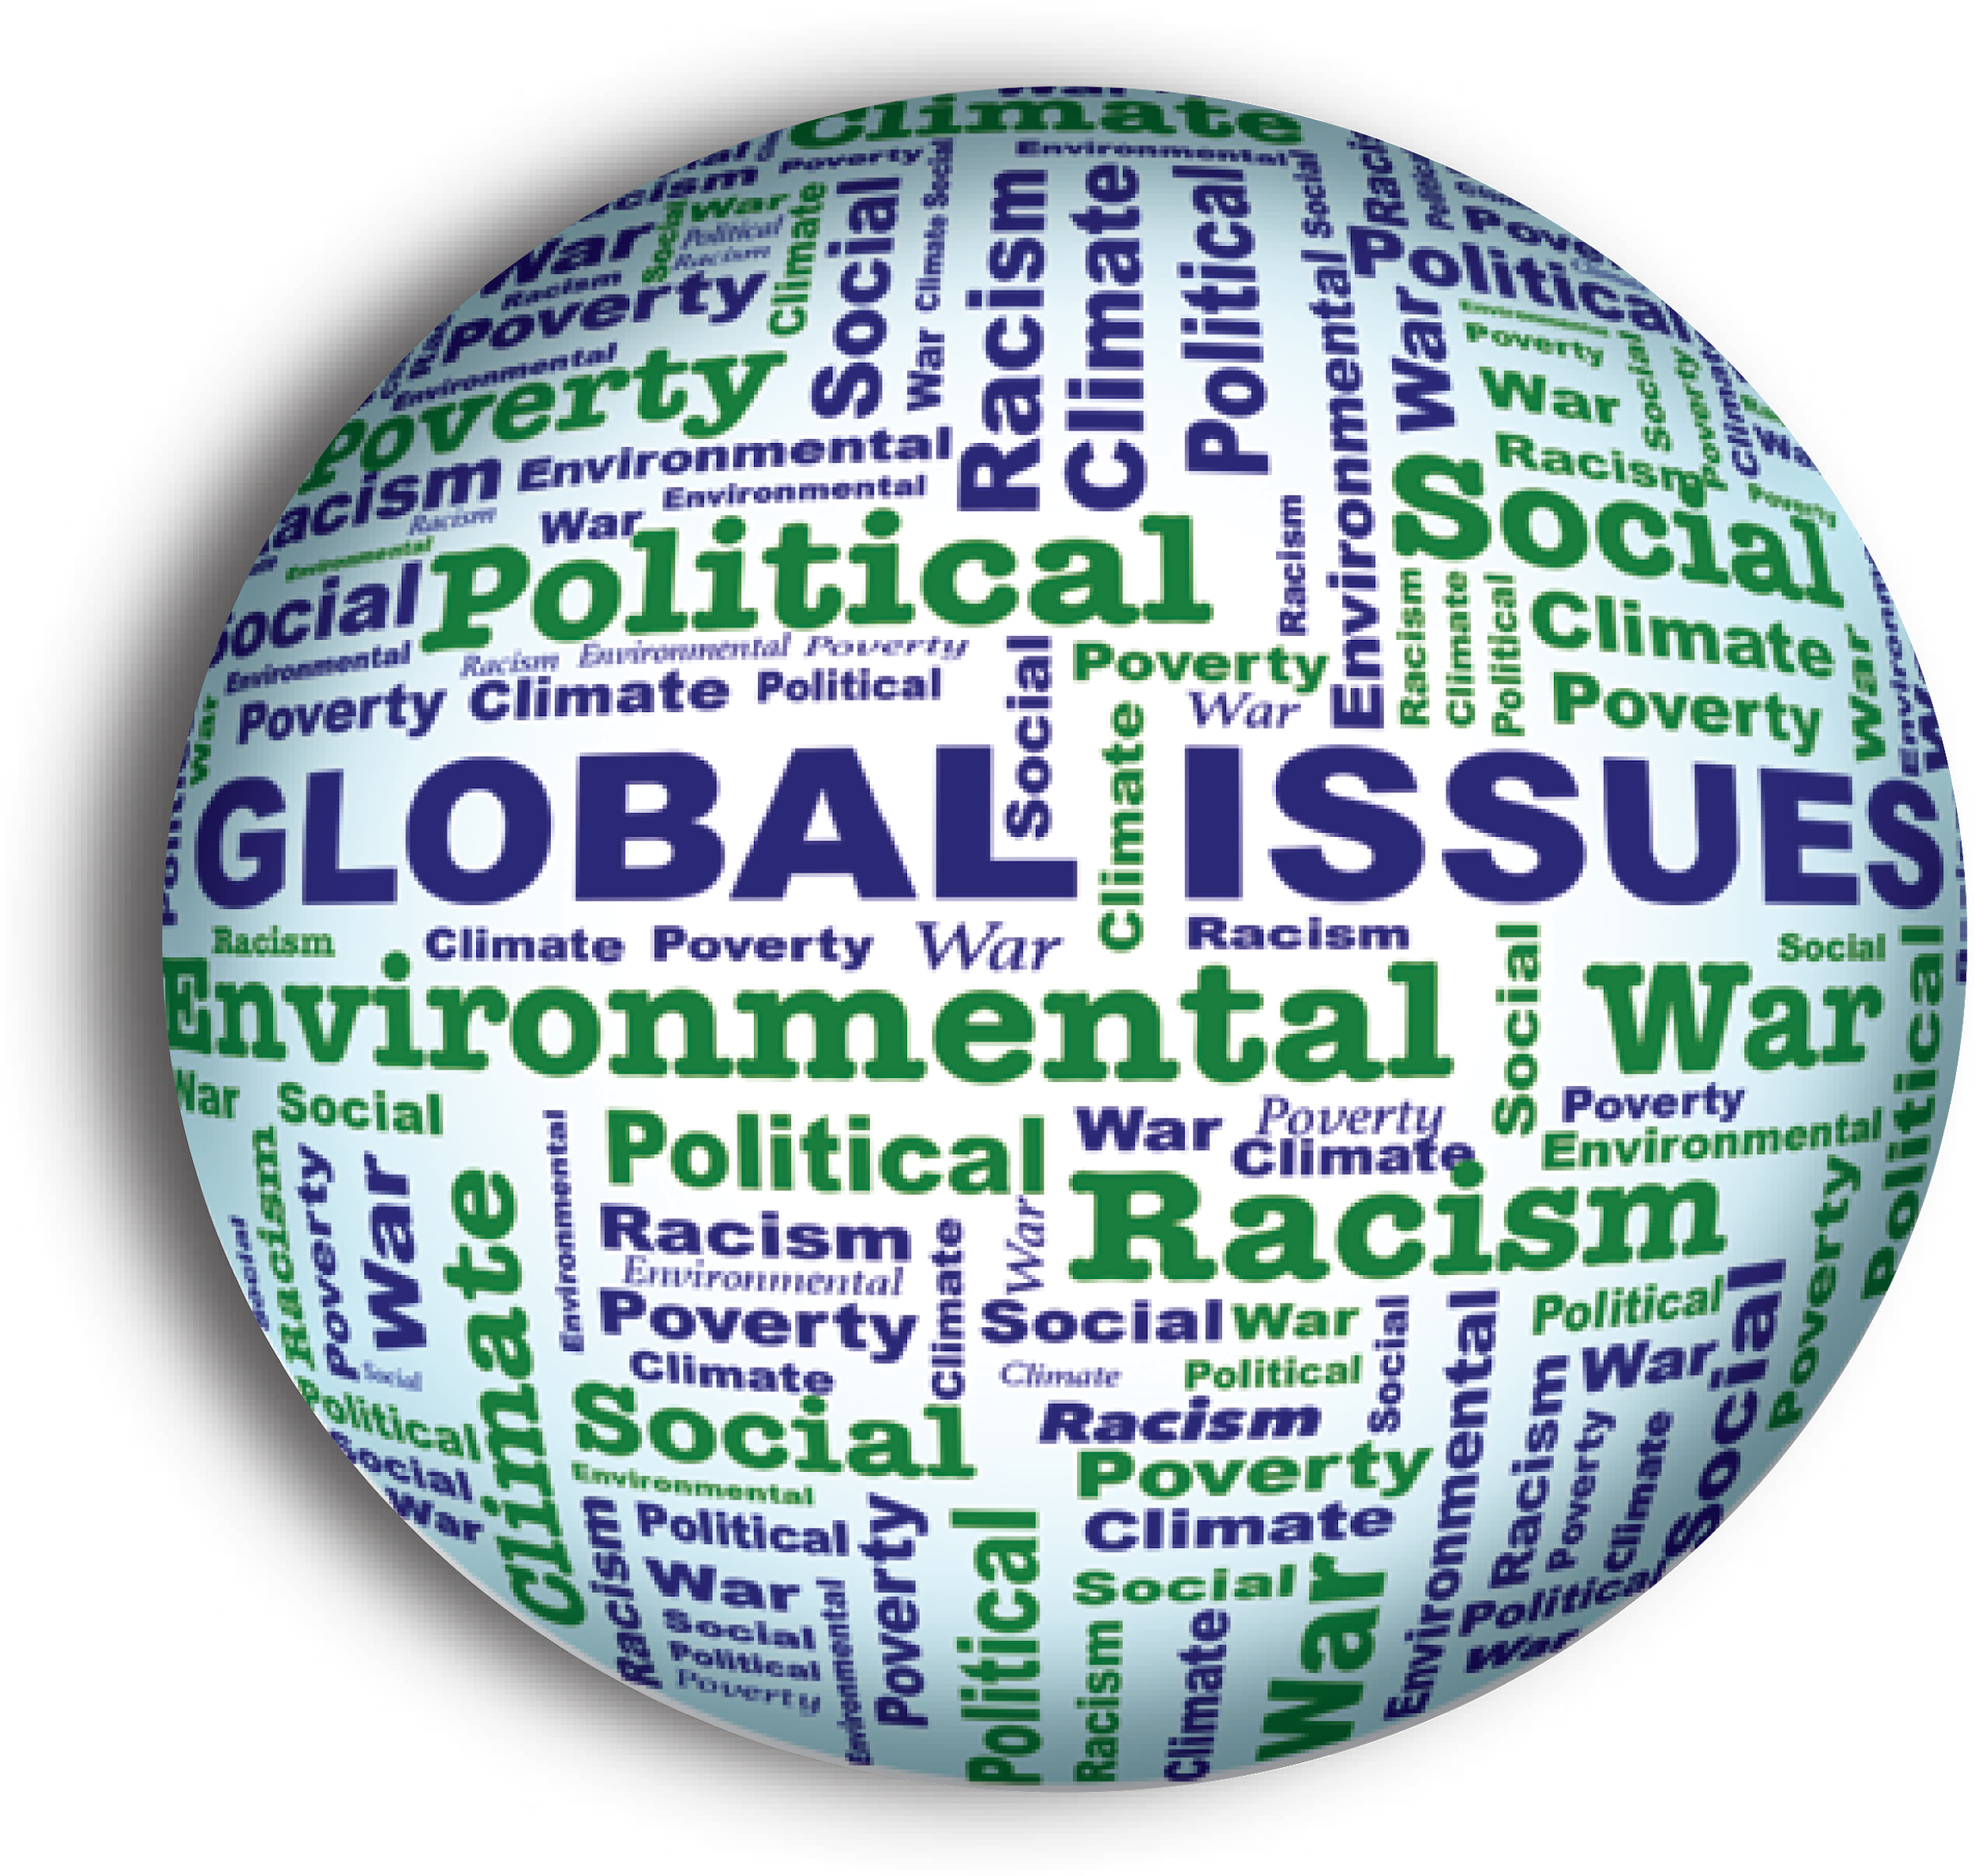 | 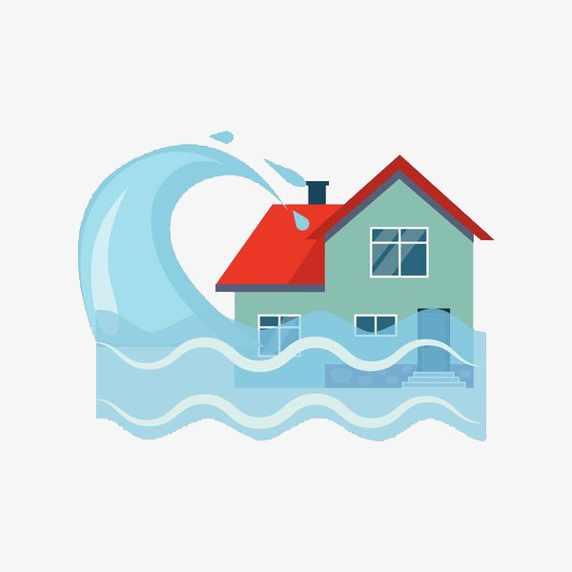 | 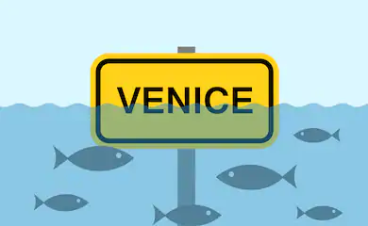

3. Read the definitions and write the corresponding word or concept from exercise 2.
- Lee las definiciones y escribe la palabra o concepto correspondiente del ejercicio 2.
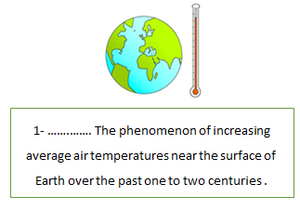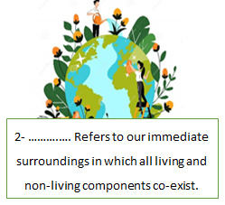
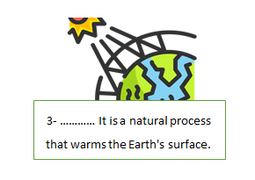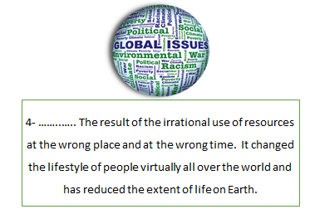
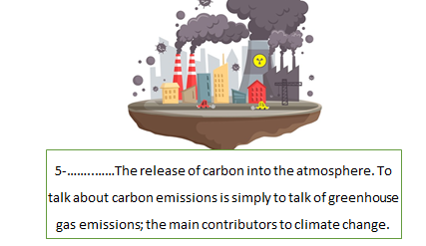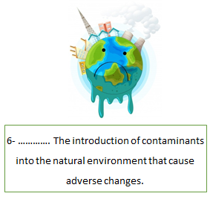
SECTION 2: LET'S PRACTICE
Climate crisis on sports

1. Before reading the text, write words and/or concepts you associate with climate change.
- Antes de leer el texto, escribe palabras y/o conceptos que asocias con cambio climático.

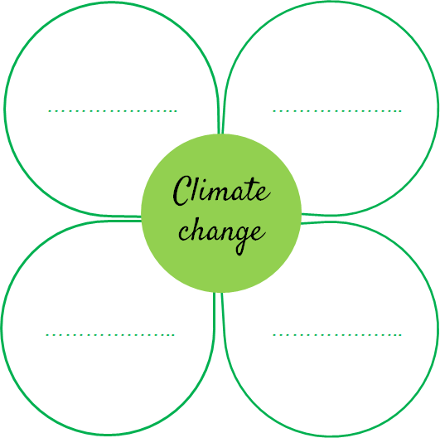

2. Read the text.
- Lee el texto.
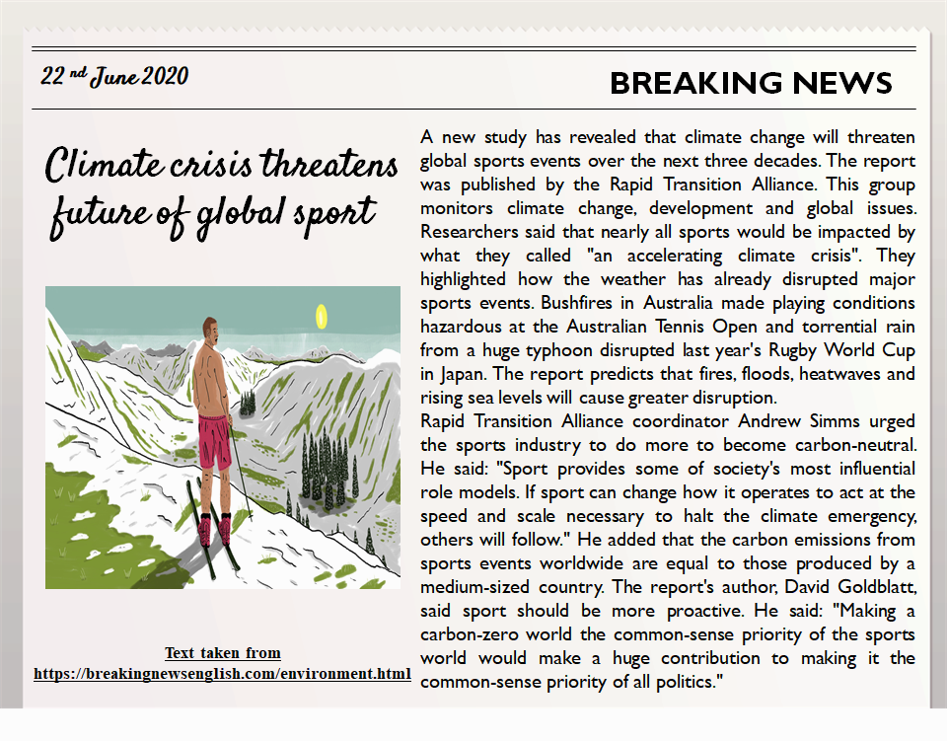

Vocabulary words
threaten: amenaza - disrupted: alterado - heat waves: olas de calor - to halt: detener

- Read the text carefully and underline the correct word.
- Lee el texto cuidadosamente y subraya la palabra correcta.

- Bushfires/climate change/sports industry will endanger sports events in the next 30 years.

- A report into sports/food/school events was published by Rapid Transition Alliance.

- Floods and heatwaves/rains and floods/typhoons and bushfires will cause greater disruption in sports.

- Sports create as much as carbon emissions/climate change/carbon neutral as a medium-sized country.

- Making a climate-zero/global issue /carbon-zero world of sports will be a huge contribution.

- Put the letters in the correct order according to the text.
- Pon las letras en el orden correcto de acuerdo al texto.

- What they called an accelerating ecltami crisis.
- Torrential nria from a huge ntyopho.
- Rginsi sea levels will cause greater disruption.
- Do more to become carbon-autnrle.
- Carbon ssoenimis.

SECTION 3: LET´S CONSTRUCT AND APPLY OUR KNOWLEDGE
Save the planet

1. Observe the image and choose 5 words or concepts, write them in the box
and then create a simple sentence with them.
- Observa la imagen y elige 5 palabras o conceptos, escríbelas/os en el cuadro y luego crea una oración simple.

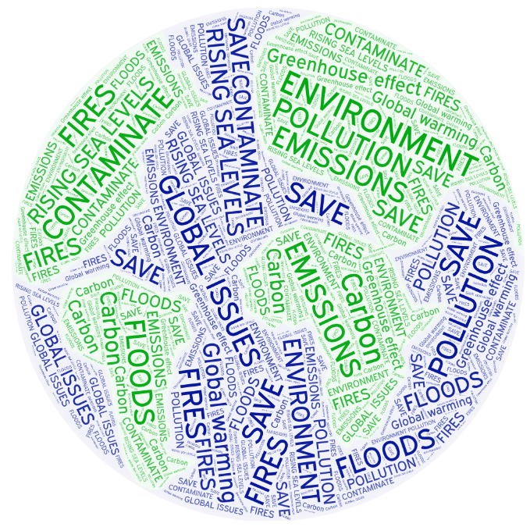

Word:  Save | Sentence:  I recycle to save the planet.

Word nº1:  ____________ | Sentence:  ____________________________

Word nº2  ____________ | Sentence:  ____________________________

Word nº3:  ____________ | Sentence:  ____________________________

Word nº4:  ____________ | Sentence:  ____________________________

Word nº5:  ____________ | Sentence:  ____________________________

2. Recognize the concepts and write 3 associated words for each one.
- Reconoce los conceptos y escribe 3 palabras asociadas a cada uno.
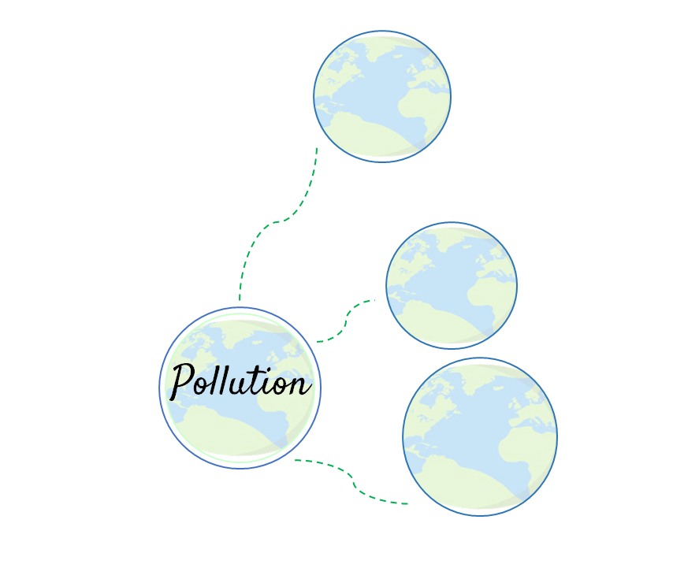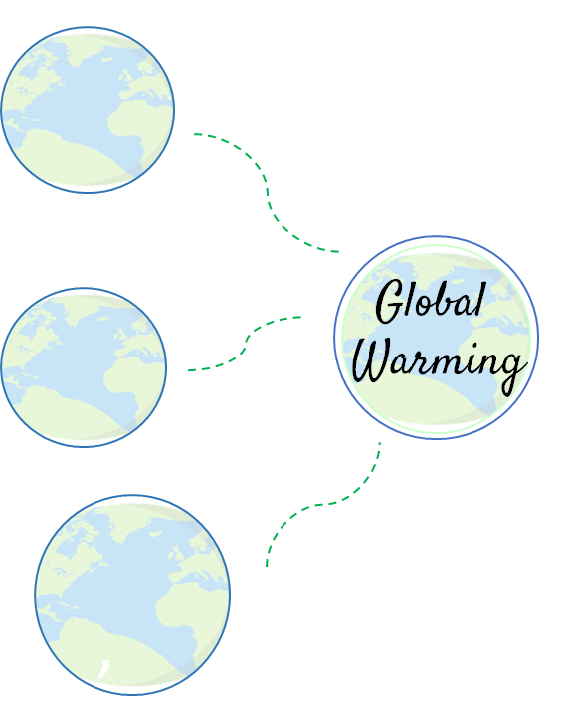

3. Choose a word or concept related to the environment and make a graffiti.
- Elige una palabra o concepto relacionado con el medio ambiente y haz un graffiti.
Examples:
Global warming Destroying the environment
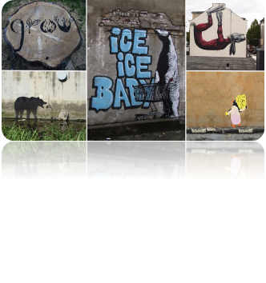
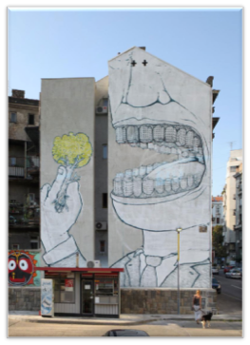

- tps://www.awesomeinventions.com/street-art-with-environmental-messages/
- http://josephminapelc.blogspot.com/2017/03/tow-24-urbanization-is-killing-us.html

Your concept: _________________________________________________________

Your graffiti:

SECTION 4: EXTRA ACTIVITY
The effects of Global Warming

1. Think about the effects that “global warming” is causing to our planet. Choose one image that represents it and write down the problem.
- Piensa sobre los efectos que el “calentamiento global” está causando a nuestro planeta. Elige una imagen que lo represente y escribe el problema.

Examples:
“Global warming is affecting polar bears”. | Example of the problem
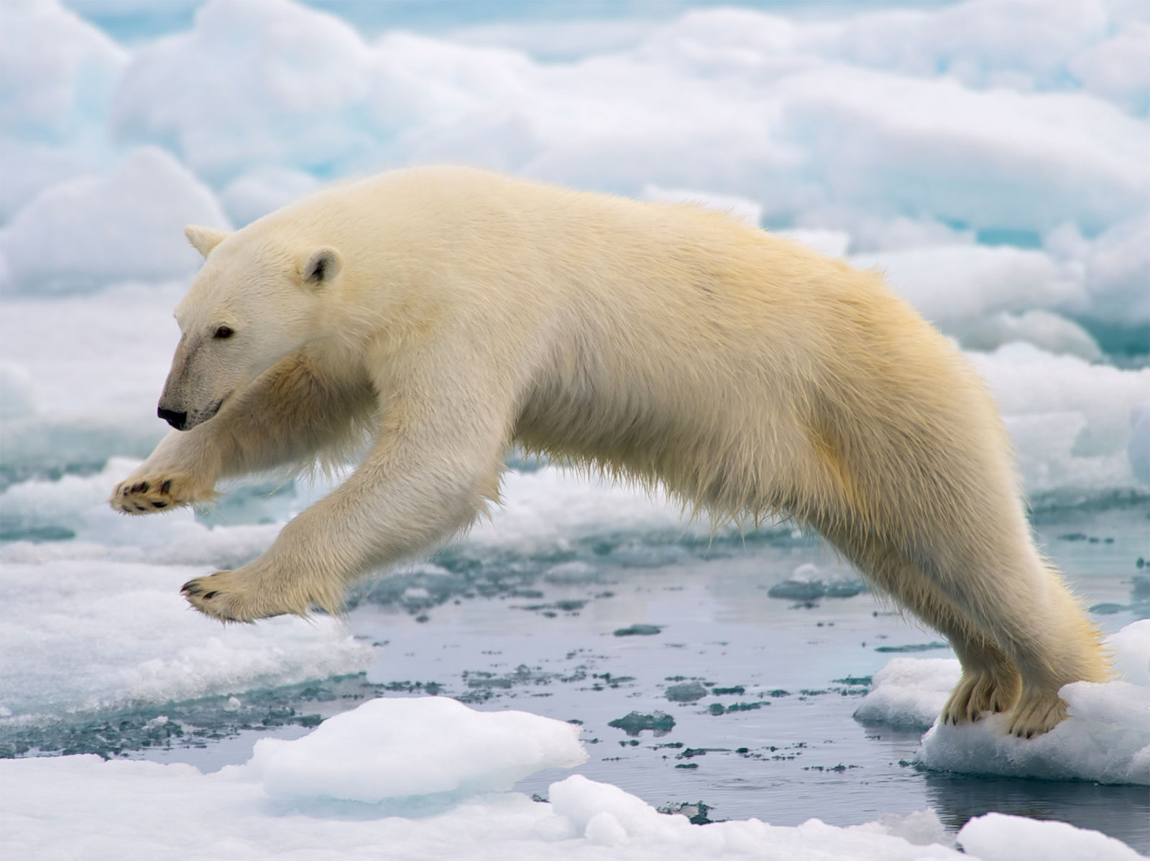 | Problem:  Less sea ice means polar bears have less space to hunt and to mate.

SECTION 5:
Digital Resources
Take a look at these links!
- https://learnenglishkids.britishcouncil.org/word-games/environment
- https://www.nationalgeographic.org/education/
- https://www.nationalgeographic.org/education/resource-library/?q=&page=1&per_page=25&subjects=Conservation
- https://kids.britannica.com/kids/article/environment/399445

NO OLVIDAR REPASAR EL CONTENIDO CON UN ADULTO

