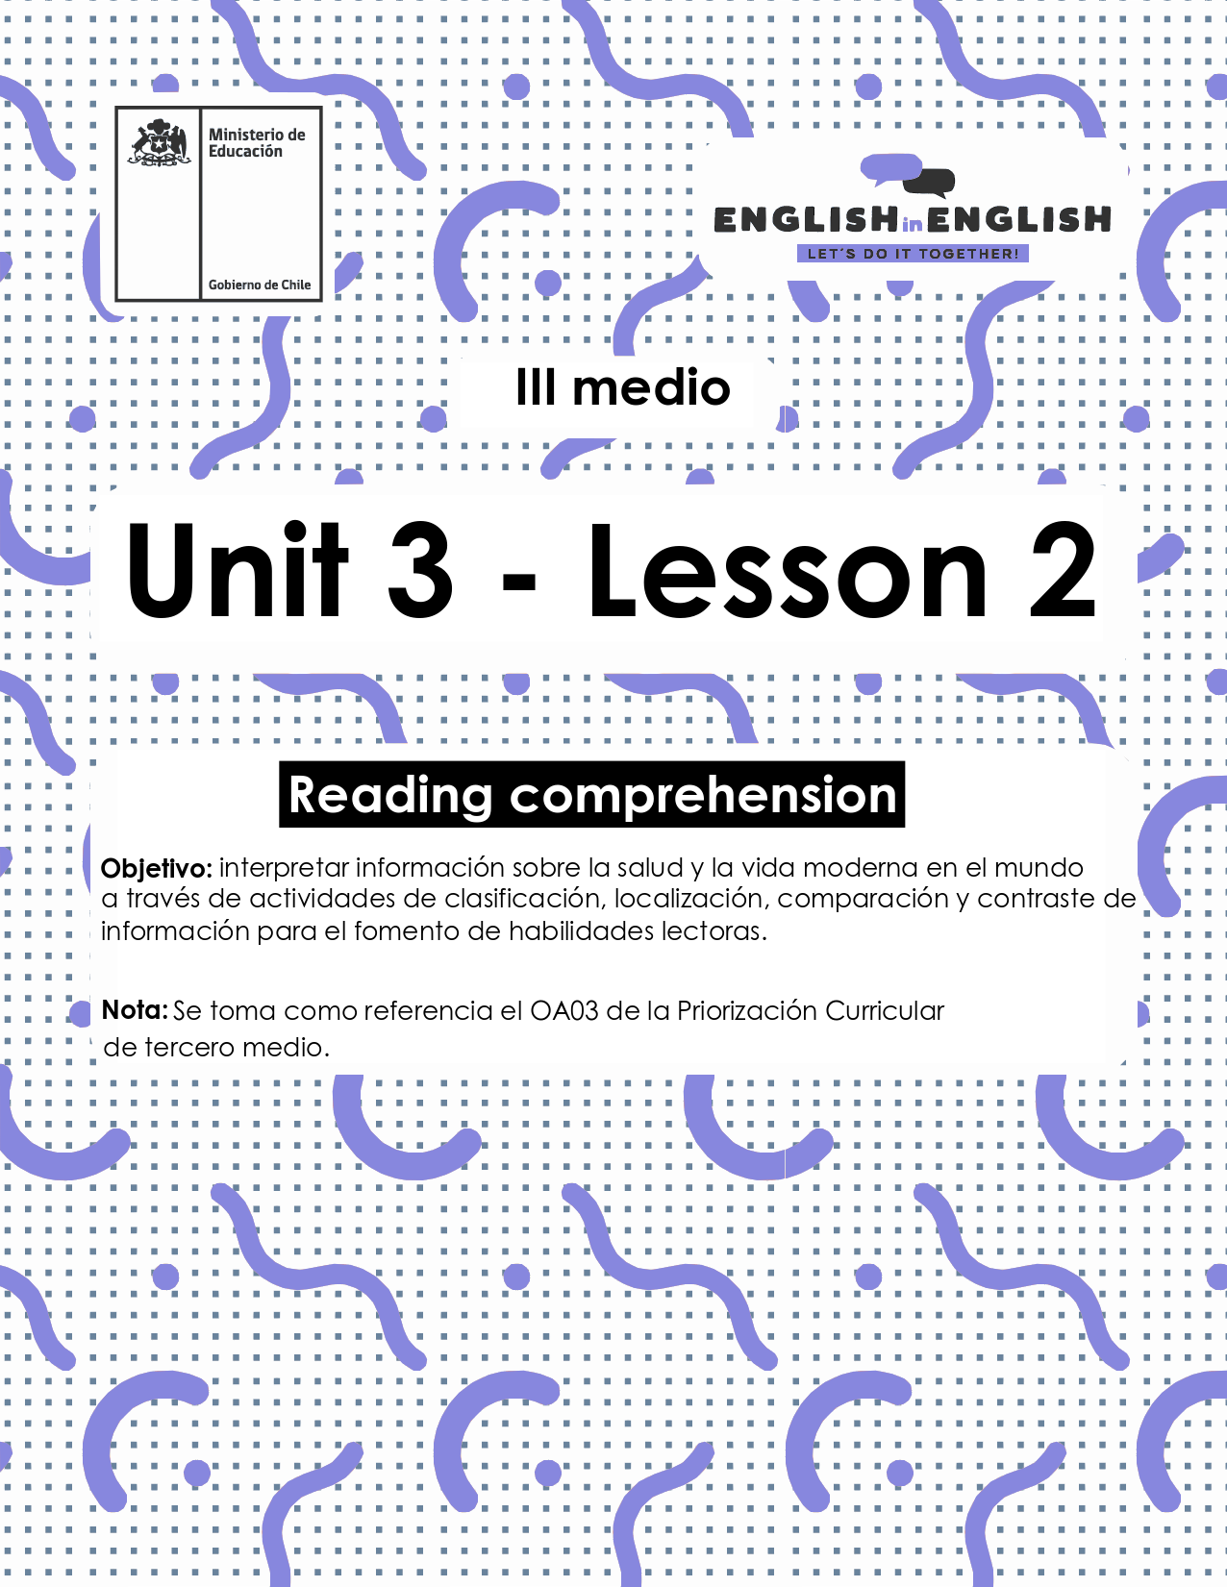

UNIT 3
LESSON 2

ÚTILES

- Texto del estudiante de 3° medio.
- Diccionario de inglés.
- Lápices.
- Cuaderno de asignatura.

ICONS FOR ACTIONS

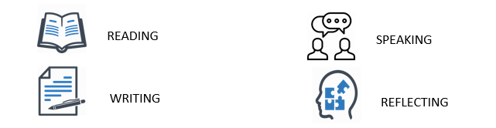

SECTION 1: SETTING THE CONTEXT:

Hello students! welcome back to lesson 2. In this lesson we will rehearse our reading comprehension skills. let´s start our work thinking about physical and mental health.
- Look at the picture and answer the following questions.
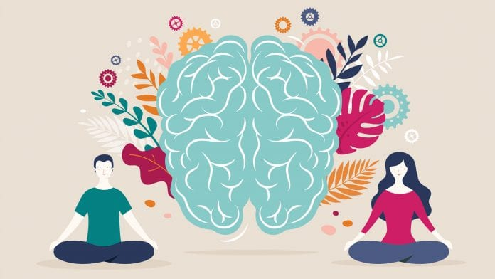
- What do you know about physical and mental health? Remember that you can use the previous worksheet as help:

- Do you agree with practices like meditation? Please explain:
.

- What do you know about natural medicine?

- Is it ok to self-medicate instead of going to the doctor? Do you agree or disagree with that? Please explain:

- Look at the word cloud about mental health and write down three key words that call your attention and explain why:
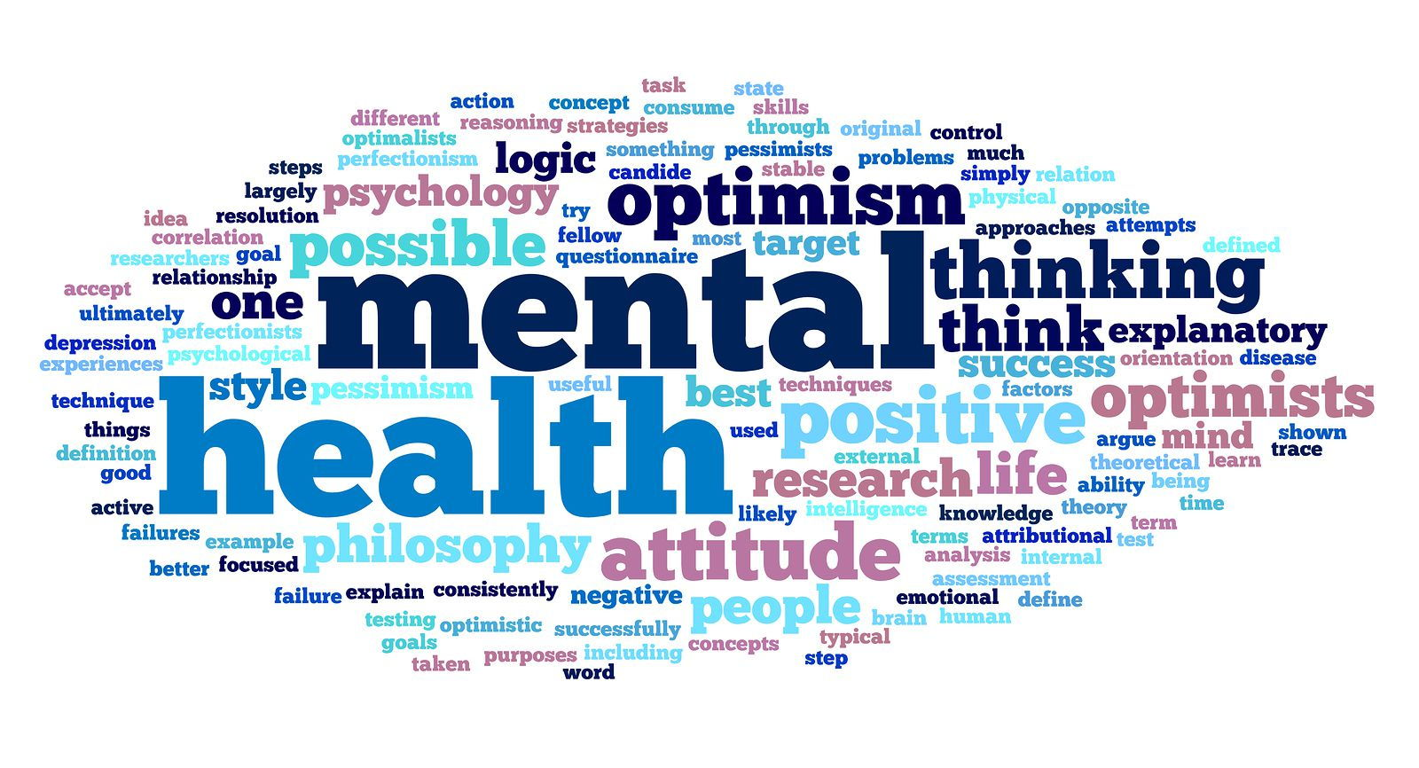
EXAMPLE:
KEY WORD: ACTIVE EXPLAIN WHY? BECAUSE MENTAL HEALTH IS ABOUT FEELING BETTER AND BEING ACTIVE IN YOUR MIND AND BODY.
Key word 1: ______EXPLAIN WHY? _________________________________________ ______________________________________________________________________________________________________________________________________________________
Key word 2: ___________EXPLAIN WHY? ______________________________________________________________________________________________________________________________________________________
Key word 3: ___________EXPLAIN WHY? ___________________________________________________________________________

- Good job! What about lifestyle behaviours and health? Read the following statements and classify them into physical (P) or mental (M) health ones.

Statements | P or M?
Take time for daily spiritual renewal.
Increasing life satisfaction.
Cultural or recreative activities.
Get adequate rest daily.
Choose healthy fats.

SECTION 2: LET´S PRACTICE
When talking about personal well-being and the importance of staying healthy, every person decides the way him or her will take care of themselves.
- read the following paragraphs and circle the correct alternative. Pay special attention to the words in bold.
Claudia, a college student says: “I always take good care of myself. I am vegetarian since I was 14 years old. I love eating chia, pomegranate, avocado and fresh fruit. I frequently exercise in the evenings, after high school. I disagree with eating food like meat, poultry or by-products of animal slaughter. Why? Because I am an animal lover, and when I learnt how animals raised for food are treated in life and death, that convinced me to stop eating meat... I won´t definitely eat meat again”
Claudia is vegetarian because...
a. She loves eating chia, pomegranate, avocado and fresh fruit.
b. She did it for medical reasons.
c. She loves animals and disagrees with the way and reasons they are raised and killed.

Benjamin, a 24-year-old student says; “I am a real fitness freak. Why? For me, staying in shape and exercising is what I enjoy the most. Going to the gym every day is part of the things I routinely do, and I cannot imagine not starting my day without doing sit-ups or lift weights. Since I started this workout routine, I feel strong and healthy. If you exercise regularly, you will easily lose weight, define and develop your muscles.”  Why does Benjamin say he is a real fitness freak? Because...  a. He thinks that not going to the gym every day is a healthy routine.  b. He agrees with the idea of staying in shape, losing weight, developing and defining his muscles.  c. At the gym, he only does sit-ups and lift weights. | 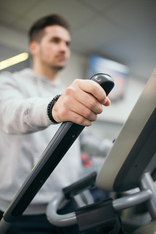

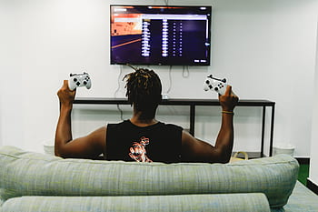 | Francisco, a seller, says “I have never agreed with the idea of dieting or exercising. I am what people call a “couch potato”. I generally spend my time watching television and videos. I will never become and athlete. I will never give up to chocolates, junk food or sugar drinks. This will probably harm my health, but I will always be happy with my lifestyle.”  Francisco considers himself as a “couch potato” since...  a. He realizes he just wants to go on with his lifestyle.  b. He knows his lifestyle is harmless.  c. He is thinking of giving up on high calorie foods.
Source: original texts.

- Read and study the following grammar cloud then find 8 adverbs in the word search. HINT: these adverbs also appear and following text.
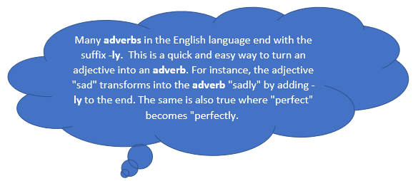
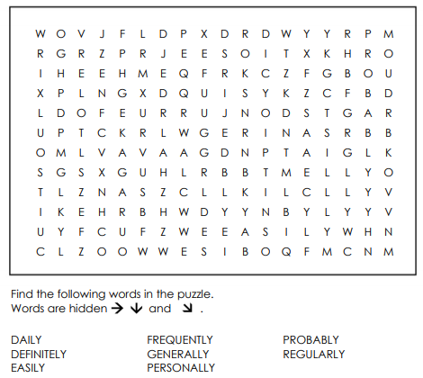

- Complete the following sentences using one of the adverbs from the previous activity. Sometimes more than one answer may be correct:
A) My parents avoid taking pills for small headaches, they say that sleeping and relaxing ________help with the ache, and I think it’s true; it works every time!
B) I _________ prefer exercising in the morning, as soon as I get up from bed.
C) My best friend and I _________ go to yoga classes and we like it better than going to the gym.
D) I know my body very well, so I can ____________ say when I need more sleep time or more free time to do activities that I like so I can relax.

SECTION 3: LET´S CONSTRUCT AND APPLY YOUR KNOWLEDGE
- Read Pedro´s experience and opinion about meditation, mindfulness and self-medicine and answer the following questions.
I love meditation because it has greatly improved my life. I began my meditation practices two years ago, after I had a panic attack in the Metro of Santiago. I started with Yoga and brain gymnastics, which are exercises that I had to do daily. Now I feel more relaxed and I am positive about my future. I personally believe that meditation can be complemented with natural therapy and common medicine, however I consider that that self-medication is too dangerous, so whenever something similar happens to my friends, I tell them that they to go to the doctor, especially now that we are not seeing each other frequently.

- What does Pedro think about meditation?
______________________________________________________________________
- when did he have to do his brain gymnastics?
______________________________________________________________________
- What is his belief about self-medication?
______________________________________________________________________
- Why do you think Pedro is not seeing his friends now?
______________________________________________________________________

- Thinking about today’s topic (Physical and Mental health) create an infographic or tryptic to give advice to your friends about how to keep a good mental and physical state during quarantine.

- To begin with the project, write down some of the advices presented in the readings from the worksheet. For example, “Drink water and avoid coffee”:
1._______________________________________________________
2. ______________________________________________________
3._______________________________________________________

- Finally, add some adverbs to make them more suitable for the format! For example: “Drink water regularly and avoid coffee”
1._______________________________________________________
2. ______________________________________________________
3._______________________________________________________
