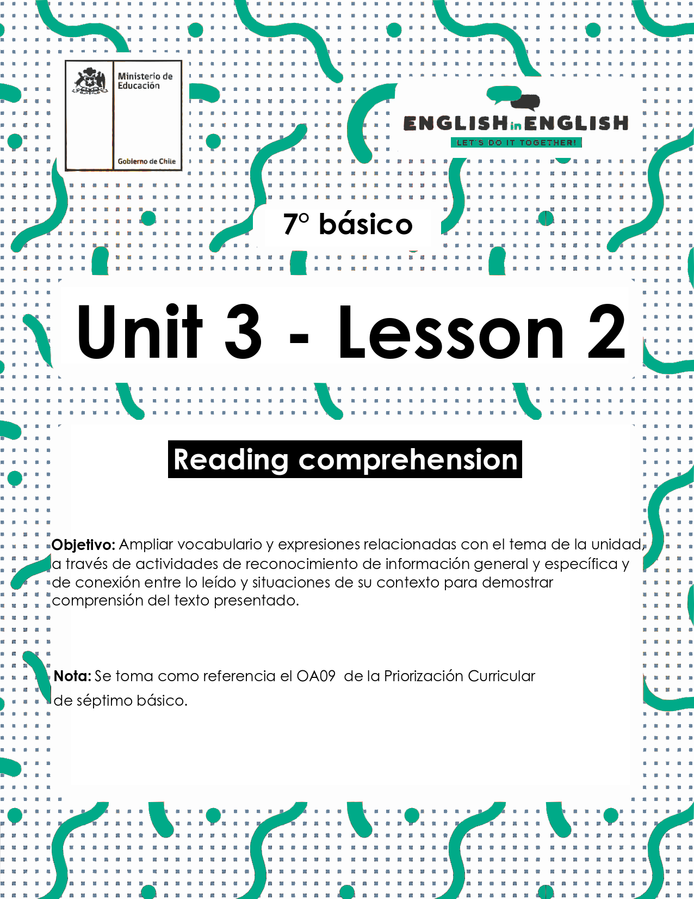
UNIT 3
LESSON 2

ÚTILES RECOMENDADOS:
- Texto del estudiante 7° básico.
- Cuaderno de inglés o 2 hojas en blanco.
- Lápiz grafito y goma.
- Diccionario de Inglés físico / online https://dictionary.cambridge.org/es/diccionario/espanol-ingles/

SECTION 1: SETTING THE CONTEXT
Sports
1. Observe the images and write the corresponding sport.
- Observa las imágenes y escribe el deporte correspondiente.

Snowboarding - gymnastics - weightlifting - football - basketball athletics - swimming - tennis

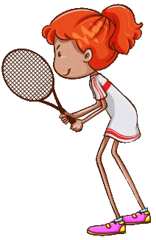 | 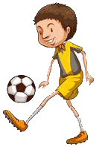 | 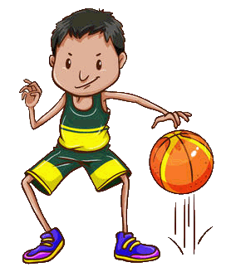 | 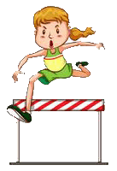
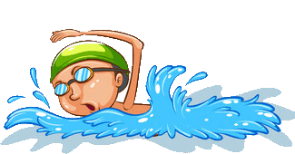 |  | 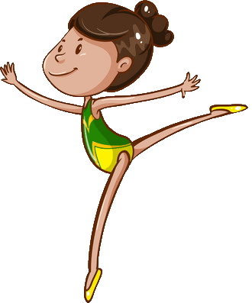 | 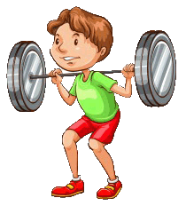

2. Observe the images and match them with the corresponding statement. Follow the example.
- Observa las imágenes y relaciónalas con la afirmación correspondiente. Sigue el ejemplo.

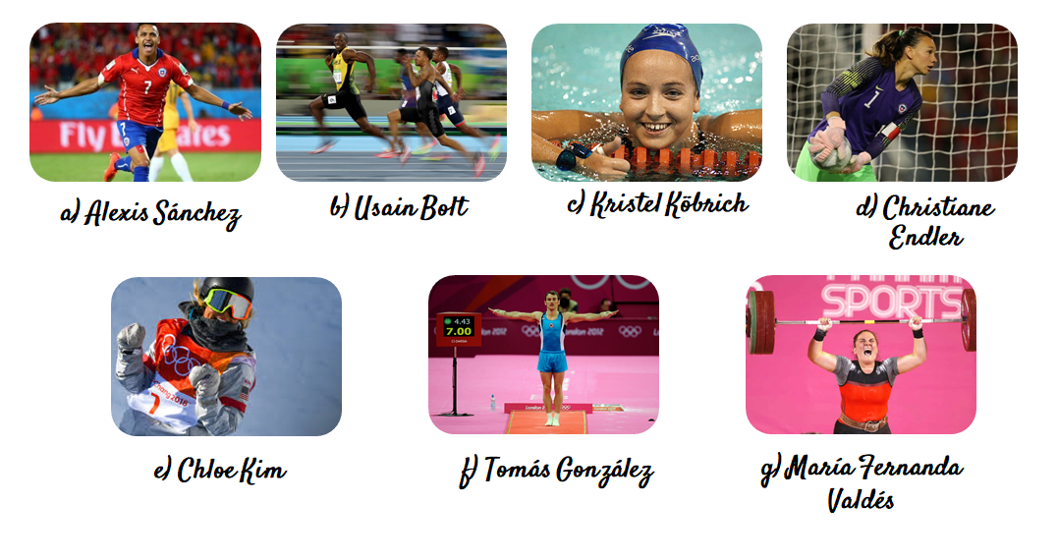
_a_ scored the winning goal at Copa America 2015.
......She was the first Chilean swimmer to get a medal at Panamerican Games 2003.
….. He finished fourth on the floor and vault finals, at the 2012 Summer Olympics.
..…. In 2017, the Chilean Olympic committee named her the best sportswoman of the year.
..…. She was chosen by the French football federation as the best goalkeeper of the season 2018-2019.
…... He broke records throughout his whole running career.
…... She won an Olympic gold medal at the age of 17.
3. Who is he? Observe the image and complete.
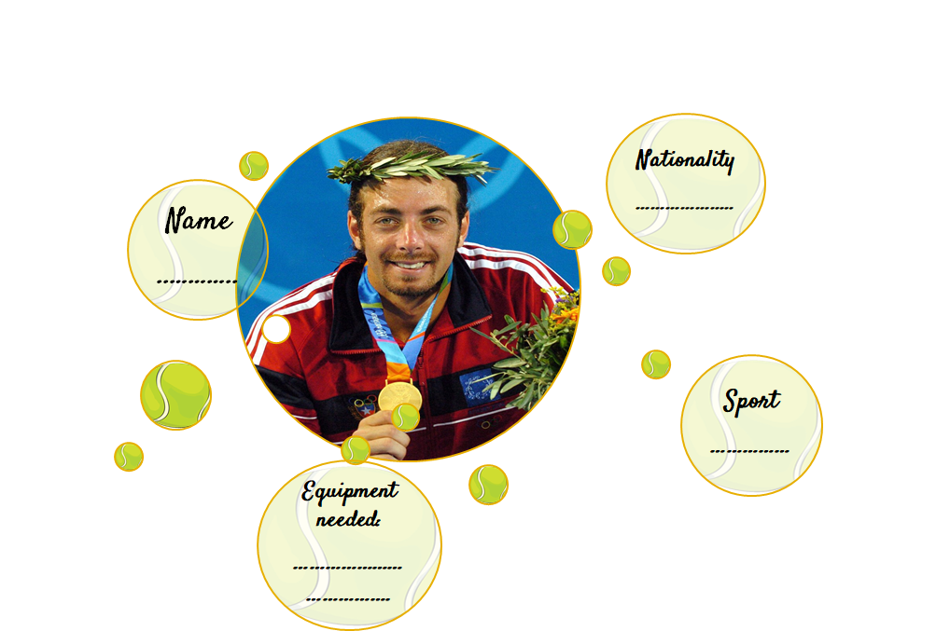
- ¿Quién es él? Observa la imagen y completa.

4. Observe these 2 events. What do they represent? Choose A or B.
- Observa estos 2 eventos. ¿Qué representan? Elige A o B.
- Alexis Sánchez scored the winning goal at Copa América 2015.
- Erika Olivera participated in 5 Olympic marathons in history.
- present actions? B) past actions?

SECTION 2: LET'S PRACTICE
A popular sport
- Before reading the text, answer.
- Antes de leer el texto, responde.

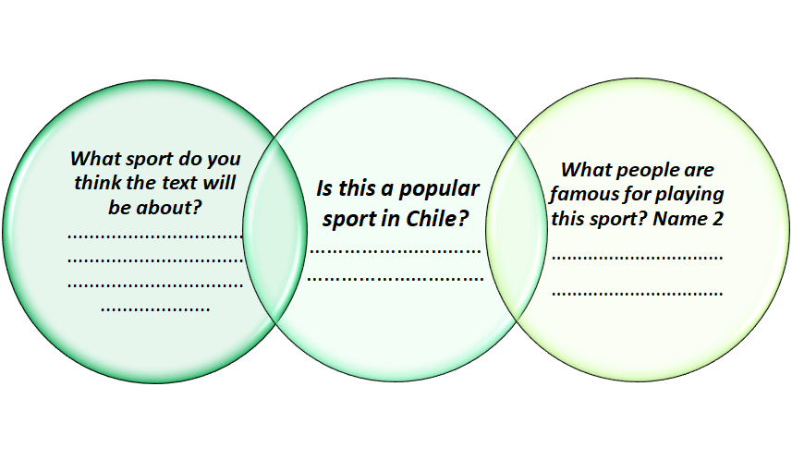

- Read the text and find 1 action in the past. Write it.
- Lee el texto y encuentra 1 acción en pasado. Escríbela.

- ……………………………………………………………………

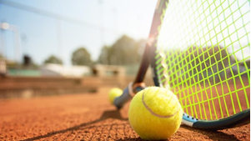
Tennis is one of the oldest sports in the world. The name 'tennis' is said to have come from the French expression 'tennis' which means take. The player preparing to serve the ball usually called out this word to the receiver at the other end of the court. Tennis started off as an indoor game called court or royal tennis, which used to be played by French and English royalty. It was only in 1873 that 'lawn tennis' (which is popularly played today) was introduced by a British army officer, Major Walter Winfield. Lawn tennis was first played on a court shaped like an hour-glass and divided by a high hung net. It required speed, agility and a great deal of accuracy in hitting the ball. It soon became popular with the English young people.
Shortly after lawn tennis was introduced in Britain, an English officer who was sent on duty to Bermuda took a long supply of balls and rackets. The game became popular, there too. At that time an American girl by the name of Mary Erwin Outerbridge happened to be visiting the island. When she saw the game of tennis being played, she became very enthusiastic about it. Before returning home to New York, she purchased a few rackets and balls and took them with her.
Miss Outerbridge had hoped to interest her friends in the new game, but the other girls did not take to it first. They feared it was not very lady like to leap and dash about the court. However, the boys, especially her brothers enjoyed it tremendously. Gradually, tennis spread throughout United States and Canada.
In 1877, the first lawn tennis championship matches were held at the old Wimbledon grounds near London. A few changes were made in the game during the championship. The court was no longer hour-glass shaped but was rectangular. The net was lowered, and the badminton method of scoring abandoned.
Not long after, tennis began to spread to other countries of the world. Today, it has become popular, a popular sport enjoyed internationally by both the sexes.

Text taken from https://en.islcollective.com/english-esl-worksheets/vocabulary/sports/tennis/4518
Vocabulary
Court: cancha - lawn tennis: tenis sobre césped - spread: expandió
hour-glass shape: forma de reloj de arena - championship: campeonato

- Read the text carefully and decide if the following sentences are correct(C) or incorrect(I).
- Lee el texto cuidadosamente y decide si las siguientes oraciones son correctas (C) o incorrectas (I).
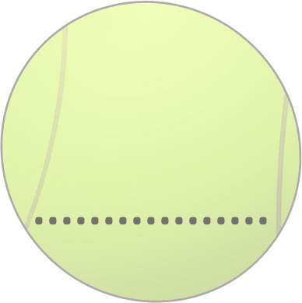 | Tennis started as an outdoor game.
 | Walter Winfield introduced “lawn tennis” in 1873.
 | Miss Outer bridge was the first British woman in playing tennis.
 | Tennis is one of the oldest sports in the world.
 | Lawn Tennis was first played on a court shaped like a rectangle.
 | When hitting the ball, tennis required agility, intelligence and equipment.

- Write the correct order of the events from 1 to 7.
- Escribe el orden correcto de los eventos desde 1 al 7.

……Tennis became internationally enjoyed by men and women.
……Lawn tennis was introduced in Britain.
……Mary Outerbridge introduced tennis in New York
..1...Tennis started to be played by French and English royalty.
……The court became rectangular in shape.
……Lawn tennis was played on a court shaped like an hour-glass.
……The first lawn tennis championship was held at Wimbledon.

SECTION 3: LET´S CONSTRUCT AND APPLY OUR KNOWLEDGE
A popular sport in Chile
- Create a profile for a popular sport in Chile. Complete the table.
- Crea un perfil para un deporte popular en Chile. Completa la tabla.
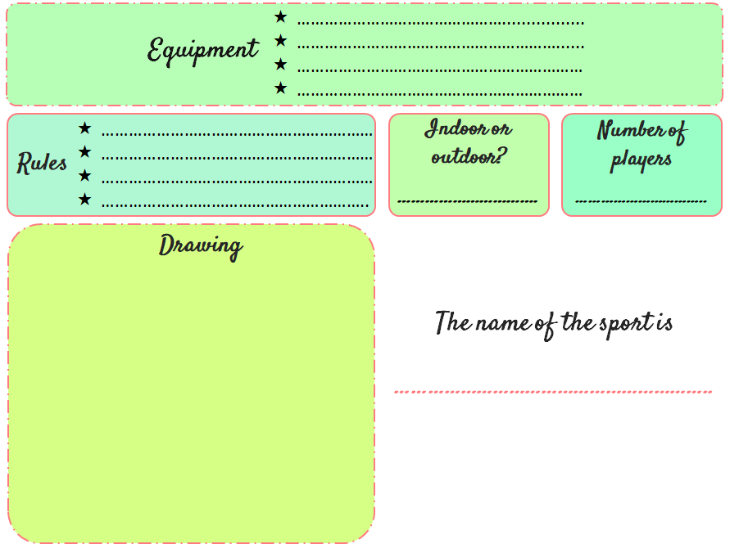

SECTION 4: EXTRA ACTIVITY
My favorite sportsman/sportswoman
1. Complete a Fact File with information of your favorite sportsman or sportswoman.
- Completa el expediente con información de tu deportista favorito.

Fact file | Example | Fact file | Your favorite athlete
Name | Usain Bolt | Name
Sport | Running | Sport
Nationality | Jamaican | Nationality
Height | 1.95 mts. | Height
Weight | 94 kl. | Weight
Nickname | “Lightning ´Bolt” | Nickname
Equipment needed | sneakers, running shorts and a T-shirt | Equipment needed
Competitions and Sports Awards  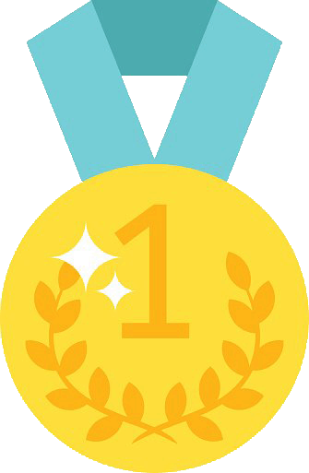 | Gold medals in Beijing Olympics. 100m. 200m and 4*100m relay in London Olympics. | Competitions and Sports Awards
Interesting fact | 100m: 9.58 seconds (August 16, 2009, Berlin) | Interesting fact

SECTION 5:
Digital Resources
Take a look at this links!
- https://bdescolar.mineduc.cl/info/top-101-athletes-00046211
NO OLVIDAR REPASAR EL CONTENIDO CON UN ADULTO

