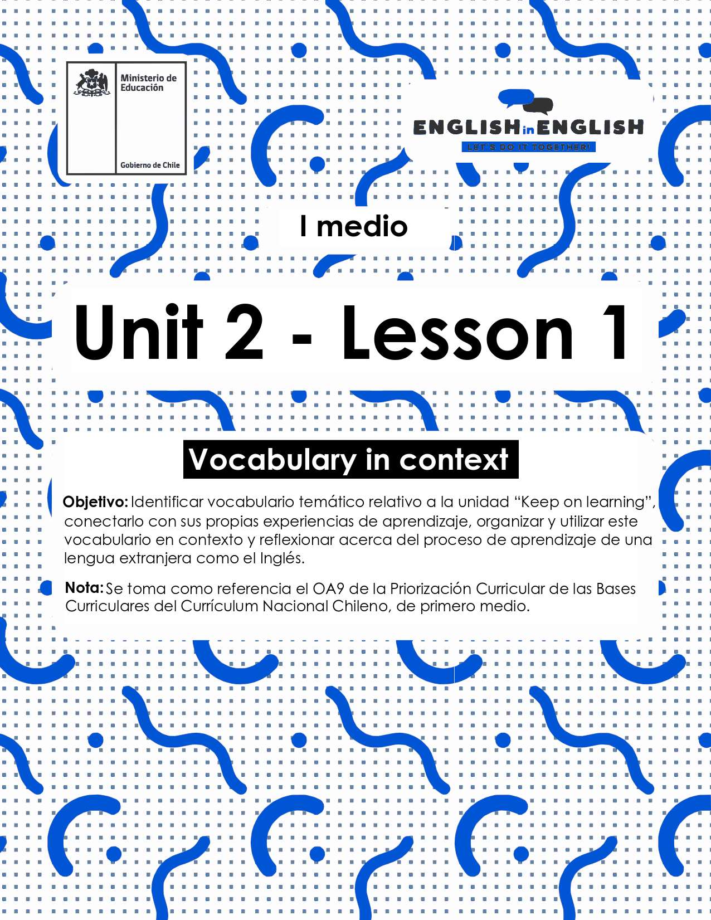

LESSON 1  
VOCABULARY IN CONTEXT

## ÚTILES RECOMENDADOS:

* Texto del estudiante 1° Medio
* Cuaderno de inglés o 2 hojas en blanco.
* Lápiz grafito y goma.
* Pictionary (Incorporado al final de esta guía)

## SECTION 1: SETTING THE CONTEXT

1. **Look at the pictures and examine each one carefully.**

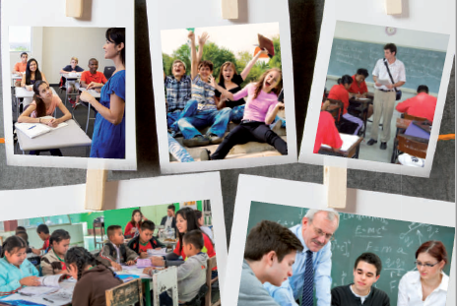

1. **Reflect about what you saw in the pictures.**

* **Think about people, places, materials, and actions performed.**
* **For example: Students, school, and study.**
* **Use the chart below to write your ideas.**

|  |  |  |  |
| --- | --- | --- | --- |
| Place(s) | People | Materials | Actions performed |
|  |  |  |  |

(Source: Adapted from students’ book)

1. **Do you know the meaning of these words and phrasal verbs?**

* **Read the words and phrasal verbs with their definitions and match them to the corresponding picture like the example.**
* **You can use the Pictionary at the end for extra help.**

|  |  |  |
| --- | --- | --- |
| Stress out: To make someone feel nervous about something. |  | Archivo:Money template 1.png - Wikipedia, la enciclopedia libre |
| Bully: To harm, laugh at, bother, or intimidate someone else. | Learning kids with icons | Free SVG |
| Afford: To have enough money to pay for. | Message Chat Communication - Free vector graphic on Pixabay |
| Laugh at: To make the noise with your voice that shows you think something is funny. | Business Stress Free Stock Photo - Public Domain Pictures |
| Learning: The process of gaining knowledge and experience, for example by studying. | Bully,bullying,boys,free pictures, free photos - free image from ... |
| Message: A piece of written or spoken information that you send to someone. | Laughing smiley vector image | Free SVG |

(Source: Original Material)

1. **Expand your vocabulary! Match the words and phrases related to Education with their definitions.**



  (Source: Taken from 1st Graders Student’s Book)

## SECTION 2: LET’S PRACTICE

1. **Think about your school days.**

* **Do you remember your friends, teachers, and favourite activities you performed there?**
* **Read the following story about school days and use the words from the**word bank **to coherently complete it.**

## stressed out      laugh at     bullied

## cruel messages      cannot afford it         learning

When I was at primary school, I never felt _________or unhappy.  I have the best memories of my old school and classmates! We could always have a _________anything, we were never ________and we were __________ interesting things in most of the classes.

I am about to finish high school now and I have been studying very hard to complete all my online assignments. I have lots to print every week, but I____________, so I write down the answers in my copybook and send a picture to my teachers.

As we are not attending school, we have had to participate in forums as well. All opinions are accepted, but ___________are not allowed.

 (Source: original material)

1. **Put the sentences into the correct order.**

* **The following sentences contain some words from activity 4 in the previous item.**

1. **a real/ My summer job/ it was/ learning experience for me. / wasn’t fun but**

______________________________________________________

1. **to attend/ Sophie/ a scholarship/ was awarded/ Boston University.**

______________________________________________________

1. **through a series of/ The course/ lectures and seminars. / will be taught**

______________________________________________________

(Source: Original Material-Sentences taken from MacMillan Dictionary)

## SECTION 3: LET’S CONSTRUCT AND APPLY OUR KNOWLEDGE

1. **Reflect about your own experience learning English and define difficult and easy things about it.**

* **Use the graphic organizer bellow to organize your ideas.**

(Source: Taken from 1st Graders Student’s Book)

## SECTION 4: SPONGE ACTIVITY

* **Select four new words from the ones you learned from this guide.**
* **Then, write a short sentence based on your school experience.**
* **Ex: I feel stressed out with my online assignments.**
* **You can use the Pictionary at the end for extra help.**



## SECTION 5: PICTIONARY

