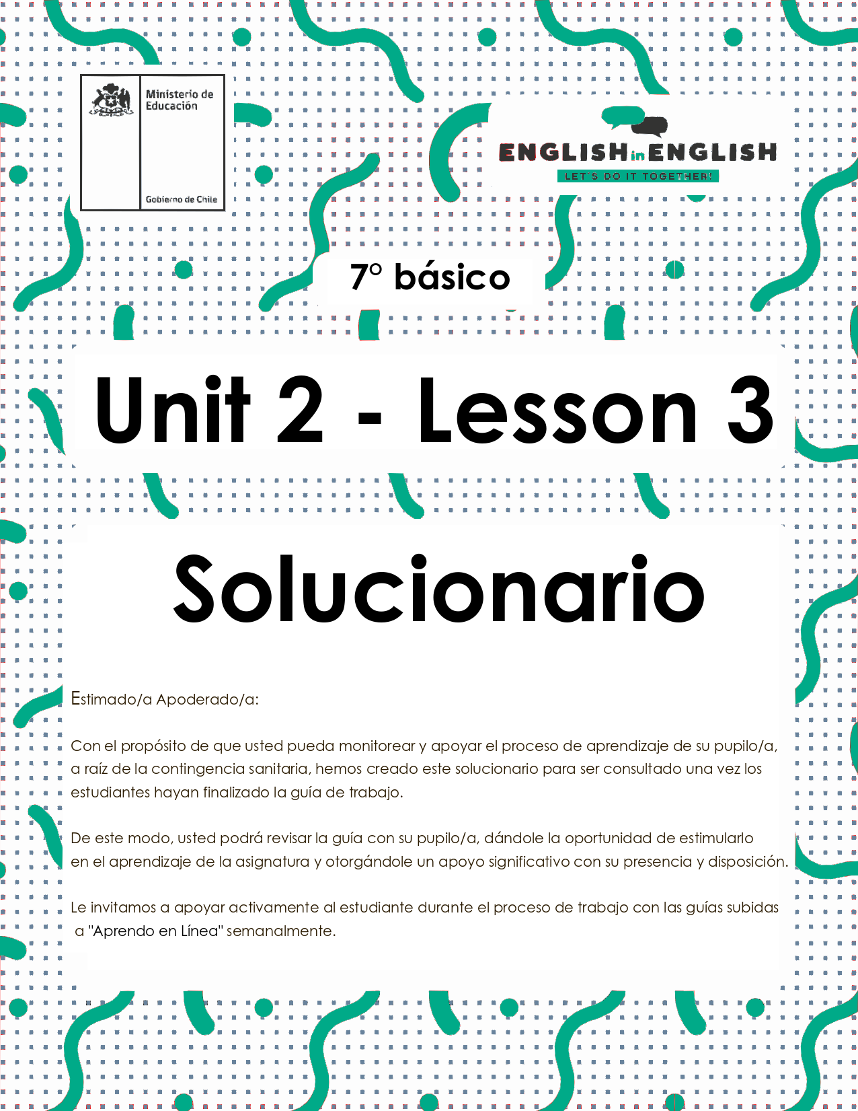
UNIT 2
LESSON 3

ÚTILES RECOMENDADOS:
- Texto del estudiante 7° básico.
- Cuaderno de inglés o 2 hojas en blanco.
- Lápiz grafito y goma.
- Diccionario de Inglés físico / online https://dictionary.cambridge.org/es/diccionario/espanol-ingles/

SECTION 1: SETTING THE CONTEXT

Healthy Habits

1. Observe the image and answer the questions.
- Observa la imagen y responde las preguntas.
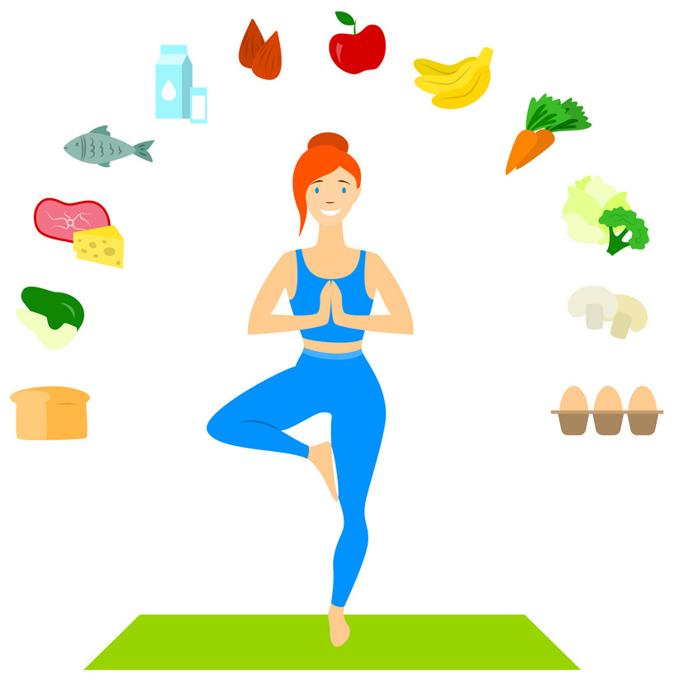

Questions | Answers
Do you think the girl is a healthy person? Why? | Yes, she is a healthy person. Because she exercises and eats healthy food.
What food items can you identify? Write at least 4. | Fish, eggs, carrots, broccoli, milk, apple, banana, bread, mushrooms, etc.
What kind of physical activities do you think the girl does? | I think she does yoga.

2. You will identify 4 healthy habits recommendations, observe the images, and match them. Write the recommendation in the space given.
- Identificarás 4 recomendaciones con hábitos saludables, observa las imágenes y relaciónalas. Escribe la recomendación en el espacio dado.
A) You must eat fruits. B) You should do physical activity.
C) Don´t smoke. D) You should drink 2 liters of water.

 | 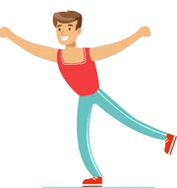 | 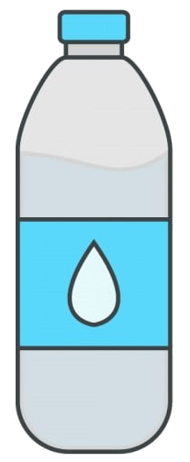 | 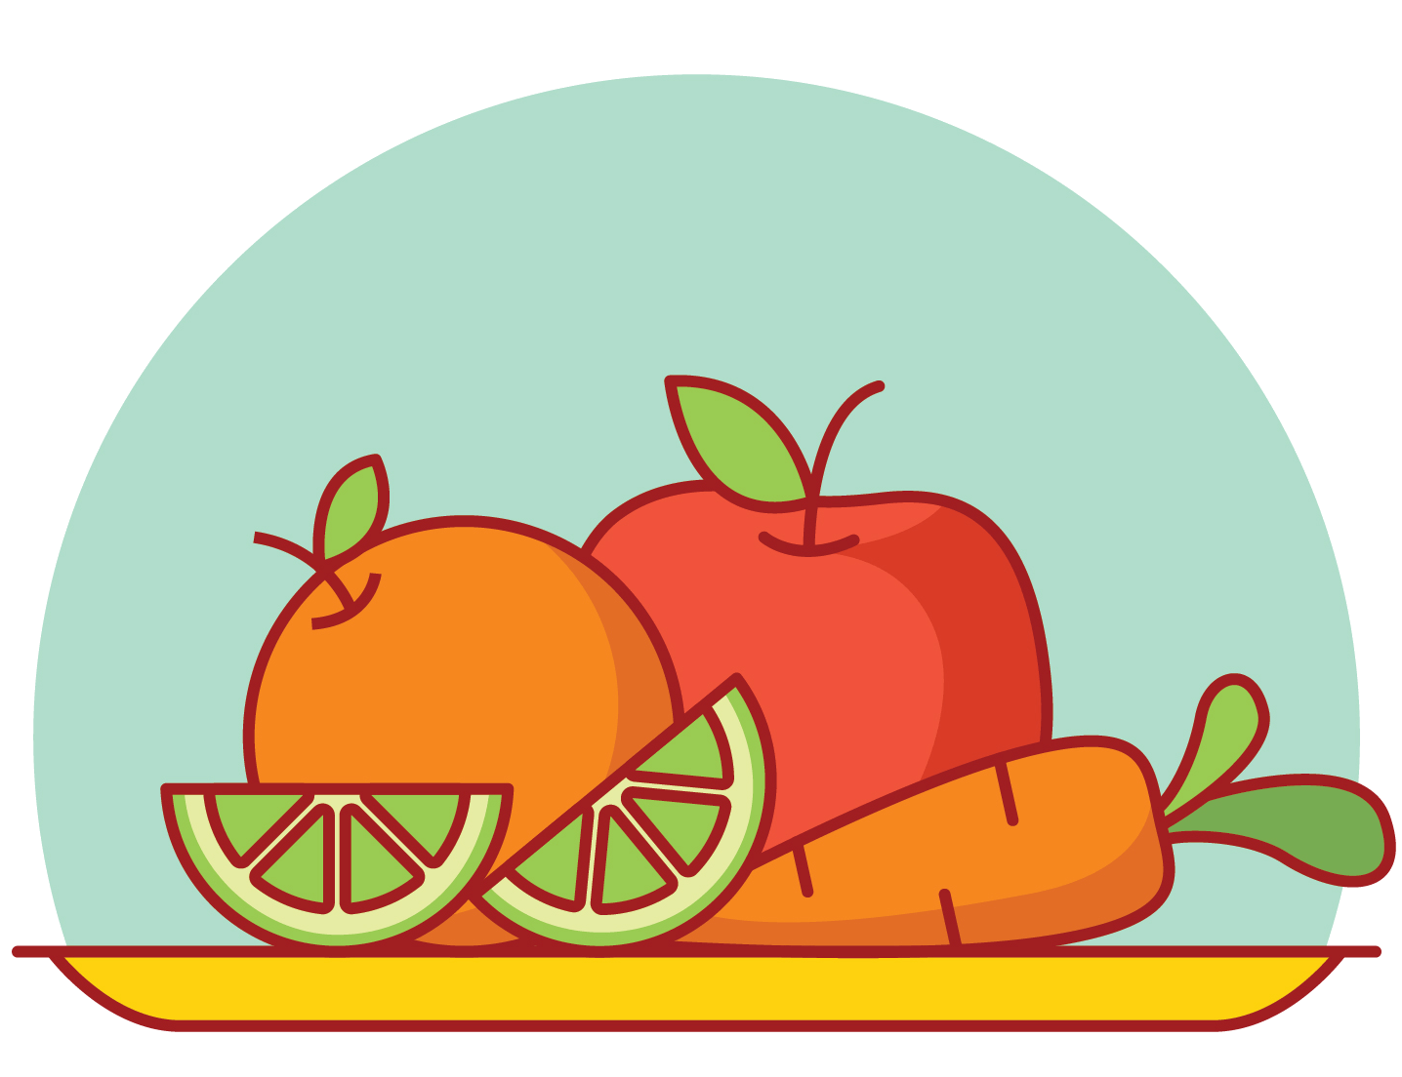
Don´t smoke | You should do physical activity | You should drink 2 litres of water | You must eat fruits

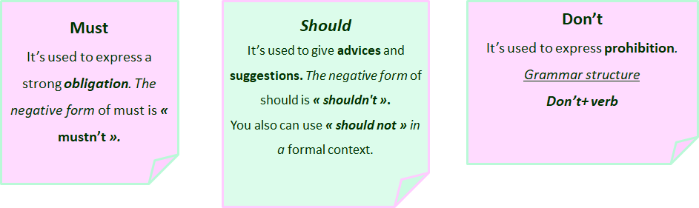

3. Answer these questions according to the previous activity. Write the corresponding letter.
- Responde estas preguntas según la actividad previa. Escribe la letra correspondiente.
A) You must eat fruits. B) You should do physical activity. C) Don´t smoke.
D) You should drink 2 liters of water.
- Which instruction expresses obligation? A
- Which instruction expresses prohibition? C
- Which instruction expresses suggestion? B and D

4. Answer these questions about you.
- Responde estas preguntas acerca de ti.
**Respuesta abierta**
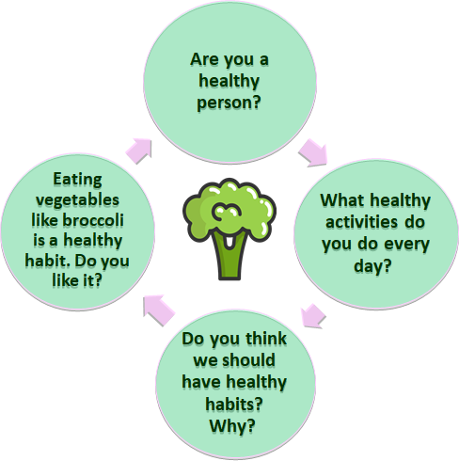
I run every day.
Yes, I am a healthy person.
Yes, it is a healthy habit, but I don't like it.
Yes, I think we should because it helps us to have a better quality of life.

SECTION 2: LET´S PRACTICE

Poem
- Read the poem and underline the words you don´t know. Look them up in the dictionary.
- Lee el poema y subraya las palabras que no conoces. Búscalas en el diccionario.

**Respuesta abierta**

My favorite food is broccoli.
I eat it every day.
There isn’t any other food
that makes me feel this way.
It makes me feel so healthy.
It makes me look so cute.
But, mostly, I like broccoli
because it makes me more astute.
Poem adapted and taken from https://www.poetry4kids.com/poems/my-favorite-food-is-broccoli/

2. Read the poem again and write a title for it.
- Lee el poema nuevamente y escribe un título para este.

**Respuesta abierta**

“ Oh, My Broccoli!! ”

3. Find in the poem words that rhyme. Example: day - way
- Encuentra en el poema palabras que rimen. Ejemplo: day - way
day and way / cute and toot

4. Write a new stanza of 4 lines for the poem in the space given.
- Escribe una nueva estrofa de 4 versos para el poema en el espacio dado.

**Respuesta abierta**

My favorite food is broccoli.
I eat it every day.
There isn’t any other food
that makes me feel this way.
It makes me feel so healthy.
It makes me look so cute.
But, mostly, I like broccoli
because it makes me more astute.
My favorite food
It makes me special
It makes me rude
Broccoli is my favorite food

SECTION 3: LET´S CONSTRUCT AND APPLY OUR KNOWLEDGE

Suggestions and obligations for a healthy lifestyle

1. Read the sentences expressing obligation and suggestion and correct them. Use words from the box to help you.
- Lee las oraciones que expresan obligación y sugerencia y corrígelas. Usa palabras del cuadro para ayudarte.
should shouldn´t must mustn´t

a) You shouldn't do physical exercise.
Example : You should do physical exercise.
b) You must drink sodas.
You mustn't drink sodas.
c) You mustn't eat fruits.
You must eat fruits.
d) You should eat pizza every day.
You shouldn't eat pizza every day.
e) You should use your cellphone for long hours each day.
You shouldn't use your cellphone for long hours each day.
f) You mustn´t respect other people.
You must respect other people.

2. Write 5 sentences about habits a friend must have a healthy lifestyle. Complete them in the chart.
- Escribe 5 oraciones con hábitos que un amigo debe tener para un estilo de vida saludable. Escríbelos en el cuadro.

**Respuesta abierta**

Example: You must eat fruits and vegetables every day.

- You must exercise everyday.
- You must drink milk and water.
- You must sleep at least 8 hours every night.
- You must eat green vegetables.
- You must do outdoor activities.

3. Write 5 sentences about habits a friend mustn’t have a healthy lifestyle. Write them in the chart.
- Escribe 5 oraciones con hábitos que un amigo no debe tener en un estilo de vida saludable. Escríbelos en el cuadro.

**Respuesta abierta**

Example: You mustn't eat junk food.

- You mustn't smoke.
- You mustn't drink alcohol.
- You mustn´t only play with your computer.
- You mustñ´t eat too much sugar.
- You mustn't only stay in bed all day long.

4. Write your own poem giving suggestions for having a healthy lifestyle. You can choose your favorite food item or your favorite physical activity. Include images and help you with all the previous activities.
- Escribe tu propio poema dando sugerencias para tener un estilo de vida saludable. Puedes elegir tu alimento favorito o tu actividad física favorita. Incluye imágenes y ayúdate con todas las actividades previas.

**Respuesta abierta**

title: Sweet apples

Apples juicy,
Apples round,
On the tree or the ground,
Apple green,
Apple red.
Apple sweet to eat.

Written by……………….

SECTION 4: EXTRA ACTIVITY

My poster
Create a poster about “Healthy habits” to encourage your family and friends to be healthy. Follow these steps:
**Respuesta abierta**

- Use images to express your ideas
- Write a title
- Express “Suggestions”, “Obligations” or “Prohibitions” in your poster
- Use vocabulary related to food and physical activities
Examples:
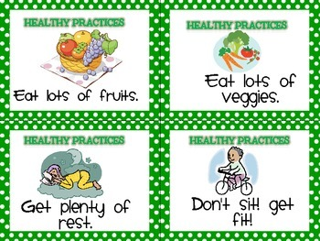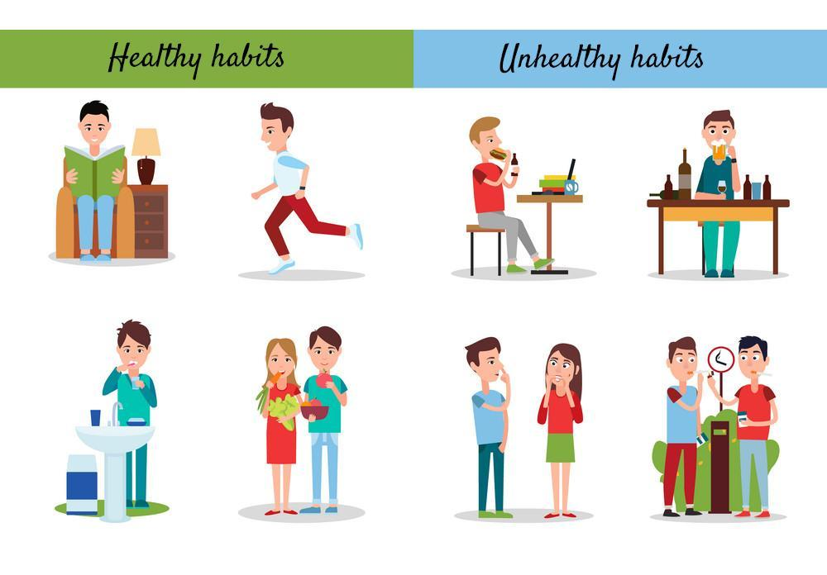
- It has a message.
- It has a creative way to present the information.
- It has colors.
- It has the precise information.
Share it with your friends through social media and eodp_chile / Students in Action.
SECTION 5: DIGITAL RESOURCES
Take a look at these links!

In addition, there are several online rhyming dictionaries. Here are a couple of the best:
- Online Rhyming Dictionary https://www.poetry4kids.com/
- RhymeZone Online Rhyming Dictionary https://www.rhymezone.com/

NO OLVIDAR REPASAR EL CONTENIDO CON UN ADULTO

