LESSON 3
WRITING

ÚTILES

- Texto del estudiante de 3° medio.
- Diccionario de inglés.
- Lápices.
- Cuaderno de asignatura.

ICONS FOR ACTIONS

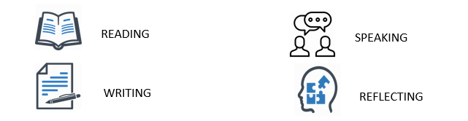

SECTION ONE: SETTING THE CONTEXT

1. First, brainstorm as many work-related words as you can from previous weeks.
- For example, “salary”.
- Take two minutes and count the words.

MONEY PART-TIME FULLTIME

Salary Benefit Obstacles Employment work

Praise EMPLOYER ASSISTANT PRODUCER POLICE OFFICER

RESUME CV job RESPONSIBLE PROACTIVE schedule

if you wrote...

from 1 to 5 words- you need to study a bit more

from 5 to 10 words- You have good memorization skills

over 10- it is evident that you have studied, Well done!

2. Read and study for two minutes the following table.
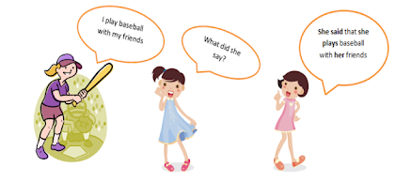

Direct Speech | Reported Speech
I am feeling unwell. | She said that she was not feeling well.
I can't go to work feeling unwell. | She told me that she could not go to work because she was feeling unwell.
We will be safe at home over the pandemic. | They mentioned that they would be safe at home over the pandemic
Secretary: Can I have your address? | The secretary asked me if she could have your address.
So, we use reported speech to represent what other person or people have said before.
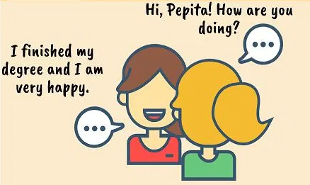
Key word: came across- encounter by chance
Adapted from: https://correctordewriting.wordpress.com/category/improve-your-grammar/
3. Read the following report sentences and classify chunks of the sentences into three categories.

- Freddy told me to go to the hospital to work, but he did not go.
- Miguel said that he was self-confident towards our future achievements at work; however, he also mentioned concerns to pay the salaries and bonusses on time.
- Evelyn asked me if I had finished the surgery on time; she also told me that no surgeries were scheduled for tomorrow!

WORK-RELATED VOCABULARY | CONNECTORS | REPORTED SPEECH VERBS
hospital | but | told
work | Also | asked
Salaries | However, | said
Self-confident | And | Mentioned

SECTION TWO: LET’S READ AND PRACTICE!

4. Re-read the table in exercise 2, and highlight the sentences from the table in the following dialogue

Maria: I am feeling unwell today Peter; I have a fever and dry cough. Could you please call a doctor for me?
Peter: Sure! give me one second. (Peter rings the medical center)
Secretary: Medical centre, how can I help you?
Peter: Hi! My name is Peter Moore. I am calling because my friend said that she was not feeling well. I am afraid that it can be something serious.
Secretary: Is she there with you?
Peter: Yes, she is. She told me that she could not go to work because she was feeling unwell.
Secretary: Well, that is a very sensitive decision. She will be safe at home over this period. I will send a nurse to visit you.
Peter: Thanks so much. Our address is 24 Alameda Avenue, Machalí.
Secretary: Thanks, the nurse will be heading to your place soon.
Peter: Thanks so much, we will be waiting
Maria: What did she say, Peter?
Peter: She mentioned that you would be safe at home, and she asked me for the address to send a nurse. You will be fine my dear!

5. by considering the above dialogue, can you complete the following reported speech sentences for Maria?
Peter: You need to take a rest at home.

María: Peter told me TO TAKE A REST AT HOME
Nurse: Take this medication for two weeks, and drink plenty of lemonade with lemon.

Maria: The nurse mentioned TO TAKE THE MEDICATION FOR TWO WEEKS and she told ME TO DRINK PLENTY OF LEMONADE WITH LEMON.
Nurse: Can I have the name of your medical insurance?

Maria: The nurse asked ME FOR MY MEDICAL INSURANCE NAME.

6. Let's practice previous vocabulary and structures from the unit.
- For each question, complete the second sentence so that it means the same as the first one.
- Use no more than three words.
- You can use the keywords from previous guides and your textbook for help:

Example:

A1) Working part-time gives you free time to hang out with your friends and study.

A2) Part-time work has many benefits, for example, free time to do other activities.

B1) Catherine said that her part-time job got cancelled because of the pandemic.
B2) Catherine MENTIONED/TOLD ME that she is not working part-time this week.

C1) Ben said that a lot of doctors and nurses are working very hard.
C2) Ben MENTIONED/TOLD ME that most doctors and nurses are working full time.

D1) Catherine said that her hospital gave her a full-time contract.
D2) The hospital gave Catherine A FULL-TIME job.

E1) Ben said that he prefers to work in a medical call center to avoid risks.
E2) Ben has worked with face-to-face interactions, BECAUSE he prefers call centers.

SECTION 3: FURTHER PRACTICE

7. Read the dialogue and expand it.
- Read about what happened when the Nurse visited Maria.
- Then, imagine you are Maria and tell Peter what the Nurse said to her:

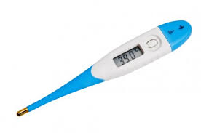

Nurse: Hello Ms Maria. I have come to check on you.
Maria: Thank you! Peter told me you would come. I do not feel good...
Nurse: You seem pale...Let me check your temperature. (The nurse uses a thermometer). You have a moderate fever.
Maria: I think I have a sore throat too. (Now the nurse checks Maria´s throat).
Nurse: It seems a bit scruffy. That is not good. Have you taken any medicine yet?
Maria: No, I have not. Peter suggested waiting until your visit
Nurse: Ok. I will prescribe one medicine and syrup. The number of dots in front of each medicine name tells you how many times in the day you need to take them. Do you have any questions about this?
Maria: No, I am clear from your explanation.
Nurse: If the pain continues for more than a week, please make an appointment with Doctor Jones. (The nurse leaves the house).

Later, Maria phones Peter and tells him what the Nurse said…

Hey Peter! The Nurse just left a couple of minutes ago. First, I told her I was not feeling good and that I had a fever, then she told me TO GET/BUY SOME MEDICINE AND SYRUP. SHE ALSO MENTIONED TO MAKE AN APPOINTMENT WITH DOCTOR JONES IF THE PAIN CONTINUES.

