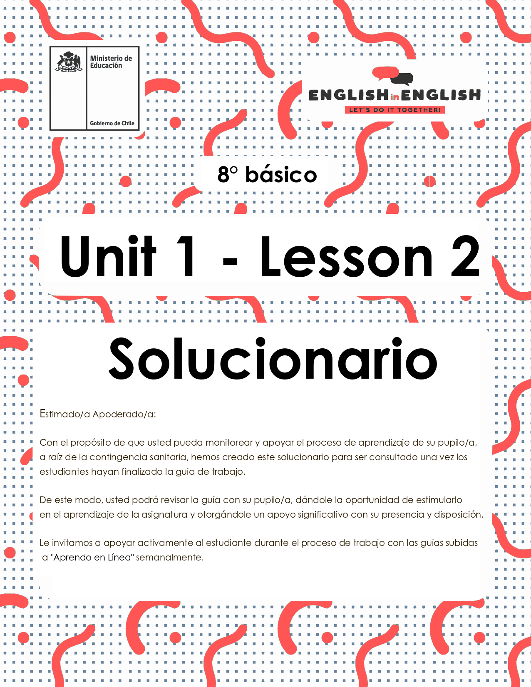

WEEK 2  
READING COMPREHENSION

ÚTILES

* Tu cuaderno de inglés o hojas en blanco.
* Lápiz grafito, goma, regla.
* Marcadores de colores y/o lápices de colores.

ACTIVITY 1: BEFORE READING

*(Tiempo estimado: 20 minutos)*

1. **Answer the following questions.**

*Responde las siguientes preguntas*.

|  |  |
| --- | --- |
| **Do you know what an ode is?** | **YES / NO**  **\*La respuesta puede ser Yes o No** |
| **What type of text is an ode?** | **Lyric** |
| **Descriptive** |
| **Narrative** |
| **Instructive** |

**\*Dependerá de los conocimientos previos del estudiante.**

1. **Read the following quotation and answer the questions below.**

*Lee la siguiente cita y responde las preguntas a continuación.*

|  |
| --- |
| **“TECHNOLOGY IS A USEFUL SERVANT BUT A DANGEROUS MASTER”** |

|  |  |
| --- | --- |
| **What does it mean? According to your interpretation.** | ** LAS RESPUESTAS PUEDEN SER VARIAS, ALGUNOS EJEMPLOS: **  1. Technology is useful in our daily life.  It can have a negative impact in our lifestyle. |
| **Do you agree with the quotation?** | Yes, I do.  No, I don’t |

1. **Match the word with the corresponding image.**

*Relaciona la palabra con la imagen correspondiente.*

|  |  |  |  |
| --- | --- | --- | --- |
| 1.- Laptop  2.- Notebook  3.- Fingernails  4.- Denim jackets  5.- Stand out  6.- Weird |  | 1 |  |
| ***4*** | ***1*** | ***6*** |
|  |  |  |
| ***3*** | ***5*** | ***2*** |

ACTIVITY 2: WHILE READING

*(Tiempo estimado: 20 minutos)*

1. **Read the following Ode carefully.**

*Lee cuidadosamente la Oda.*

Ode to...

This is an ode to

bone earrings,

rock music,

tattoos and inappropriate **laptop** stickers,

To the un-conventionalists,

multi colored tape,

the red **notebook**,

and long painted **fingernails.**

To round glasses,

thrift stores,

**denim jackets**

and angels,

To the inclusionists

andreal-world conversations ripe

with humor

and light,

To the quiet ones

and the loud

To the ones who are meek

and the ones who **stand out**

Tojolly ranchers

and **weird** games**.**

taken from:<https://powerpoetry.org/poems/ode-army-pens-keypads>

***ODE: An ode is a poem that gives praise to an object.***

1. **Read the ode and then answer the following questions.**

*Lee la Oda y luego responde las siguientes preguntas.*

1. What is the topic of the ode?

|  |
| --- |
| ***Creative people that stand out for their interests and personalities*** |

1. The ode is written to a/an:
2. Animal
3. ***Object***
4. Person
5. Nature (ocean, forest, etc.)
6. Create a title for the ode.

|  |
| --- |
| **\* LAS RESPUESTAS PUEDEN SER VARIAS. EJEMPLOS:**   * ***Ode to Cool People*** * ***Ode to stickers*** * ***Creating a style*** * ***Ode to the writers*** * ***Ode to computers*** |

1. **Read the verse and write what it means for you in one sentence.**

*Lee el verso y escribe lo que significa para ti, en una oración.*

This is an ode to

bone earrings,

rock music,

tattoos and inappropriatelaptop stickers,

** LAS RESPUESTAS PUEDEN SER VARIAS, EJEMPLO:

1 ***refers to adopt a new life style***

***Se refiere a adoptar nuevos estilos de vida***

To the un-conventionalists,

multi colored tape,

the red **notebook**,

and long painted **fingernails**

** LAS RESPUESTAS PUEDEN SER VARIAS, EJEMPLOS:

***People create art and new fashion styles.***

***/. La gente crea arte y nuevos estilos de moda.***

ACTIVITY 3: AFTER READING

*(Tiempo estimado: 30 minutos)*

1. **Read the following example.**

*Lee el siguiente ejemplo.*

***An Ode to Blueberries***

Oh blueberries,  
I see you wearing your purple crown,  
sprinkled over my waffle.  
Oh blueberries,   
thank you for swimming  
in sweet butter  
and  
maple syrup.  
Oh blueberries, you are simply delicious.

**2.- Use these instructions when working on your odes.**

*Usa las instrucciones cuando prepares tu oda.*

* + Pick an ordinary place or thing
  + Give your place or thing praise or thanks. *(Oh, _____________!)*
  + Speak directly to the object.
  + Use adjectives to describe it.
  + Use verbs to bring that object to life. *(Personification)*

**3.- Choose any technological object and write your own ode following the given example above.**

*Elige algún objeto tecnológico y escribe tu propia oda siguiendo el ejemplo de arriba.*

*\*\* LAS RESPUESTAS PUEDEN SER VARIAS, ALGUNOS EJEMPLOS:\*\**

**Oh Dear Smart TV**

**Thanks to you I can watch Netflix**

**You're so lit, I can't sleep**

**Thinking about your HD screen.**

EXTRA CURRICULAR ACTIVITY

*(Tiempo estimado: 20 minutos)*

1. **Challenge.**

Desafío

Step 1 Send the ode you created to 10 friends on Instagram or any

social media.

Step 2 Ask your friends to give a title to the ode.

Step 3 Choose your 3 favorite titles and write them down:

***1.-Depends on the student’s selection.***

***2.-Depends on the student’s selection.***

***3.-Depends on the student’s selection.***

