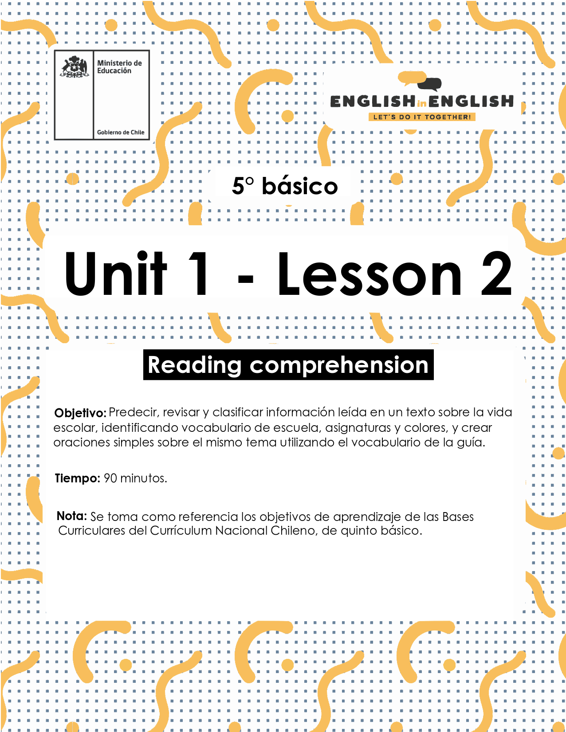

WEEK 2
READING COMPREHENSION

ÚTILES RECOMENDADOS
● Tu cuaderno de inglés o 2 hojas en blanco
● Lápiz grafito, goma.

ACTIVITY 1: WHAT DO YOU KNOW ABOUT SCHOOL? (10 minutes)
1. Look at the classroom.
- Observa la sala de clases
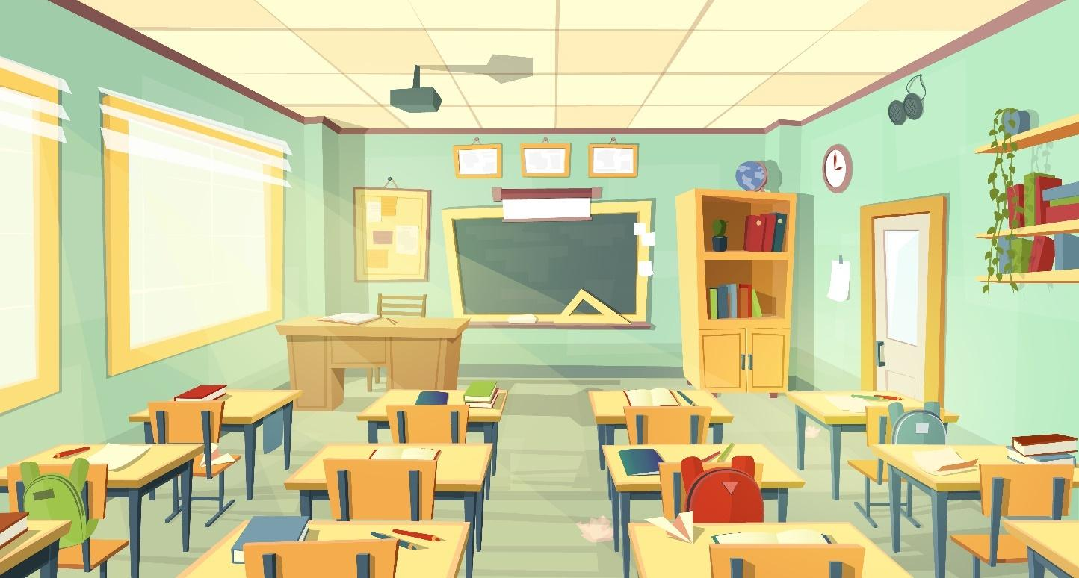
Source/Fuente: Freepik.es
2. What are the differences and similarities between the photo and your own classroom?
- ¿Cuáles son las diferencias y similitudes entre la imagen y tu sala de clases?

__________________________________________________________

3. Why is the classroom empty?
- ¿Por qué está vacía la sala de clases?

__________________________________________________________

4. Look at the picture and discuss the questions with someone in your family or someone you live with.
- Mira la imagen y discute las preguntas con alguien de tu familia o alguien con quien vivas.

- Do you like school? Why?
(¿Te gusta la escuela? ¿por qué?)

- What is your favourite school activity?
(¿Cuál es tu actividad escolar favorita?)

- Can you remember your first day of school?
(¿Puedes recordar tu primer día de escuela?)

ACTIVITY 2: SCHOOL VOCABULARY (20 minutes)
1. Look at the school objects vocabulary.
- Observa el vocabulario de útiles escolares. 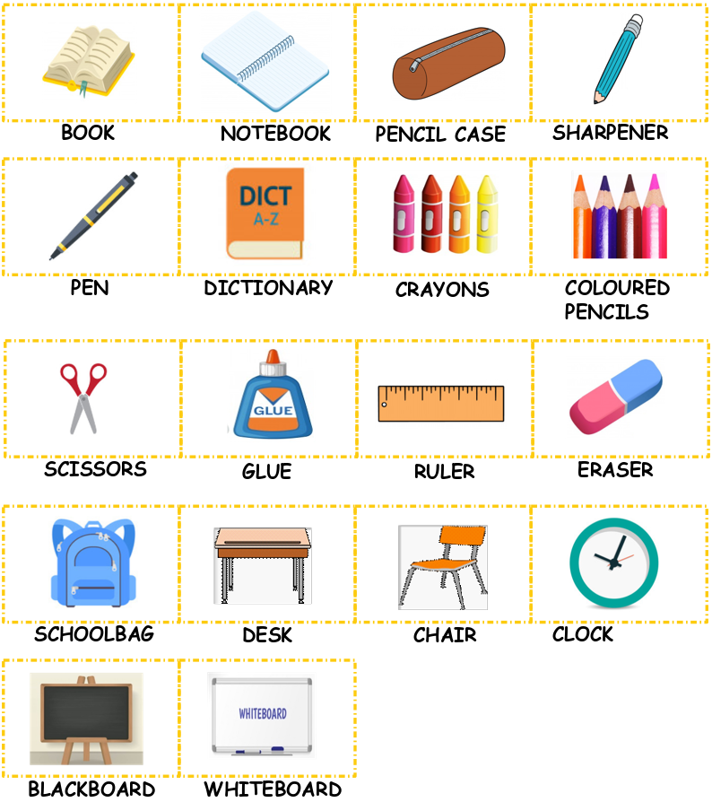

2. Arrange the letters to form a word from the school vocabulary.
- Ordena las letras para formar una palabra del vocabulario de la escuela.

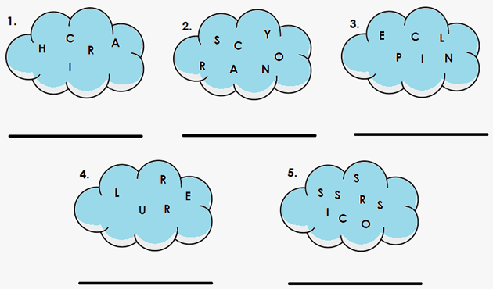
3. Create sentences to describe what color these school objects are according to the image.
- Crea oraciones para describir el color de los útiles escolares de acuerdo a la imagen.
- Example: 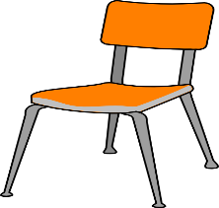 The chair is orange and grey.

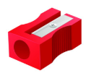
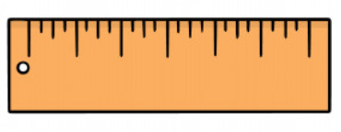

ACTIVITY 2: READING (20 minutes)
1. Read about Elena’s school and underline the words from the vocabulary that are in the text.
- Lee el texto sobre la escuela de Elena y subraya las palabras del vocabulario que aparecen en el texto.
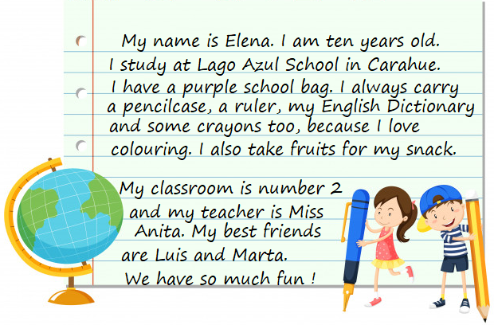
2. Answer the questions about Elena’s school text.
- Responde las preguntas del texto sobre la escuela de Elena.

- What is the name of Elena’s school?
__________________________________________________
- Mention 3 objects that Elena carries in her school bag.
__________________________________________________
- Does Elena like fruits?
__________________________________________________
- What number is Elena’s classroom?
__________________________________________________

2. Read the sentences and circle True (T) or False (F). Justify the false statements.
- Lee las oraciones y selecciona Verdadero (T) o Falso (F). Justifica las oraciones falsas.
- Elena is five years old. (T) (F) ______________________
- Elena’s teacher is Miss Anita (T) (F) ______________________
- Elena’s best friends are Jorge and María (T) (F) ______________________
- Elena has a purple school bag (T) (F) ______________________
- Elena carries a Spanish Dictionary (T) (F) ______________________

ACTIVITY 3: SCHOOL SUBJECTS ( 25 minutes)
1. Look at the school subjects box. Which school subject is your favorite?
- Observa las asignaturas del recuadro. ¿Cuál es tu asignatura favorita?
Geography | English | Science | History | Arts
Music | Language | Technology | Maths | Physical Education

2. Look at the school schedule and write the correct subject according to the images. Use the subjects from the box above.
- Observa el horario escolar y escribe la asignatura correcta de acuerdo a las imágenes. Usa las asignaturas del cuadro de arriba.
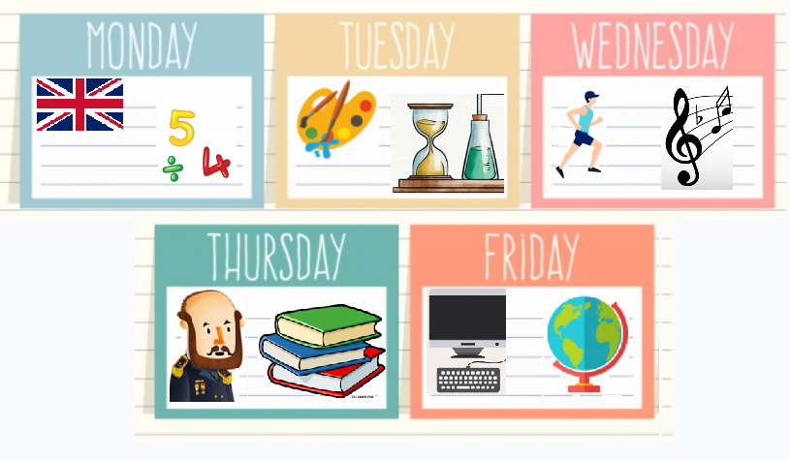

3. Complete the sentences with the subjects from the box.
- Completa los enunciados con las asignaturas mencionadas en el recuadro.
- Ejemplo: On Monday, I have English and Maths.
On Tuesday, I have _______________________ and _____________________ .
On Wednesday, I have _____________________ and _____________________ .
On Thursday, I have _______________________ and _____________________ .
On Friday, I have _________________________ and _____________________ .

4. Read the description and write the school subject that corresponds.
- Lee la descripción y escribe la asignatura que corresponde.
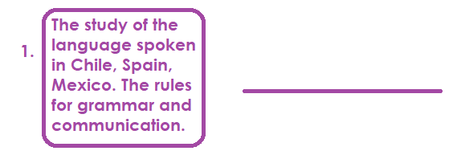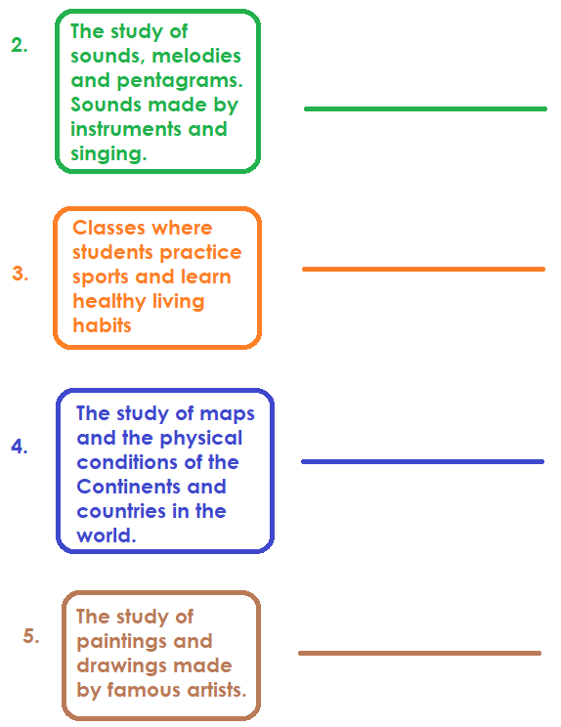

ACTIVITY 4: SCHOOL SUBJECTS ( 20 minutes)
1. School Project: design your own school schedule. You can create your own design or follow our suggestion.
- Diseña tu propio horario escolar. Puedes crear tu propio diseño o seguir nuestra sugerencia.
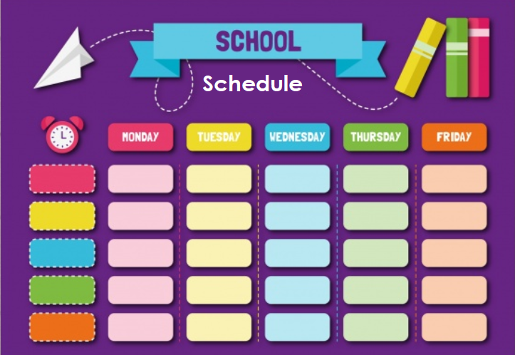

2. Create 4 sentences about your routine at school.
Look at your schedule and write the subject that you have that day and the school objects that you use.
Use the vocabulary of school objects and school subjects.
Follow the example.
- Crea 5 oraciones sobre tu rutina en la escuela. Mira tu horario de clases y escribe la asignatura que tienes durante la semana y los útiles escolares que utilizas.
- Utiliza el vocabulario de útiles escolares y asignaturas.
- Sigue este ejemplo: On Monday, I have Math class and I use my pencil.
1. On Tuesday, ___________________________________________
2. On Wednesday, _________________________________________
3. On Thursday, ___________________________________________
4. On Friday, _____________________________________________

ACTIVITY 5: SPONGE ACTIVITY

- Escucha y canta la canción de la escuela “Quiet, please” https://learnenglishkids.britishcouncil.org/es/songs/quiet-please

- Lee la historia “Off to School” Disponible en la Biblioteca Digital Escolar (Mineduc). https://bdescolar.mineduc.cl/info/off-to-school-00046495

- Lee la historia “I like to come to school” Disponible en la Biblioteca Digital Escolar (Mineduc). https://bdescolar.mineduc.cl/info/i-like-to-come-to-school-00046262

- Lee la historia “First Day” Disponible en la Biblioteca Digital Escolar (Mineduc). https://bdescolar.mineduc.cl/info/celebrate-school-first-day-00046454

NO OLVIDAR REPASAR EL CONTENIDO CON UN ADULTO.

